**SELF ORGANIZING MAPS**

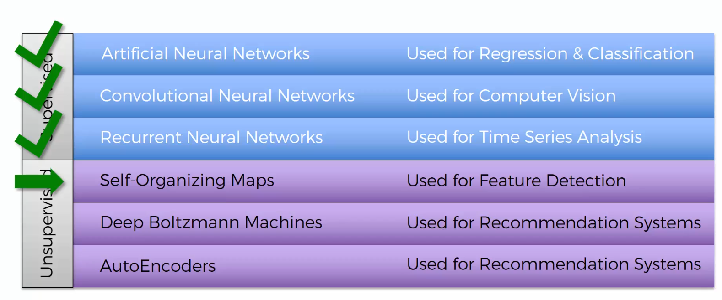

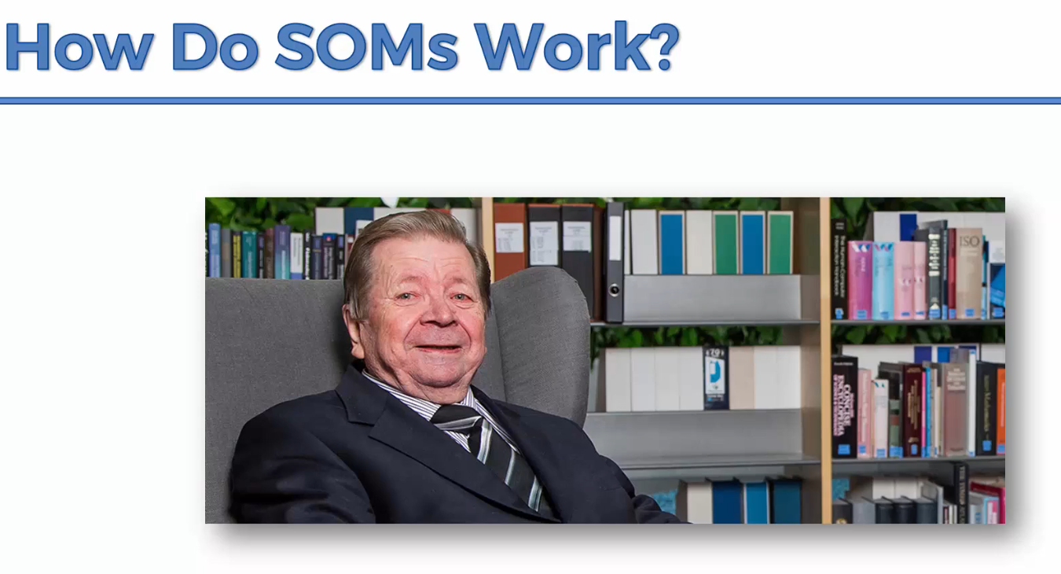

The SOM was introduced by the Finnish professor Teuvo Kohonen in the 1980s and therefore is sometimes called a Kohonen map or Kohonen network.

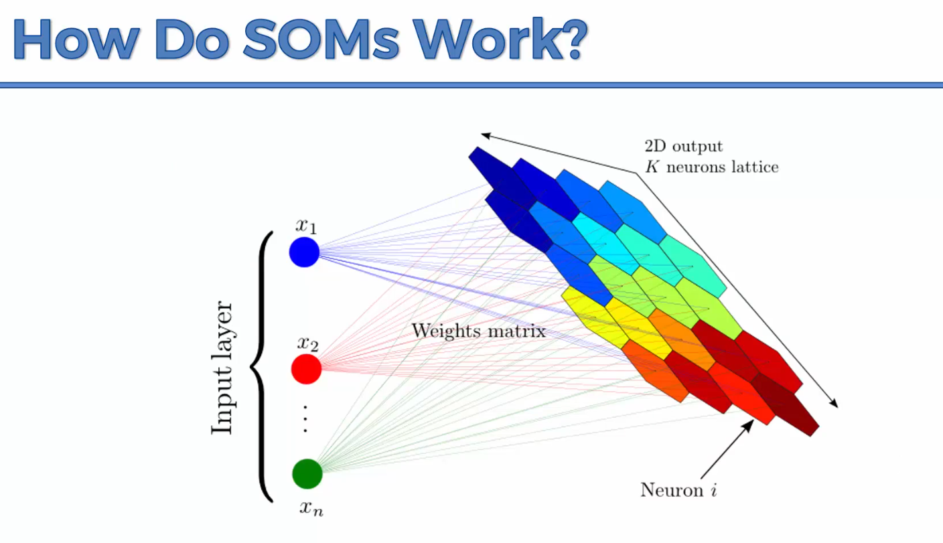

They are used for dimensionality reduction. You can use them in astronomy. They take a multidimensional dataset (lots and lots of columns) and create a 2D representation of your dataset.

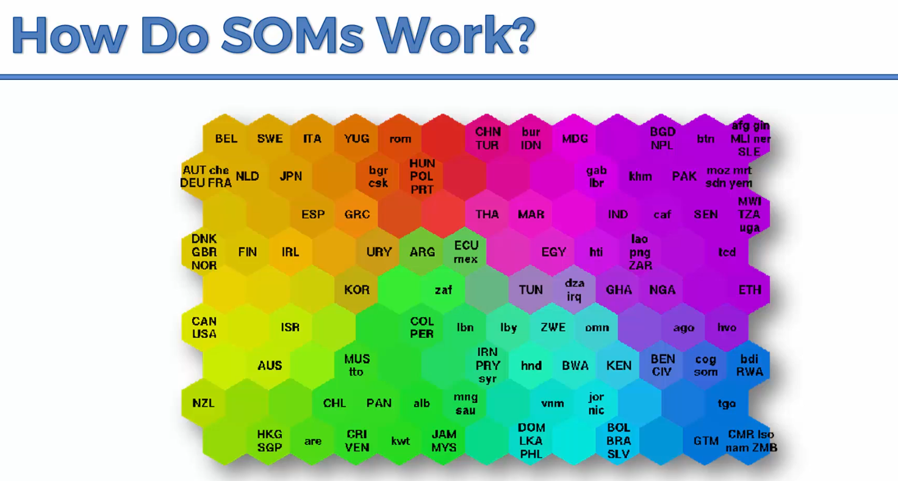

This is a SOM showcasing the different states of prosperity and poverty in different countries. They have been put in different clusters based on 39 indicators. The SOM does this in an unsupervised manner.

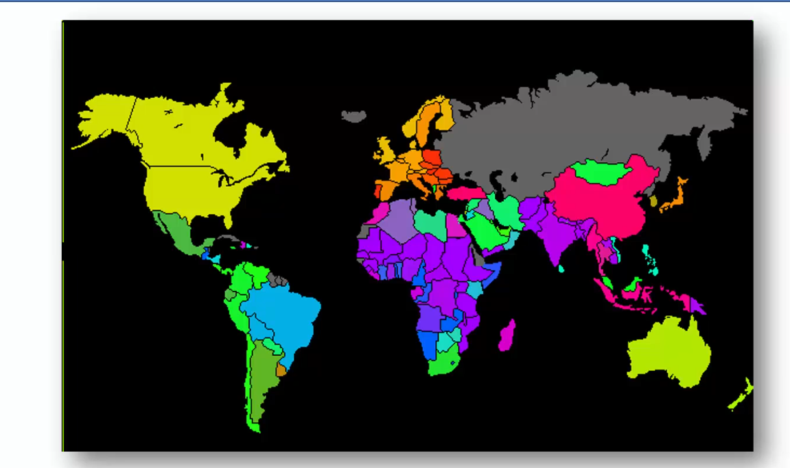

You can then put it in a world map.

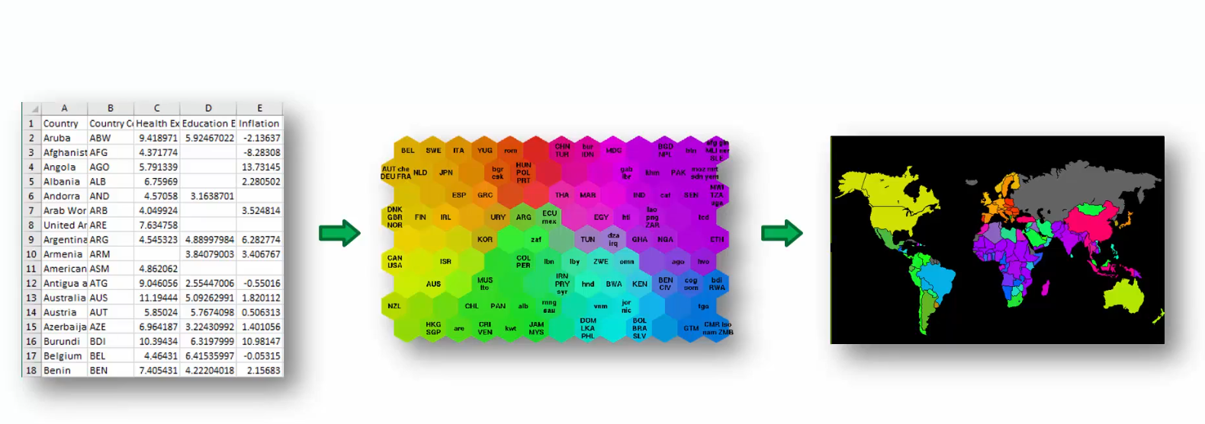

**Additional Reading**

<http://www.ai-junkie.com/ann/som/som1.html>

<https://www.visualcinnamon.com/2013/07/self-organizing-maps-creating-hexagonal/>

**K Means Clustering**

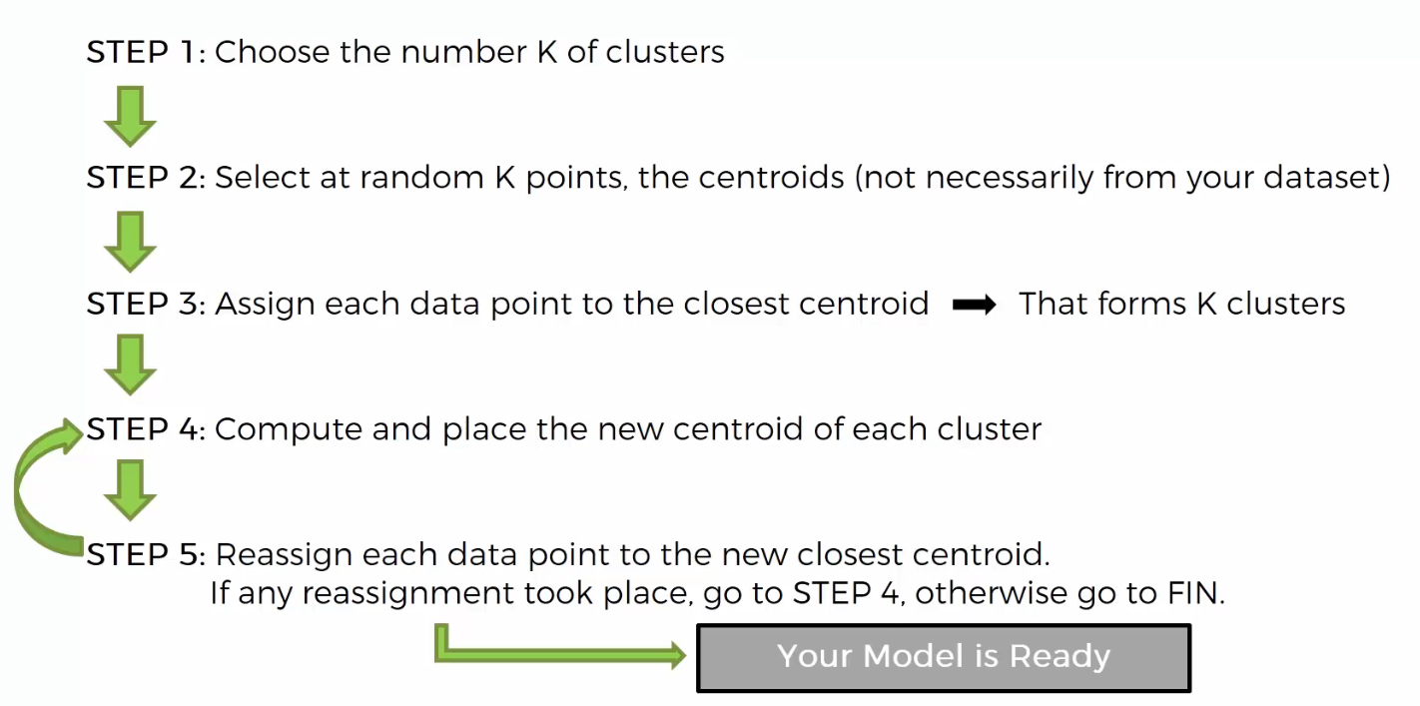

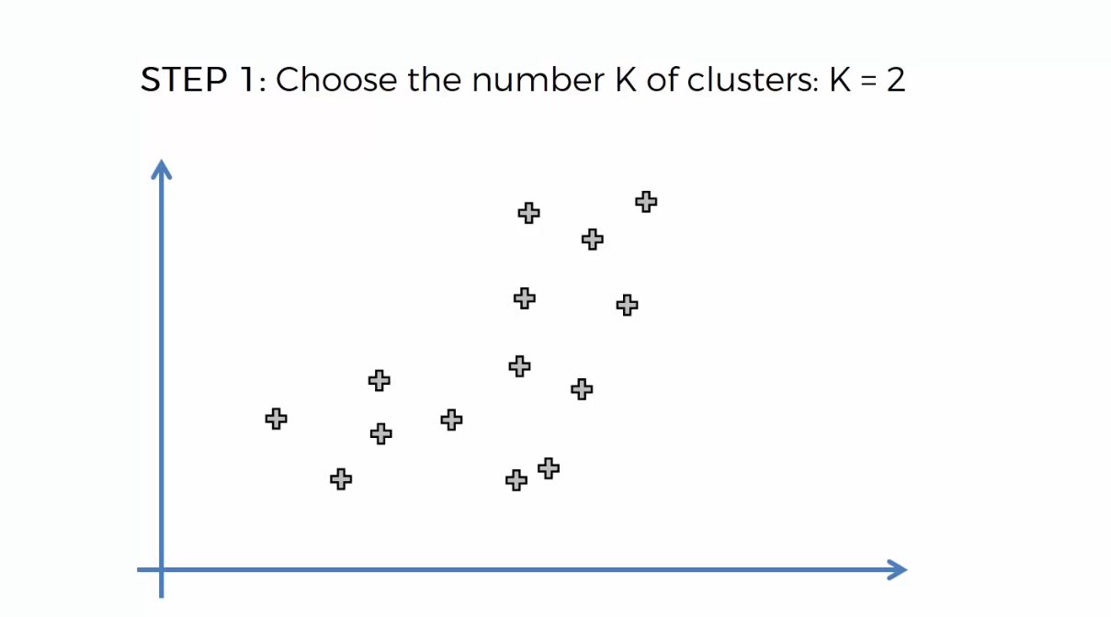

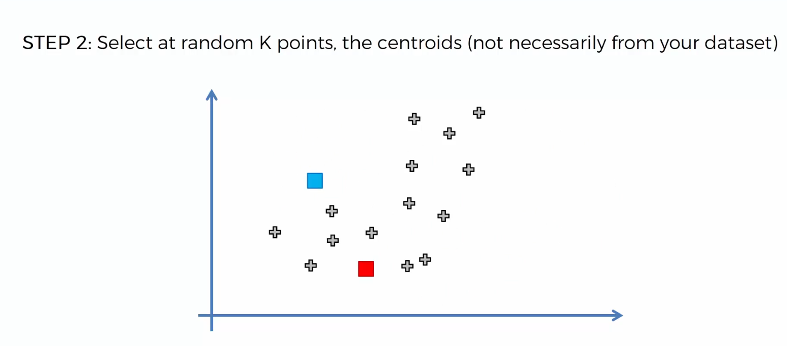

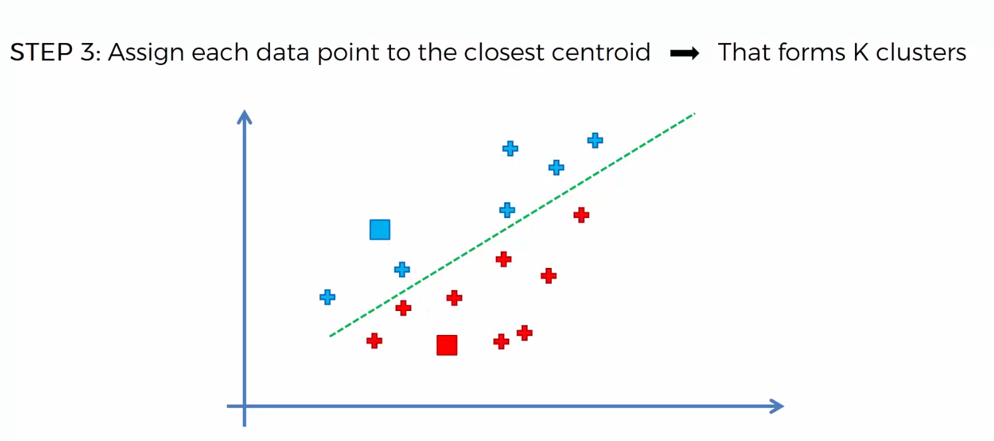

Above we’re using Euclidean distance.

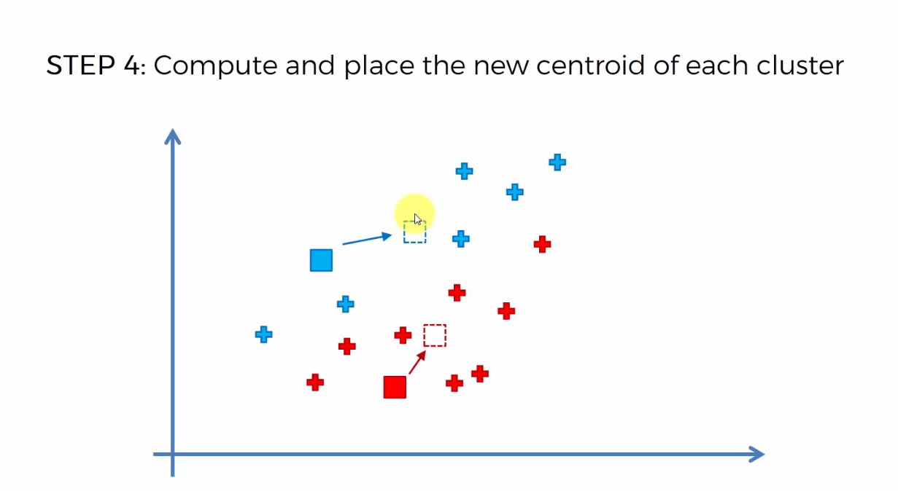

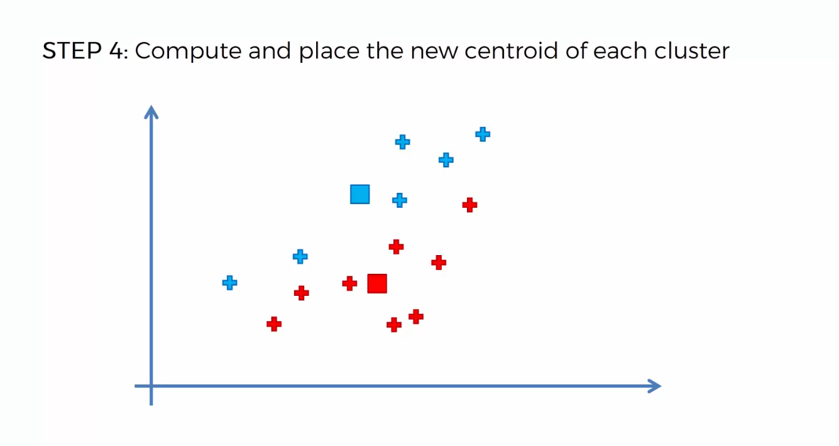

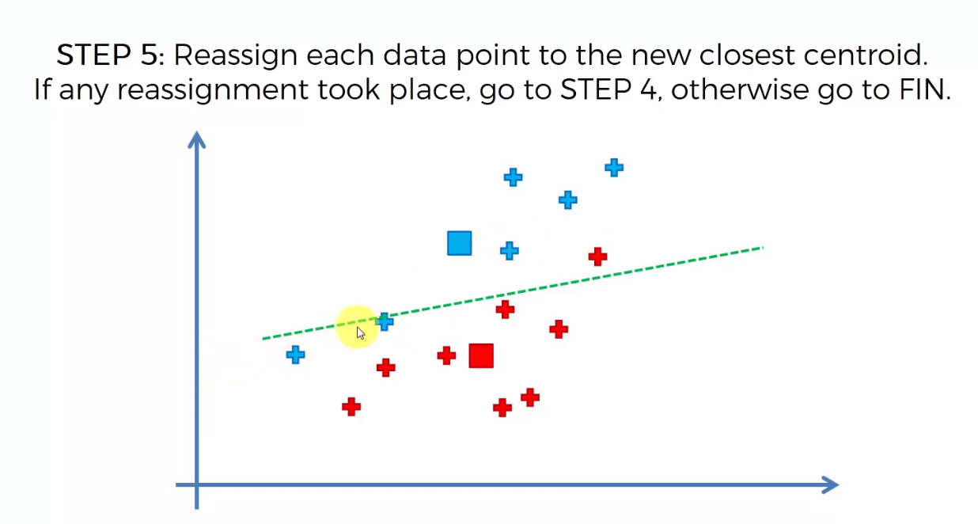

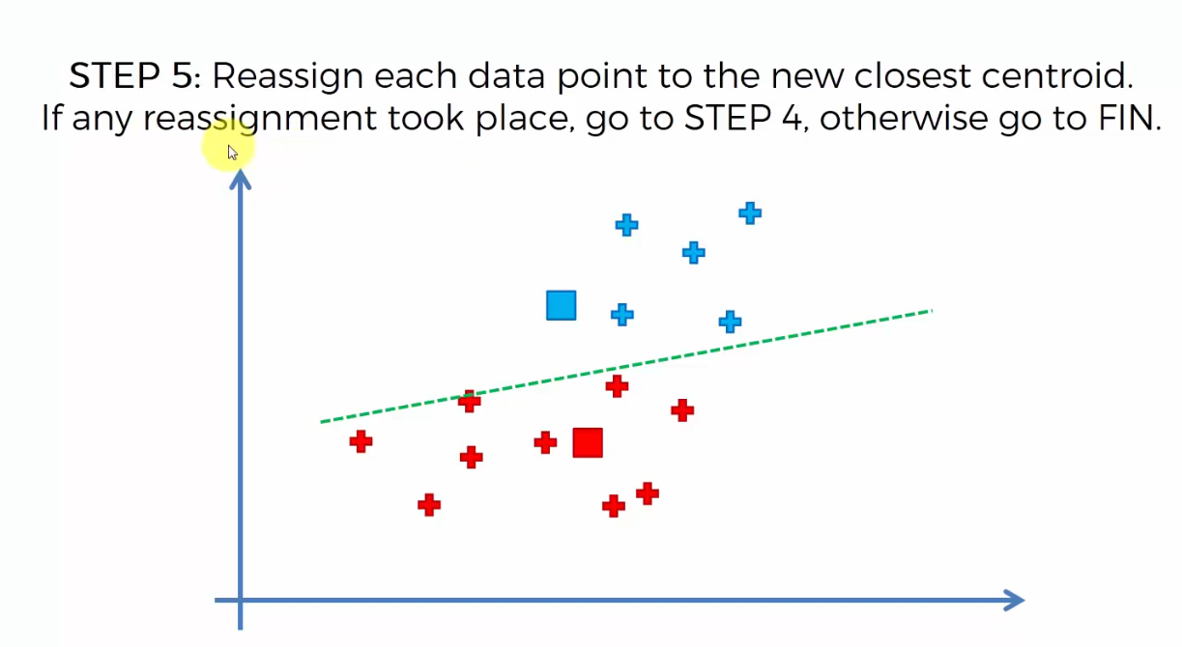

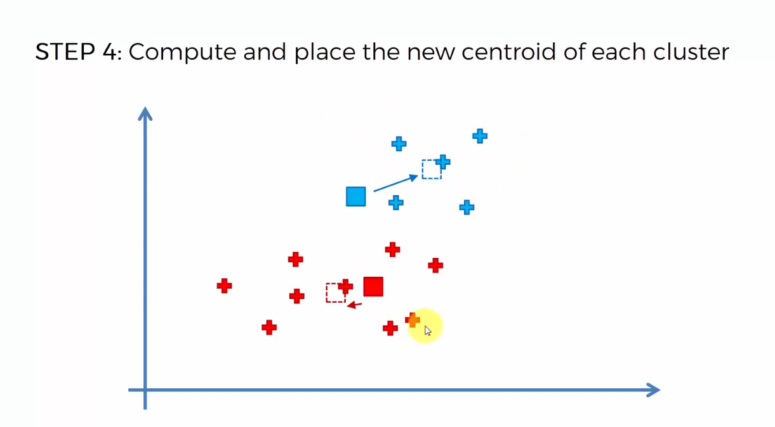

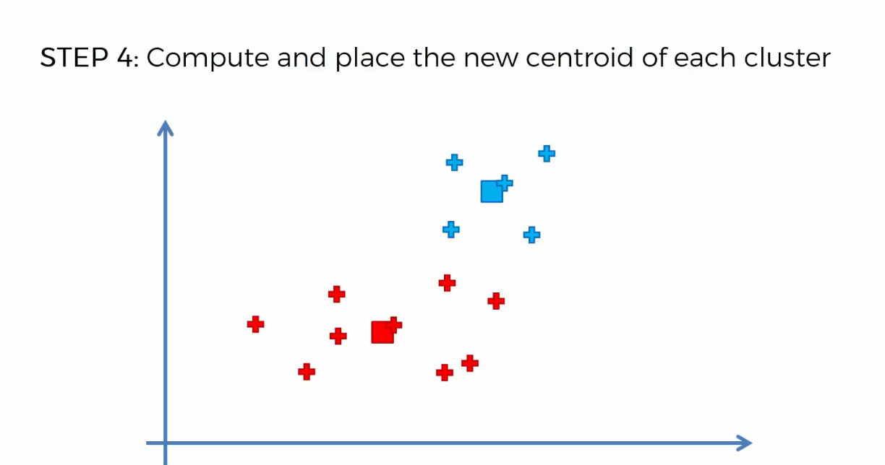

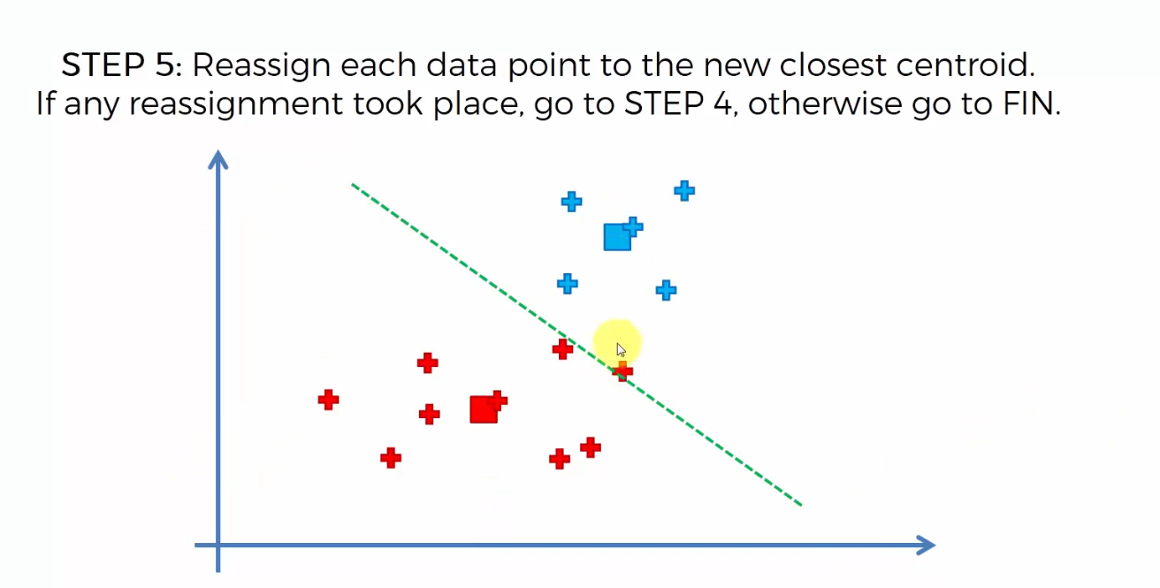

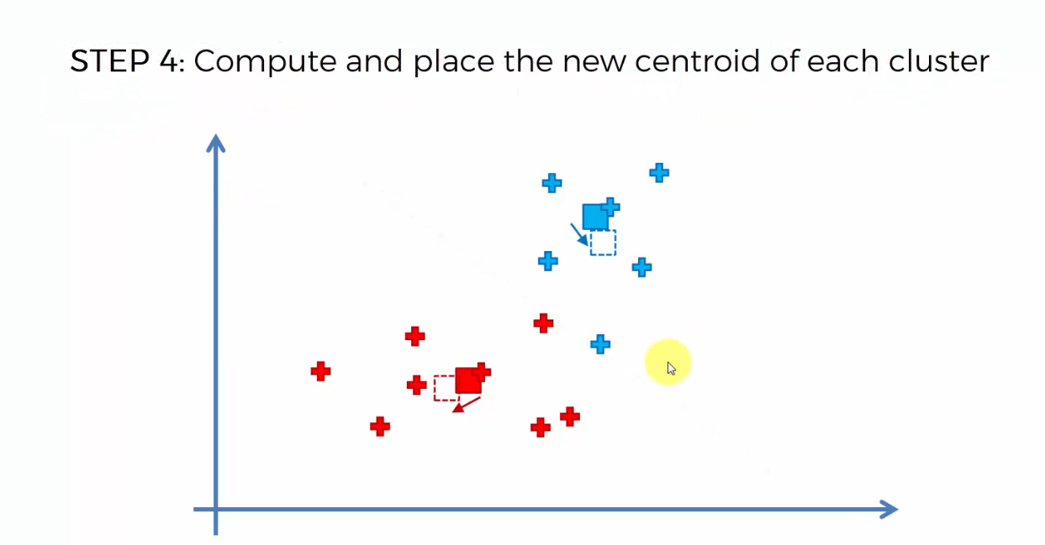

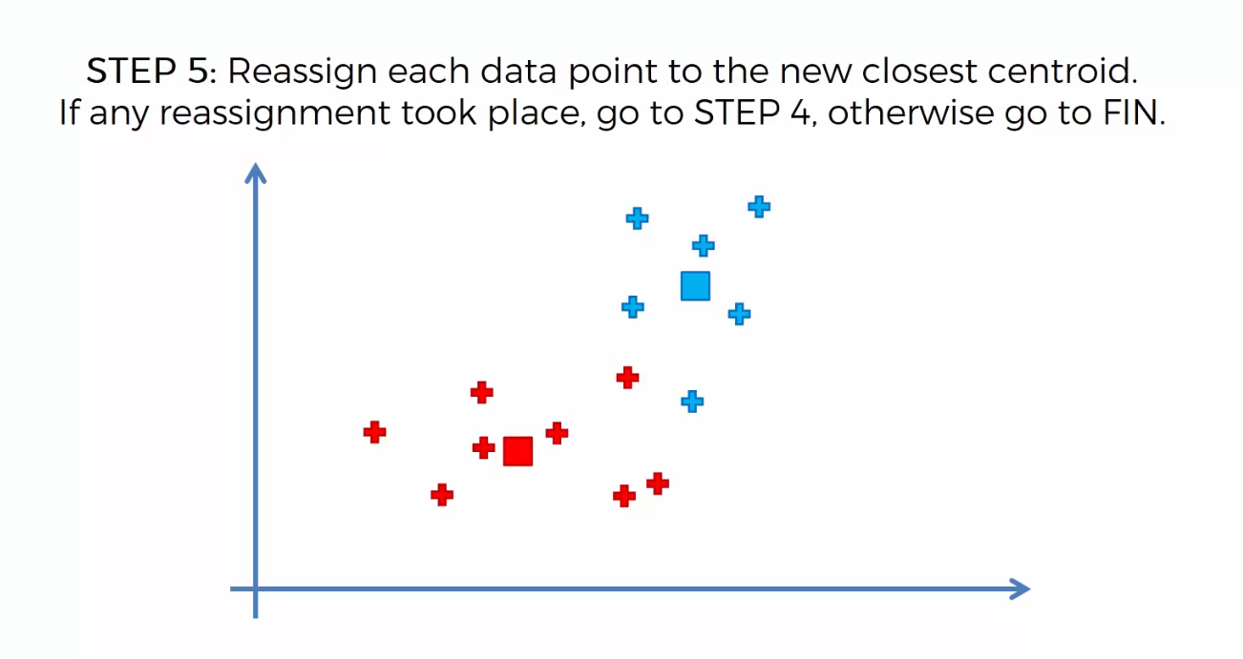

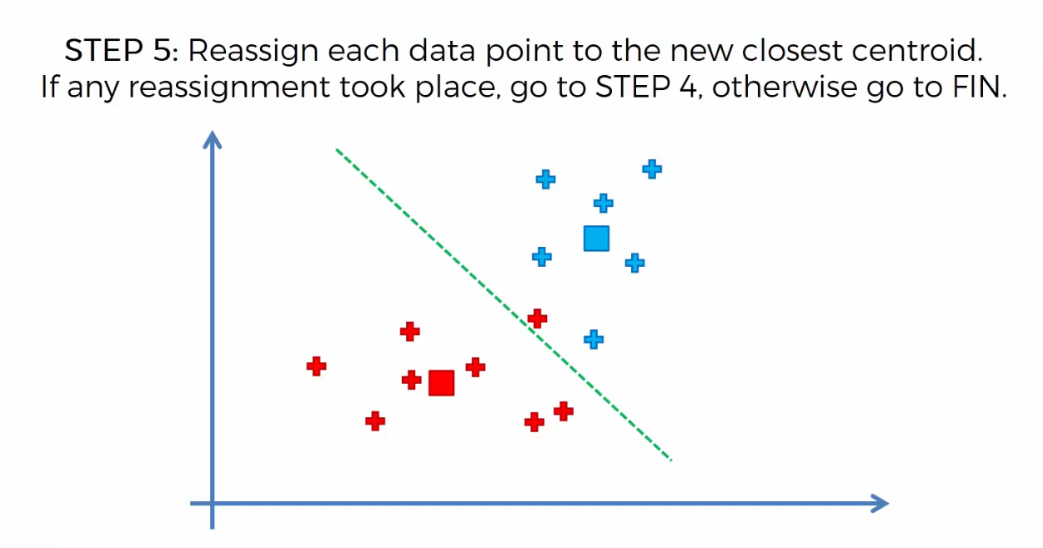

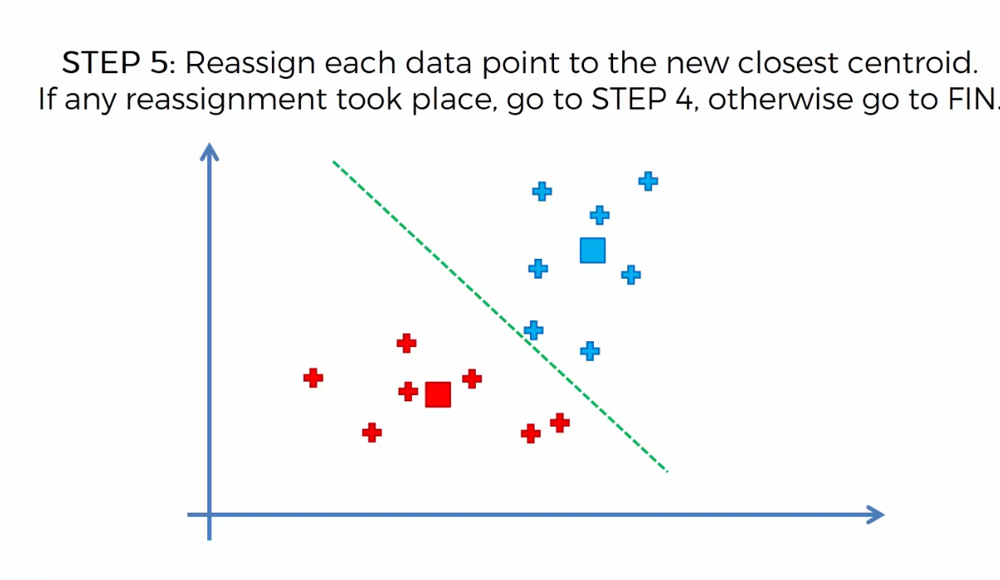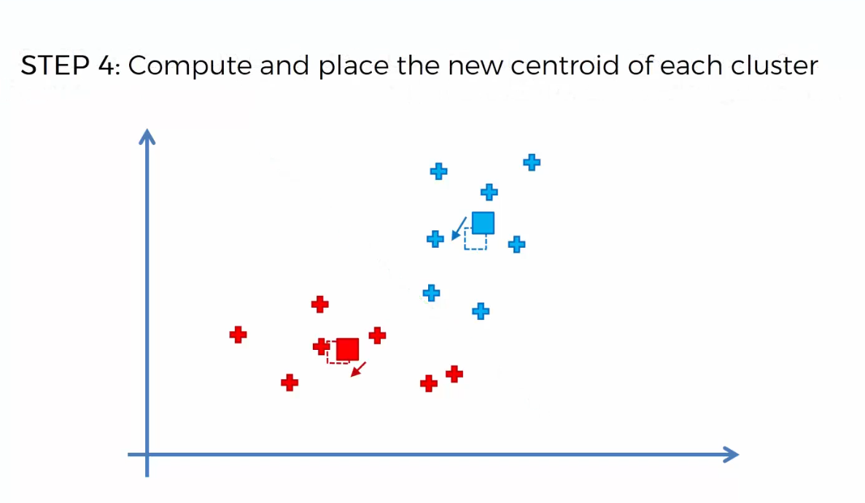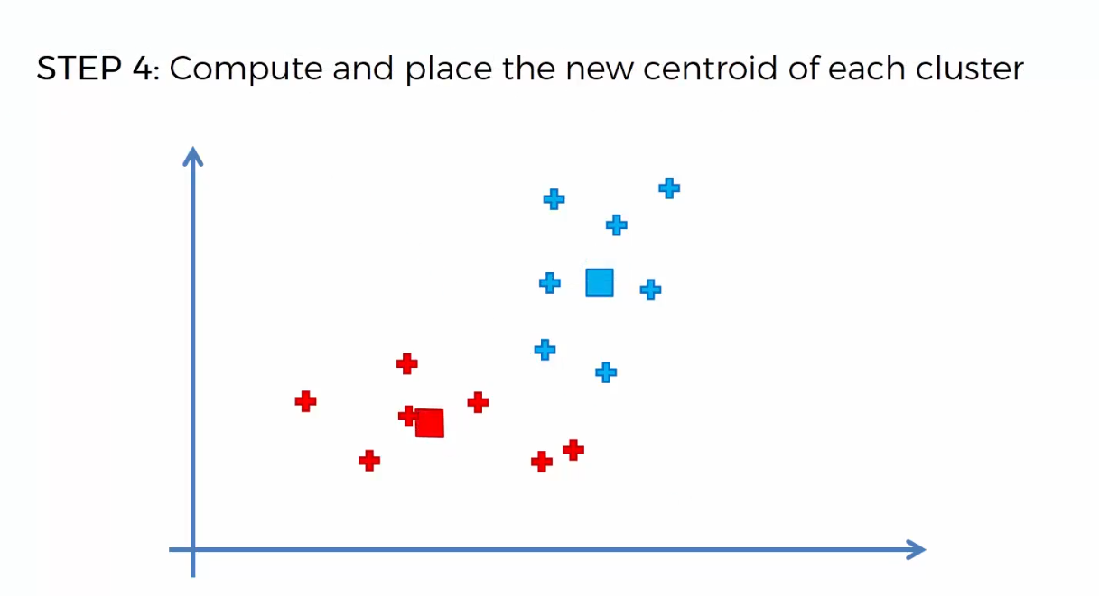

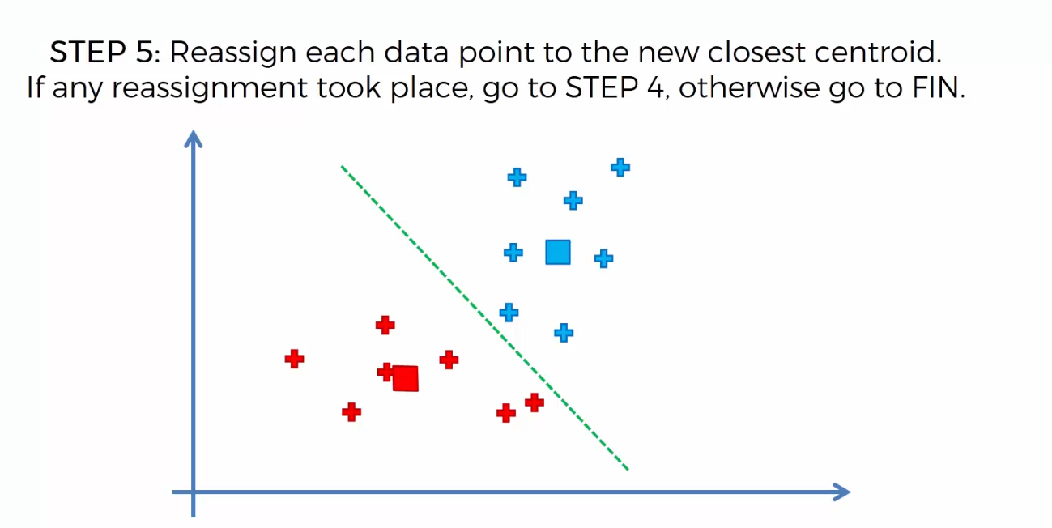

Hence here no reassignment has taken place so we finish the algorithm ends here.

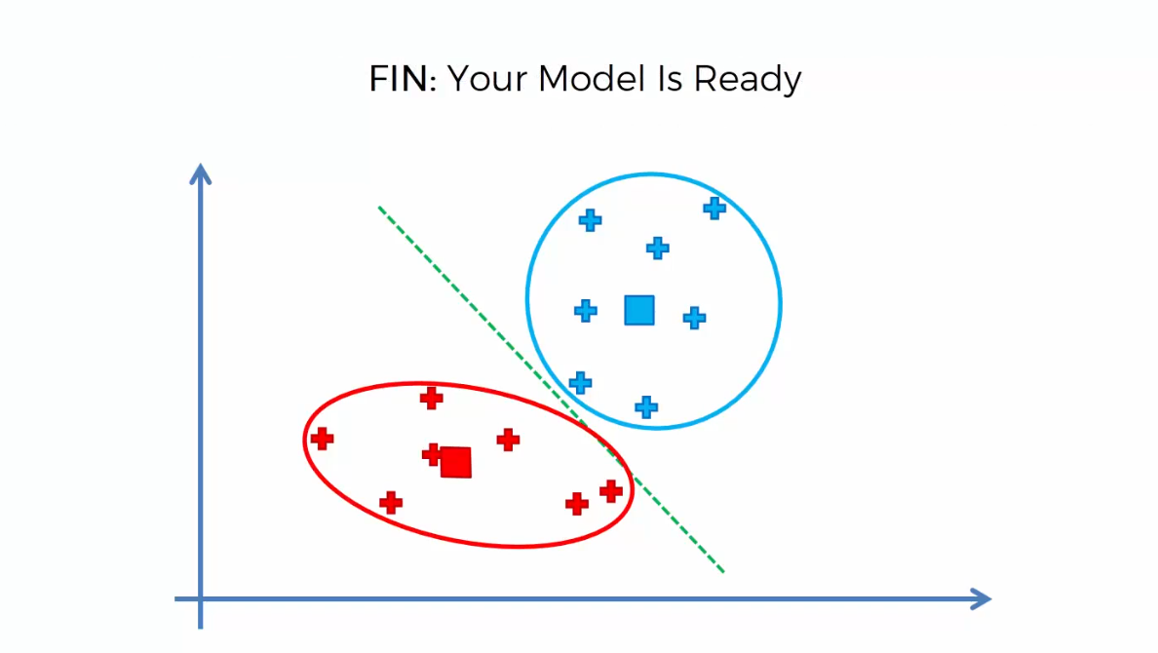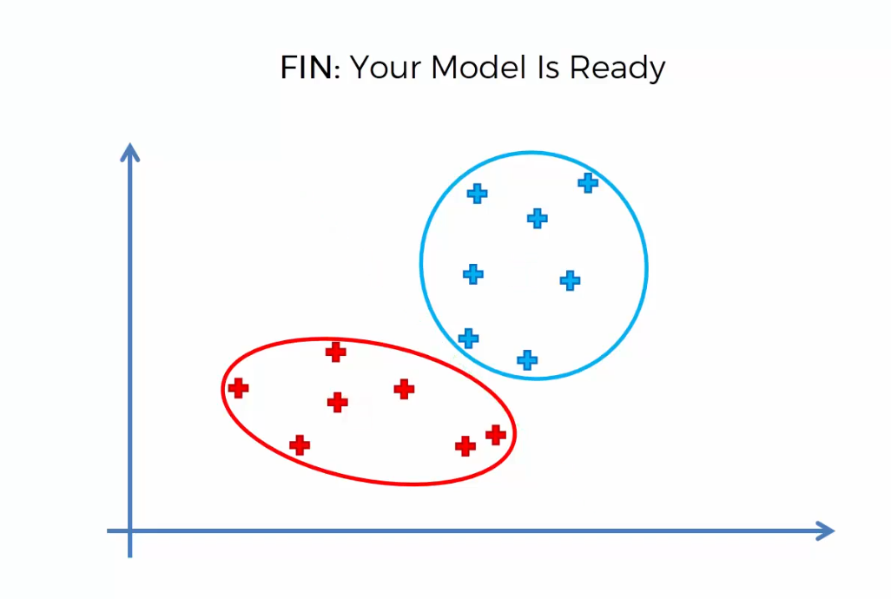

**How Do Self Organizing Maps Learn?**

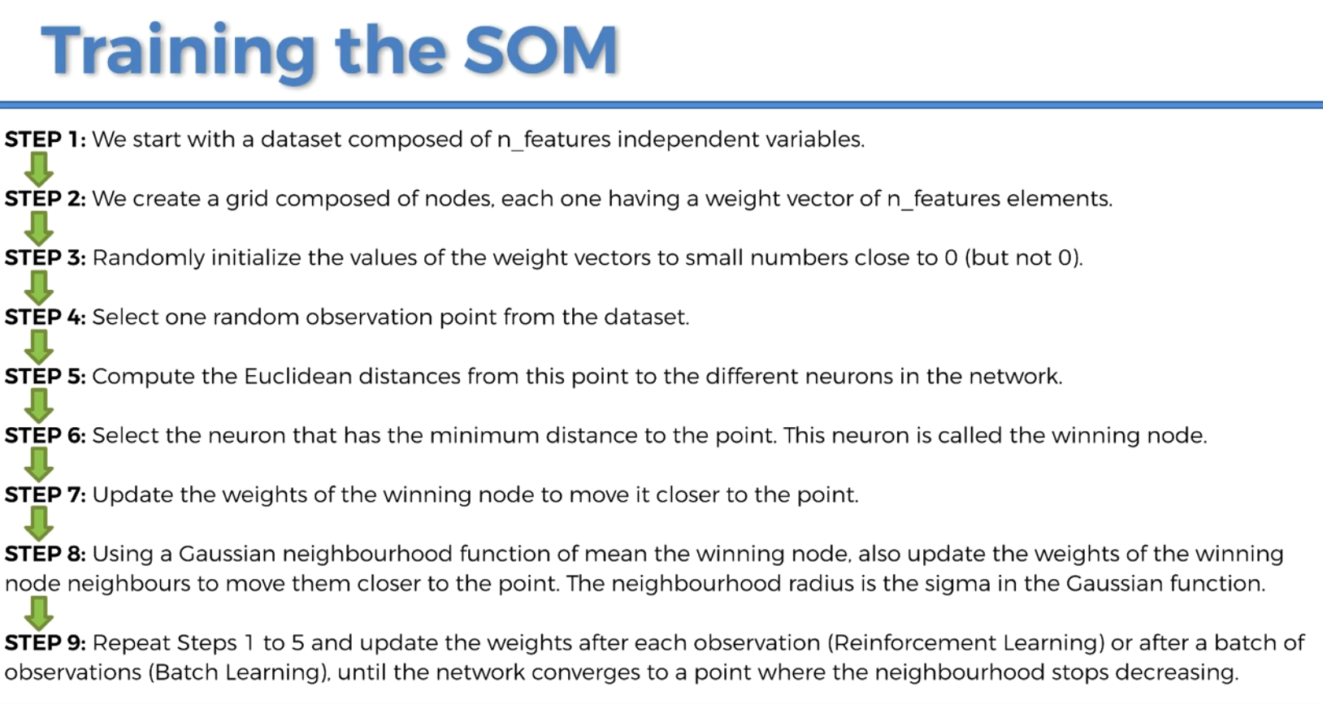

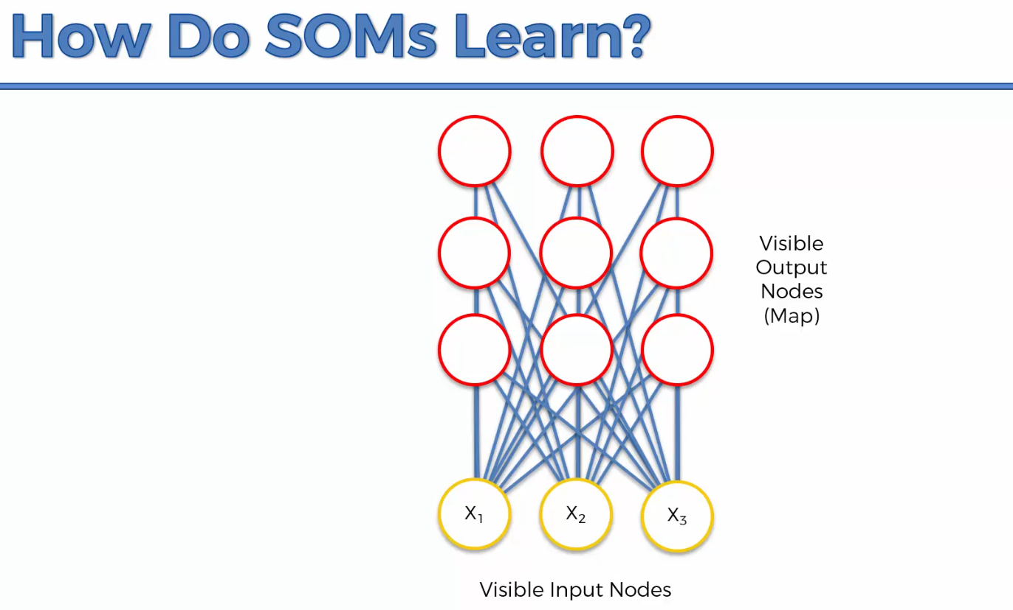

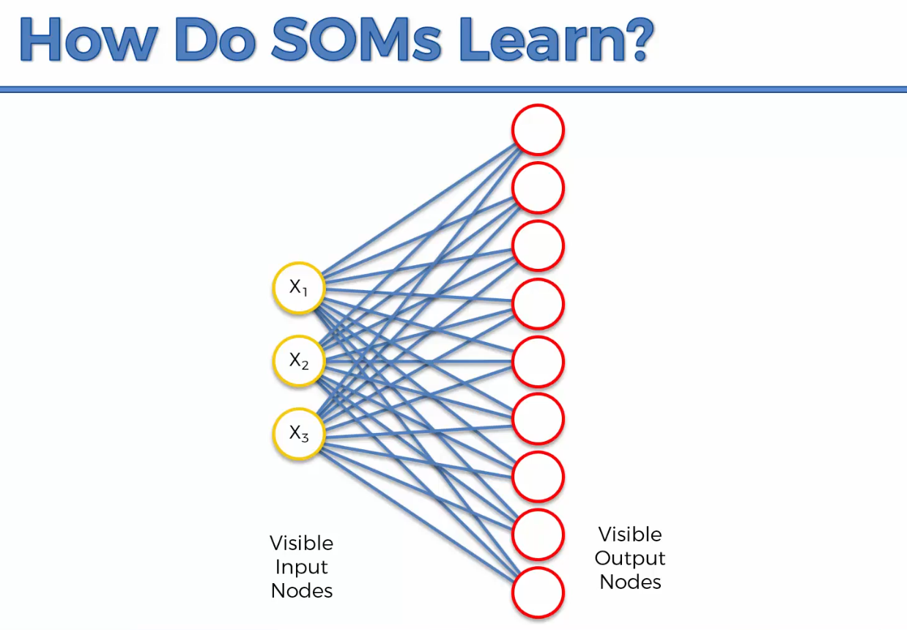

Self organizing maps are actually easy easier than neural networks but are completely different from them as well.

Weights in SOMs are used completely differently than neural networks.

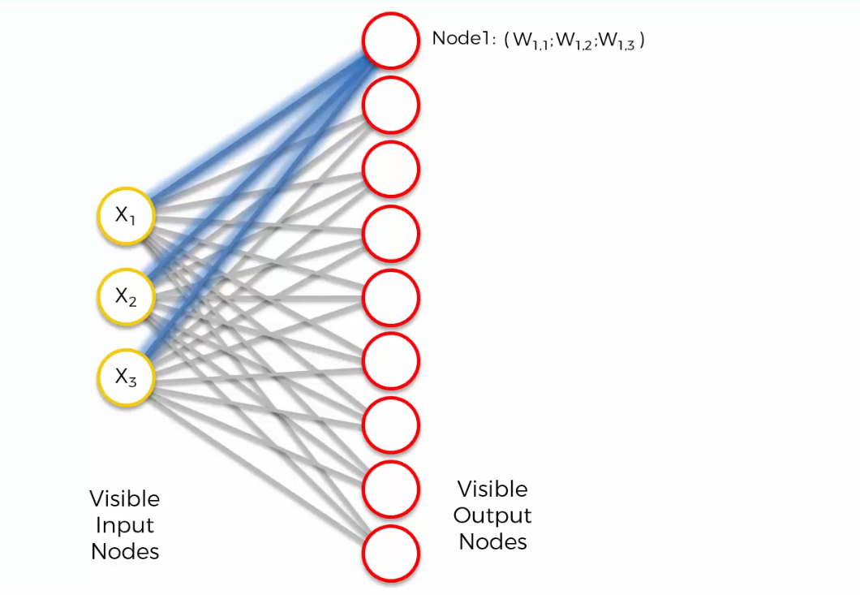

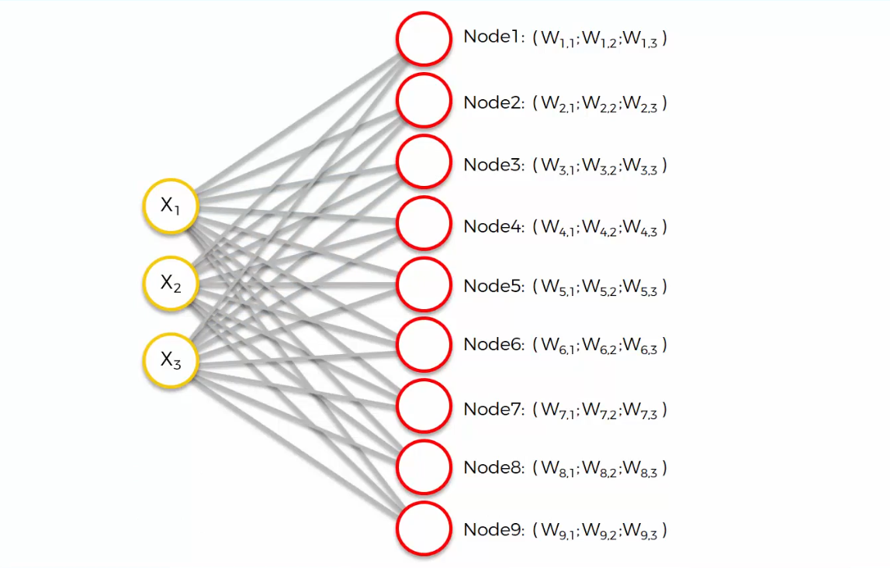

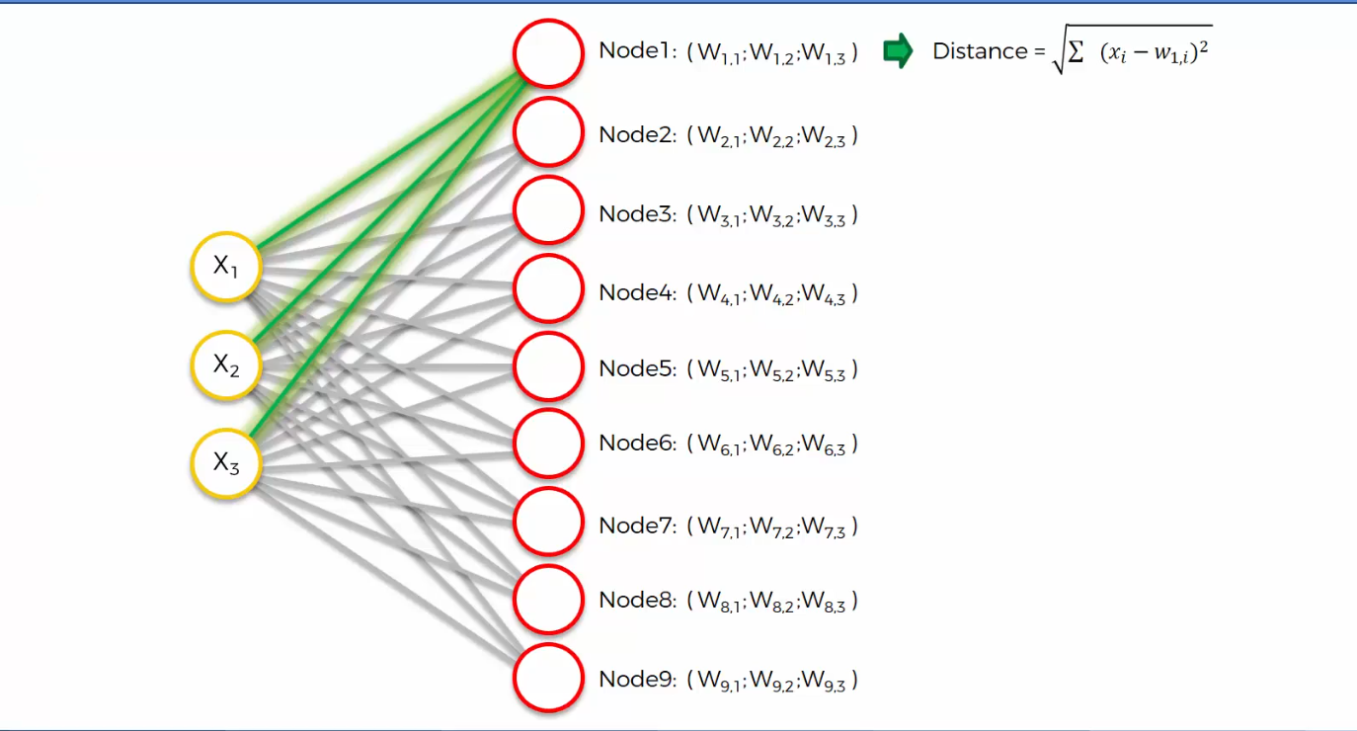

Above is the distance between row 1 and node 1 in our data set.

Closest one is node 3, and it’s called the BMU i.e. Best Matching Unit for row 1.

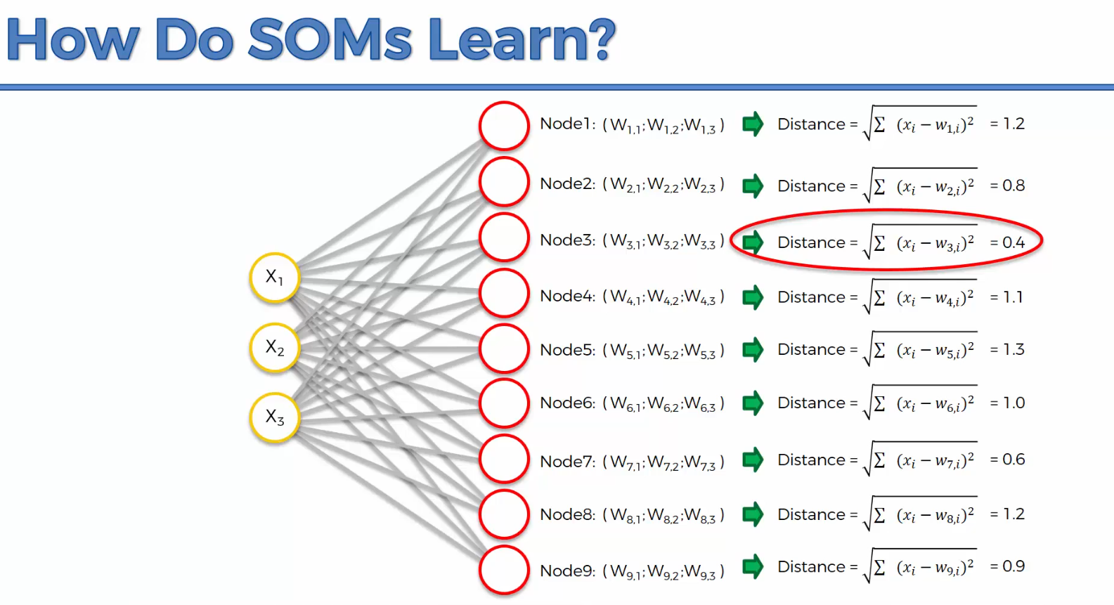

The BMU is identified and the weights are updated in the SOM

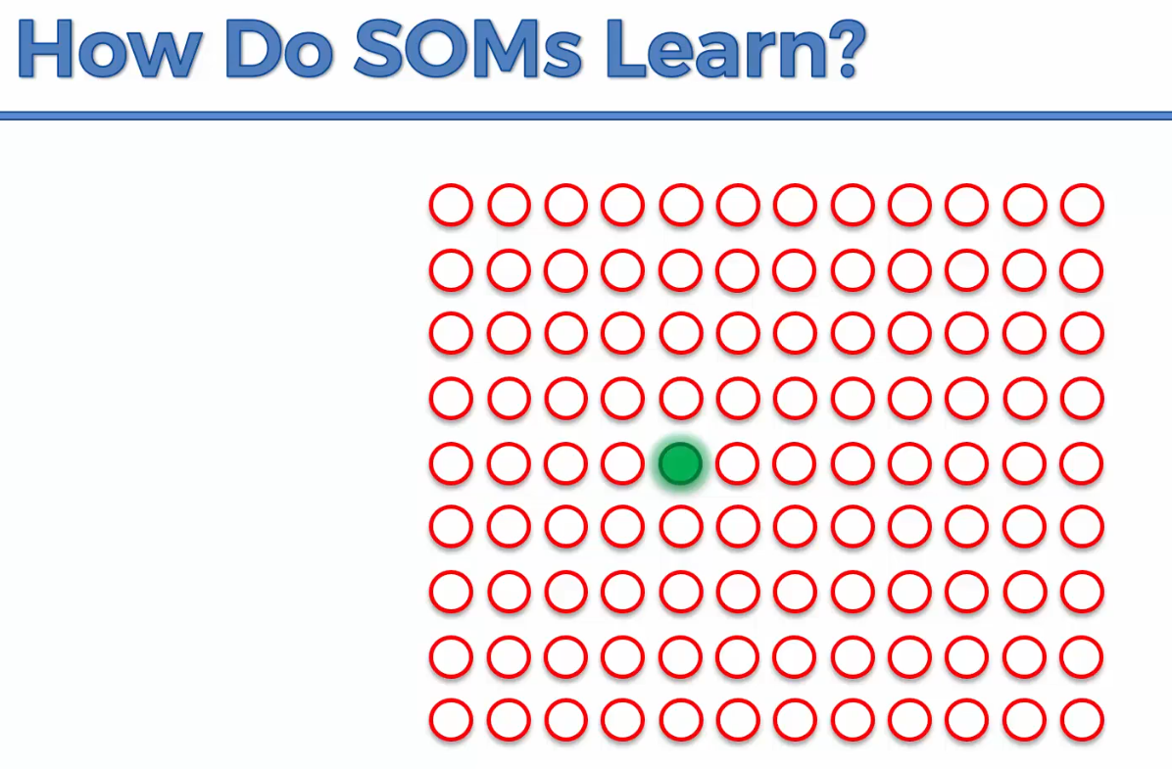

The SOM is basically coming closer to our dataset

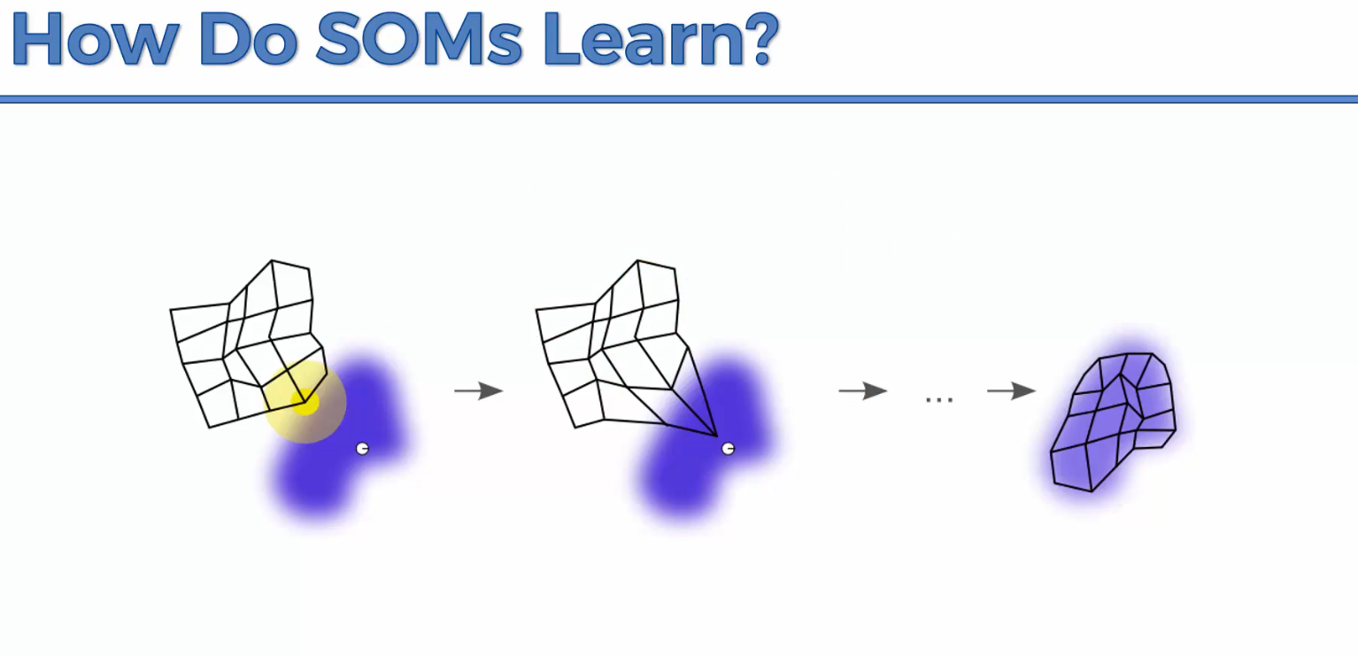

Every single node in the radius will have their weights updated for the SOM to get closer to the nodes.

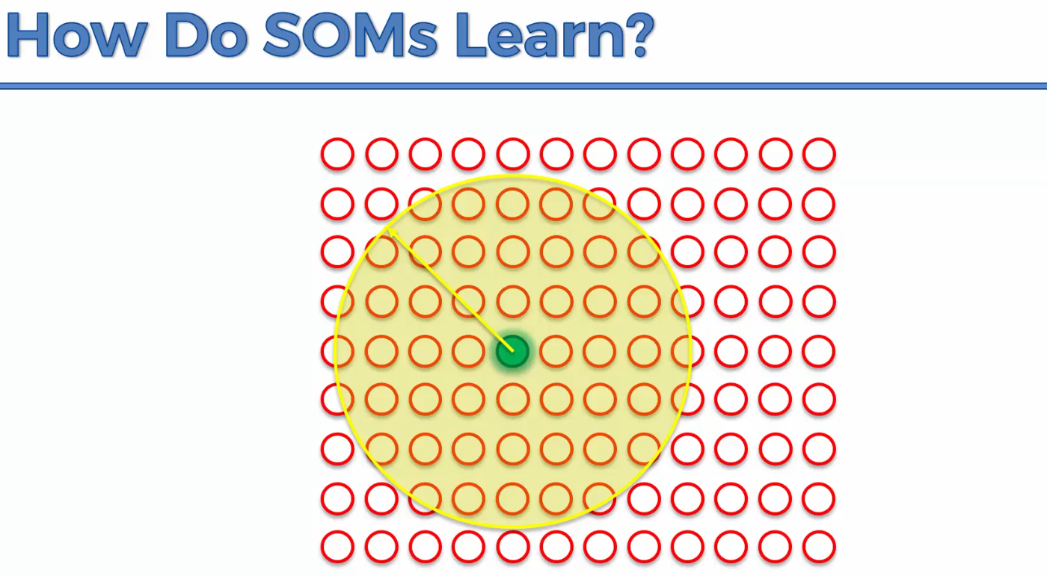

Let’s say row number two had its Best Matching Weight at the Blue spot

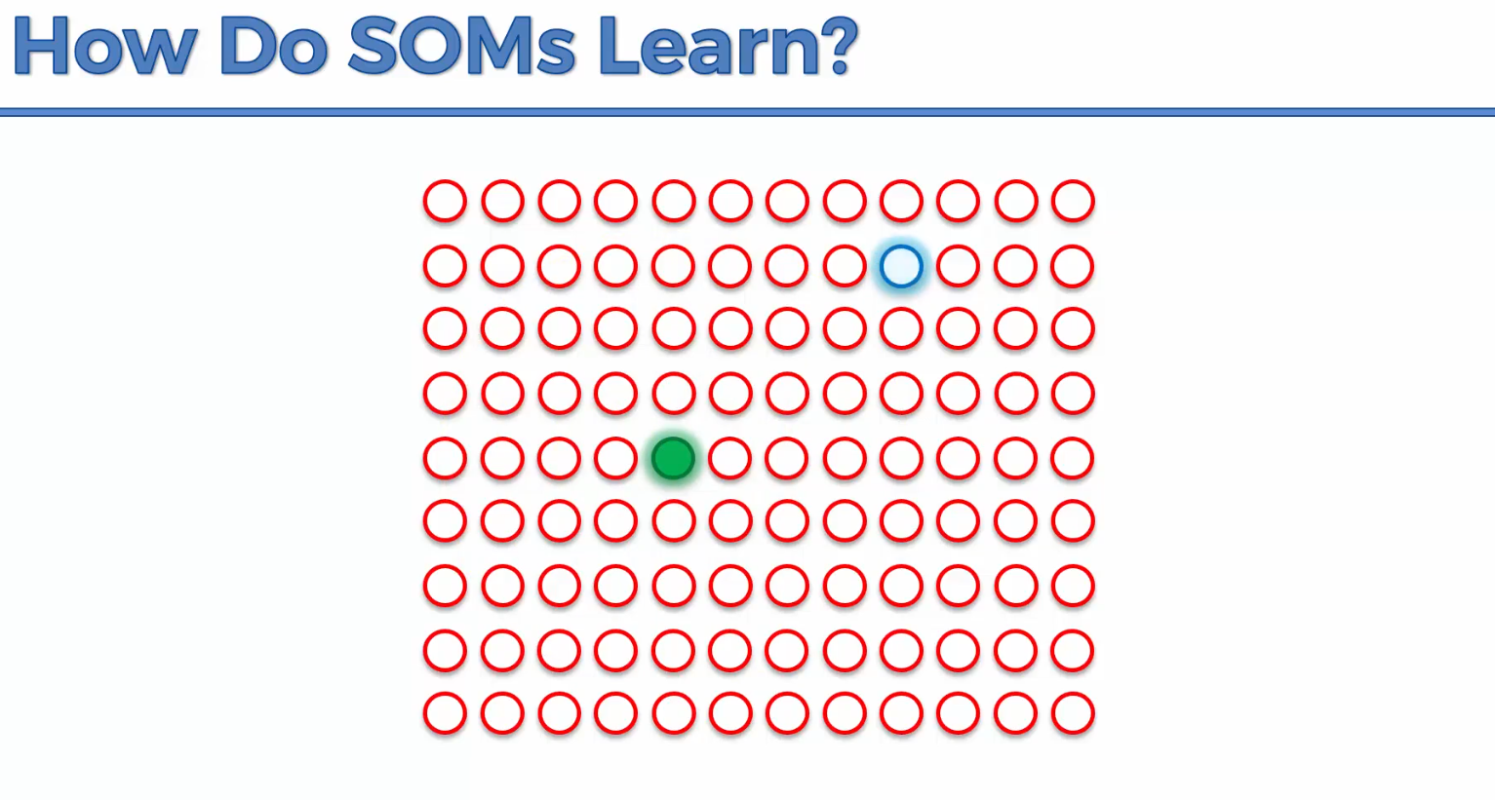

Everything in the radius will be updated to the point that it matched up to

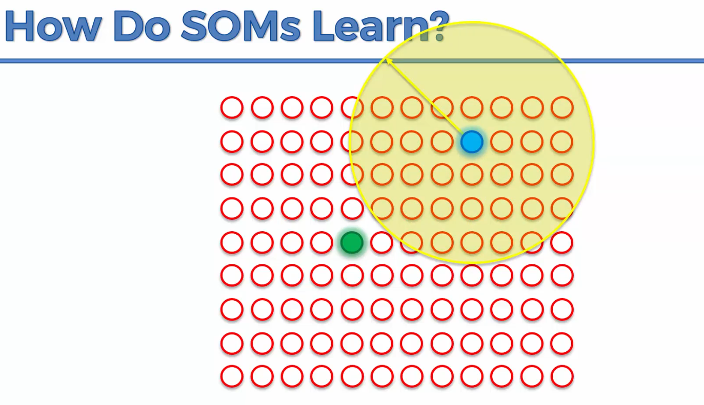

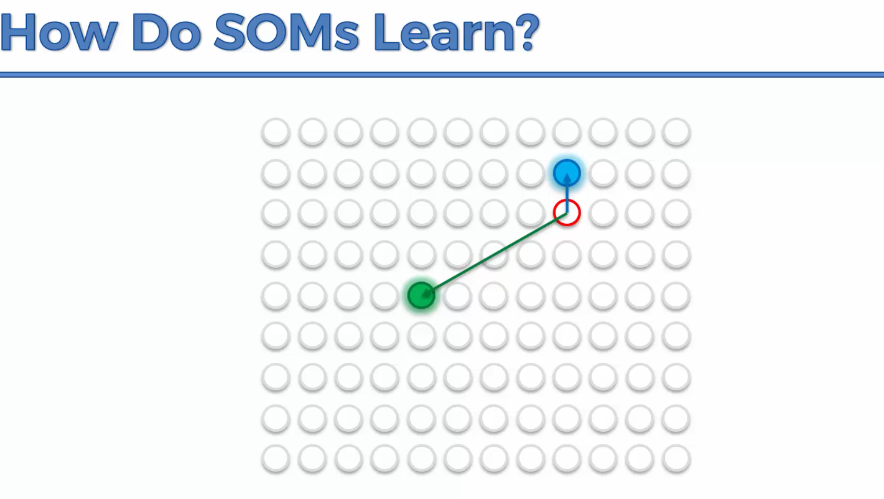

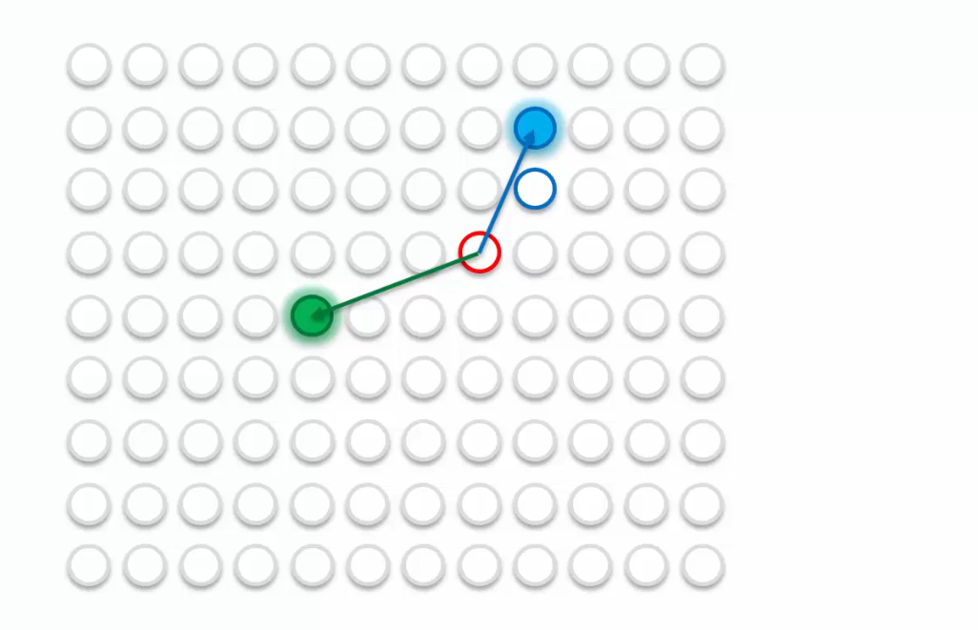

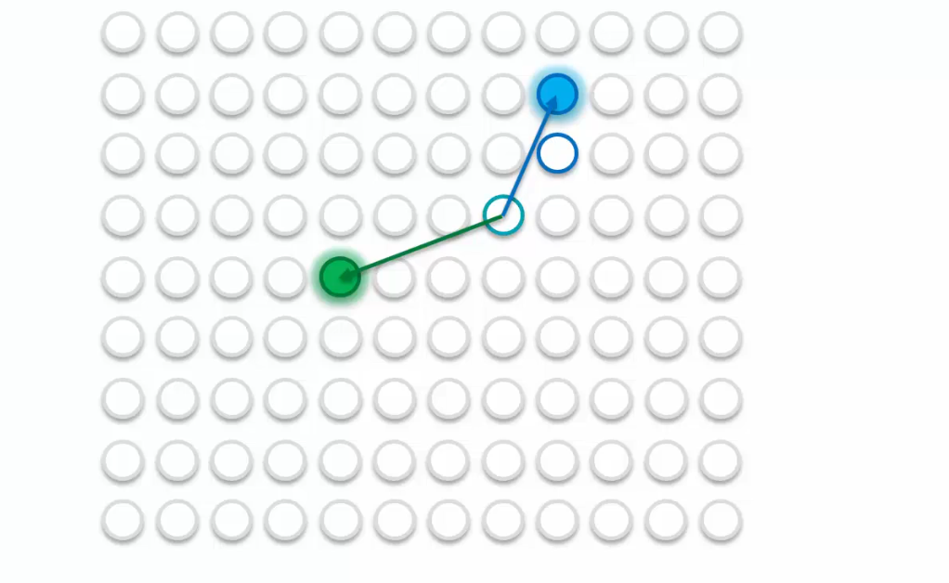

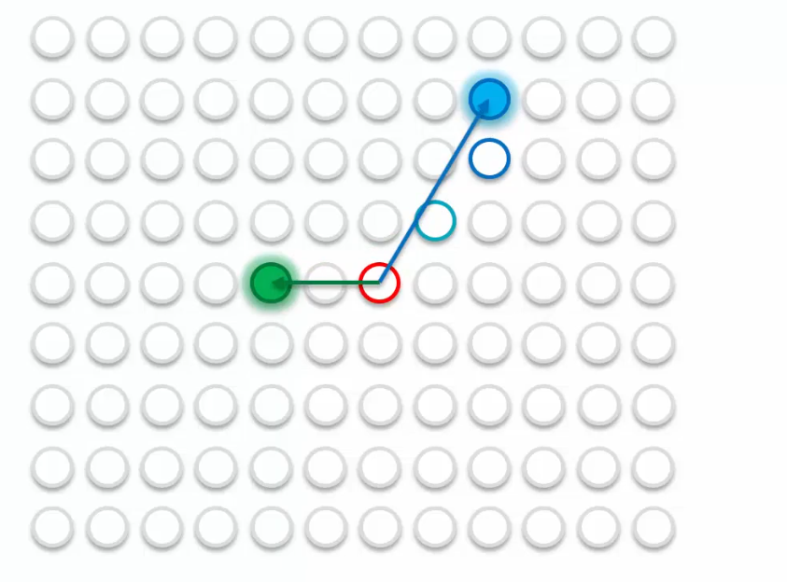

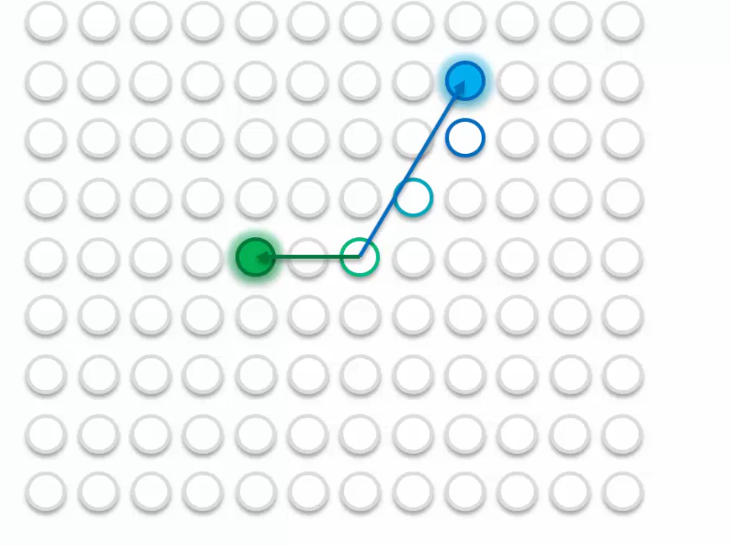

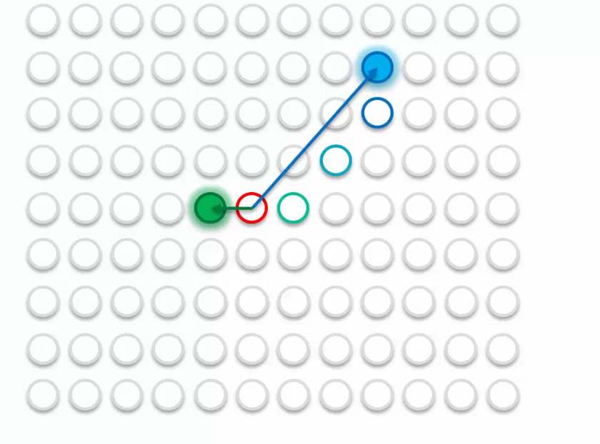

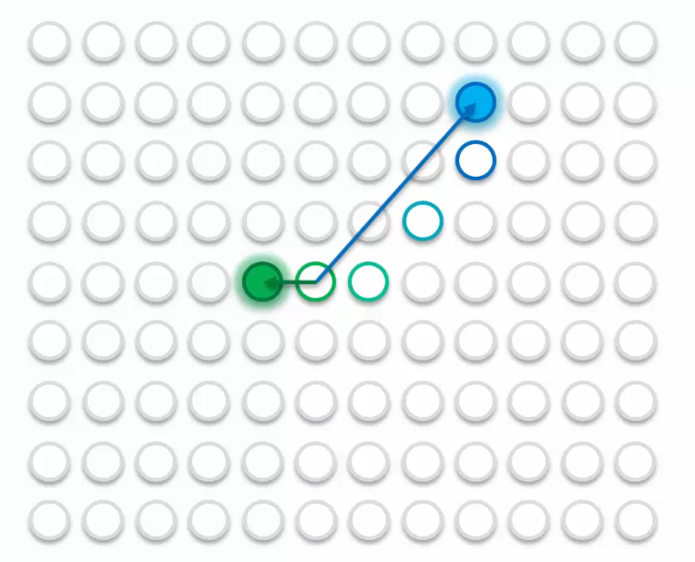

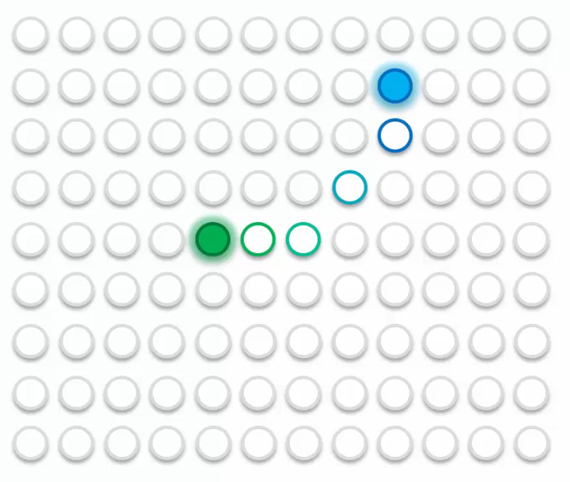

Let’s look at 5 BMUS

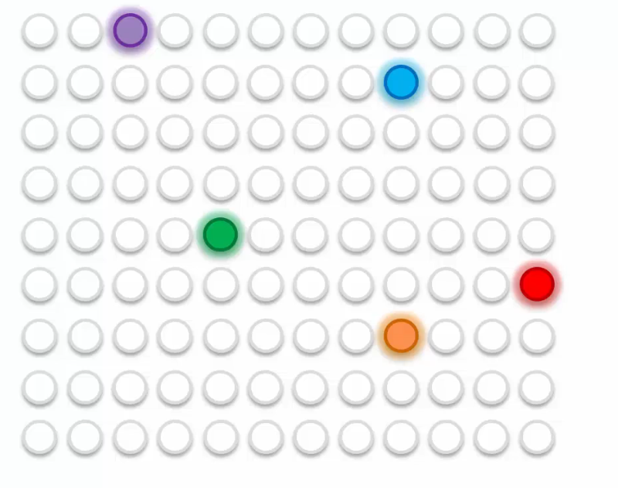

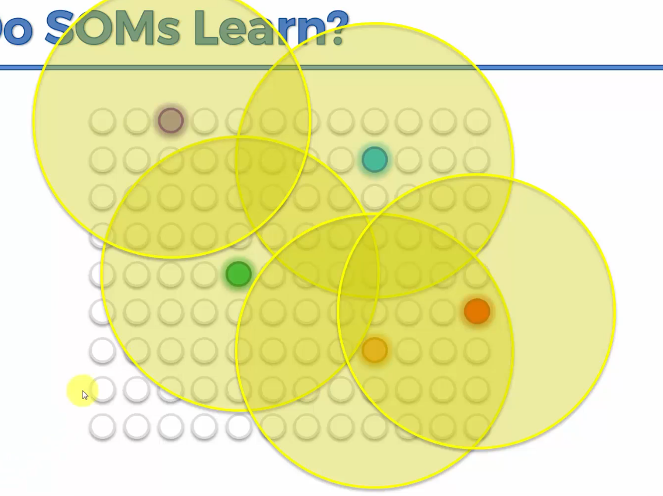

This is just an illustration but usually at the start the radius encompasses everything.

In the next epoch, your radius becomes smaller;  
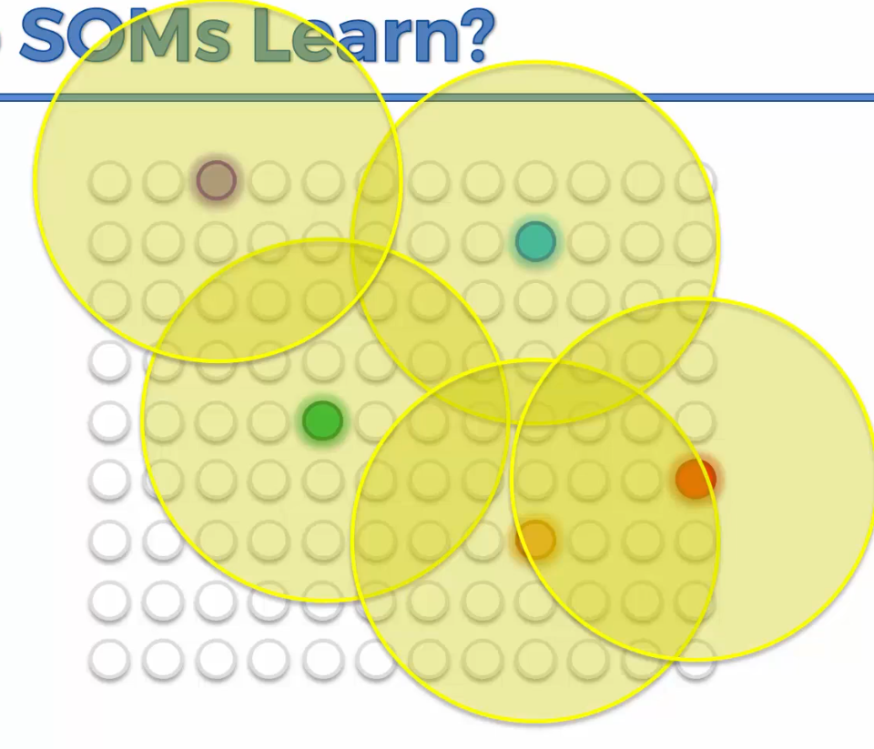

And then again;

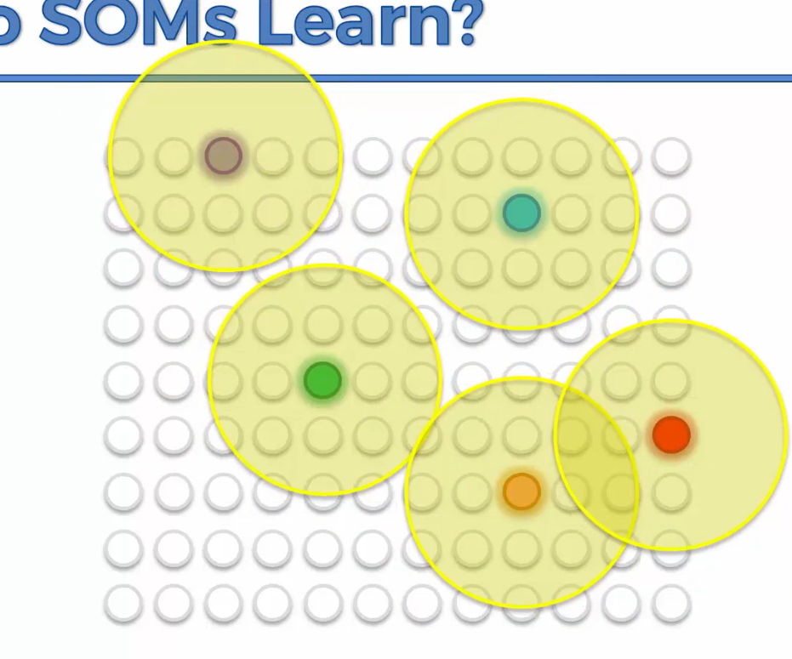

Then at the end it’ll be like this;

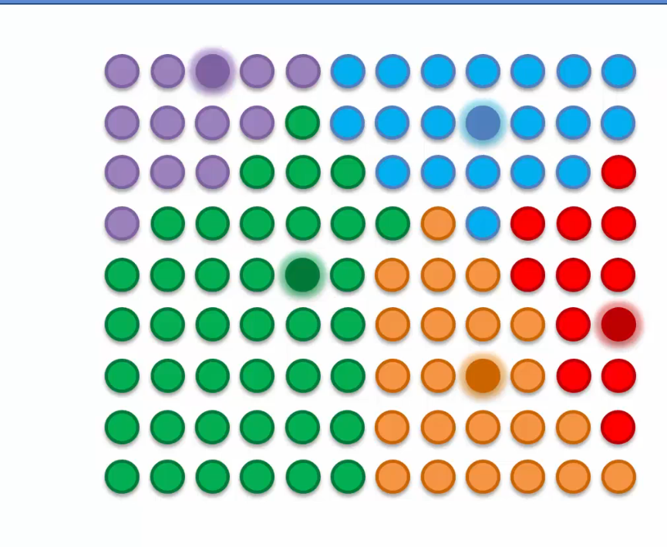

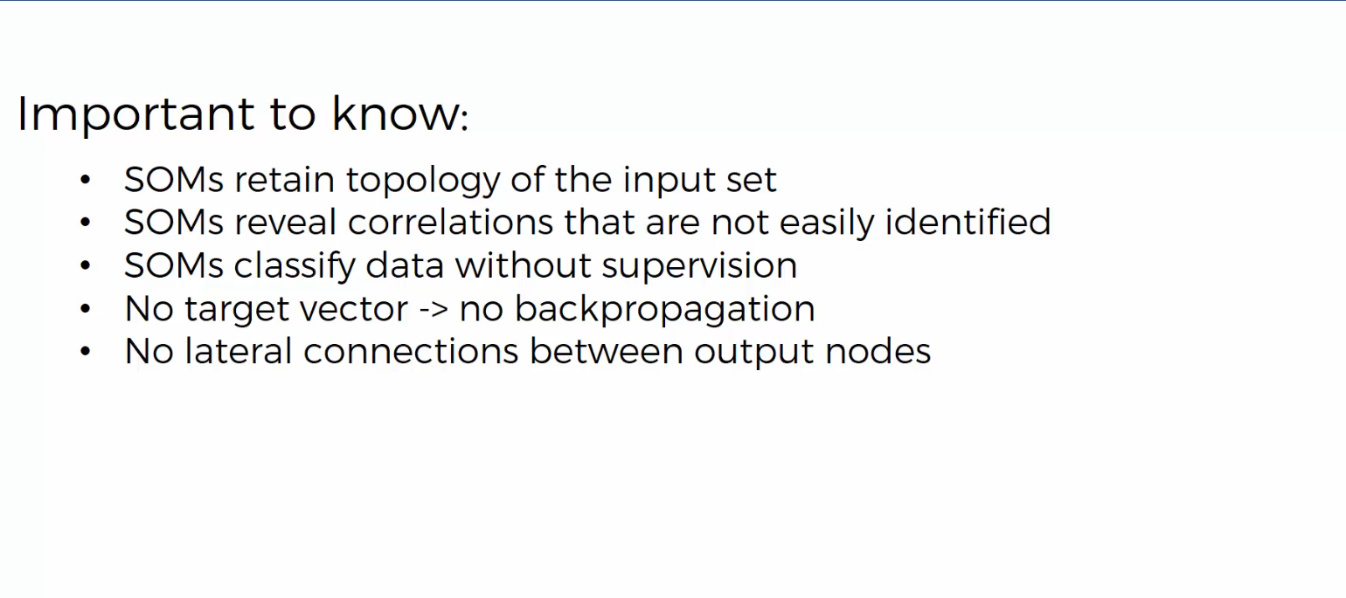

Unified Distance Matrix shows the distance between nodes on a self organizing map.

NOTE: The KMeans++ algorithm allows you to avoid the Random Initialization trap which can lead you to the wrong clusters.

The Within Cluster Some of S allows us to choose the right number of clusters.

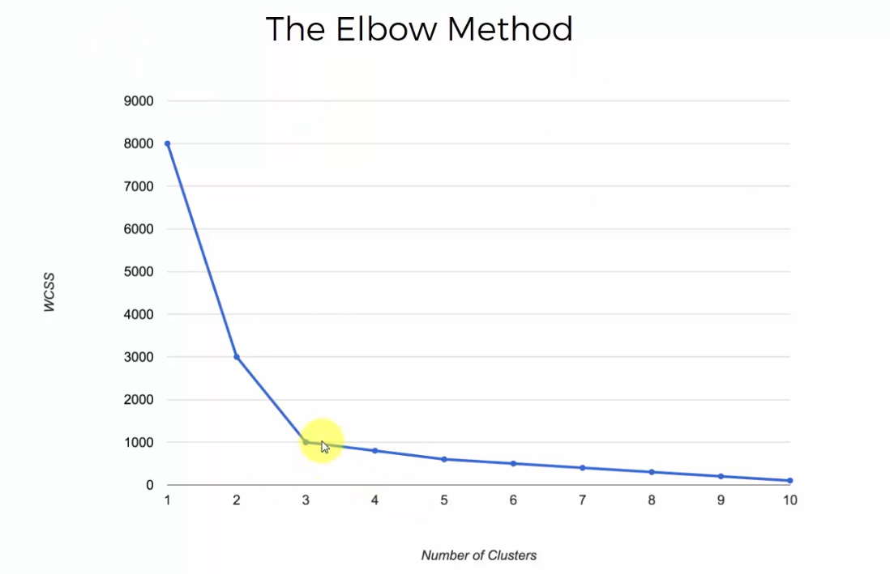

Just look for the elbow in your chart i.e. the point on your chart where the drop in WCSS is not as substantial but gradual.

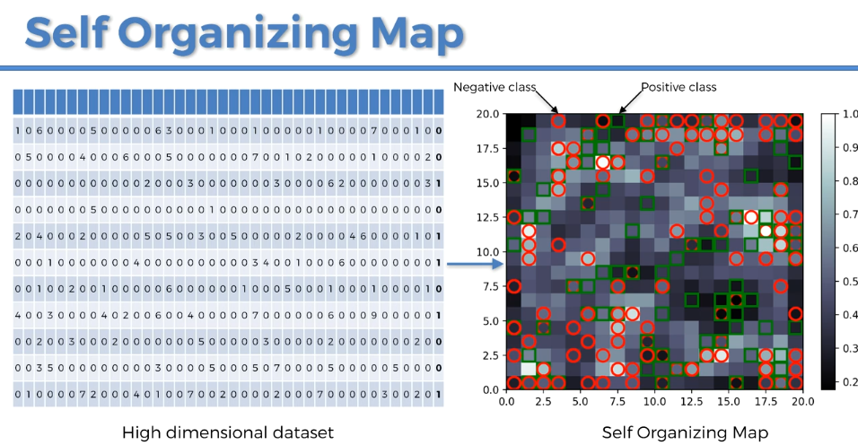

When using a SOM to detect frauds, they are the outliers. A fraud is defined by something far from the general rules. So the frauds are the outlying neurons in the 2D SOMs. To detect the outlying neuron you need the MID, the Mean Interneuron Distance of each neuron.

CTRL + i to get documentation in Spyder

**BOLTZMANN MACHINES**

**Energy Based Models**

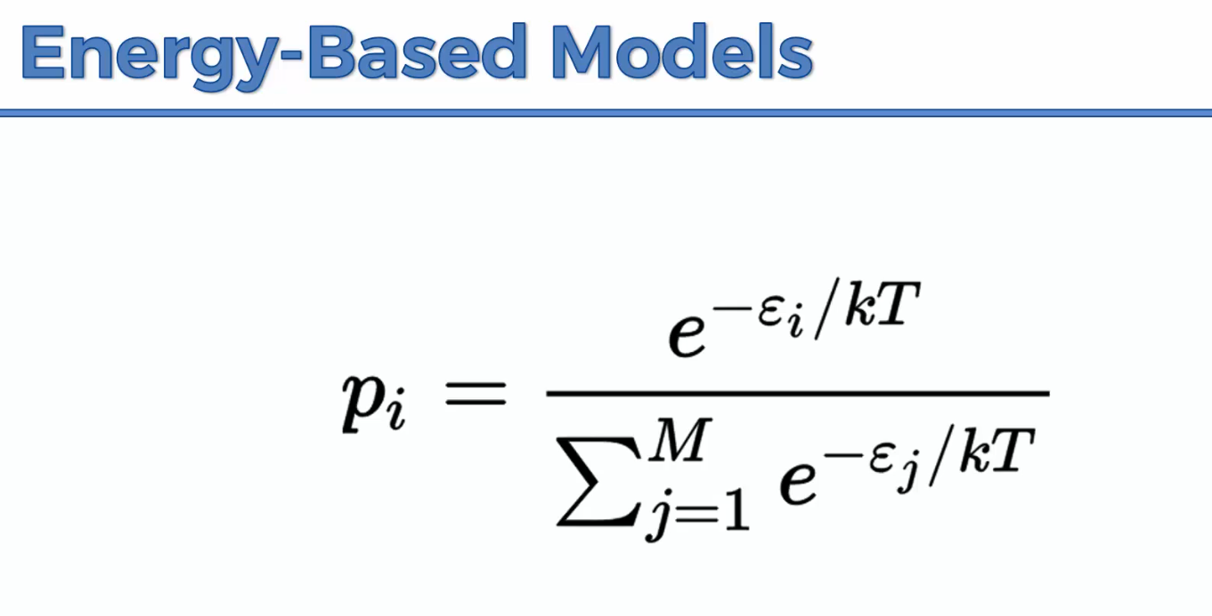

Above is the Boltzmann distribution which talks about probability.

P_i is the probability of your system being in state i. E is the energy of your system. The higher the energy of some state, the lower the probability.

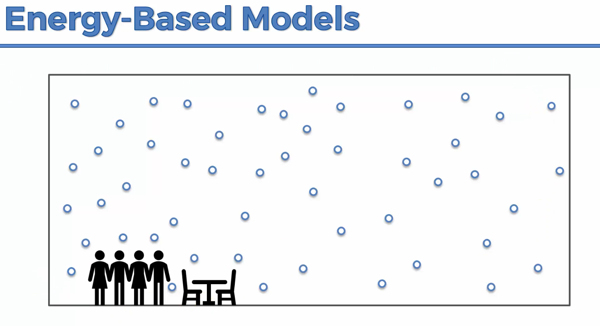

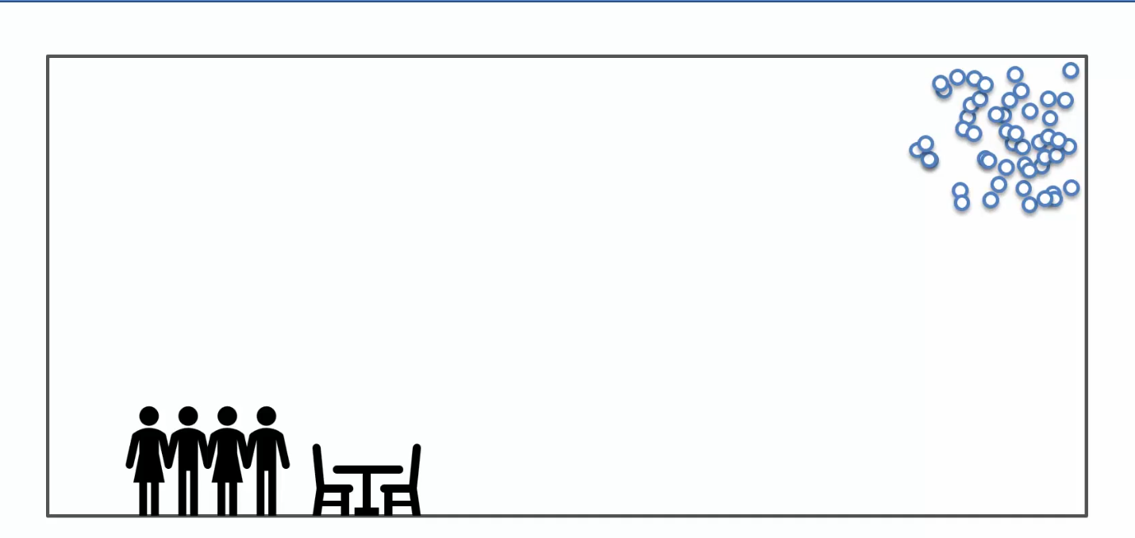

The probability of the air molecules being in one area would be very low because the energy at that point would be very big. But when the molecules are spaced is the lowest energy state of the system.

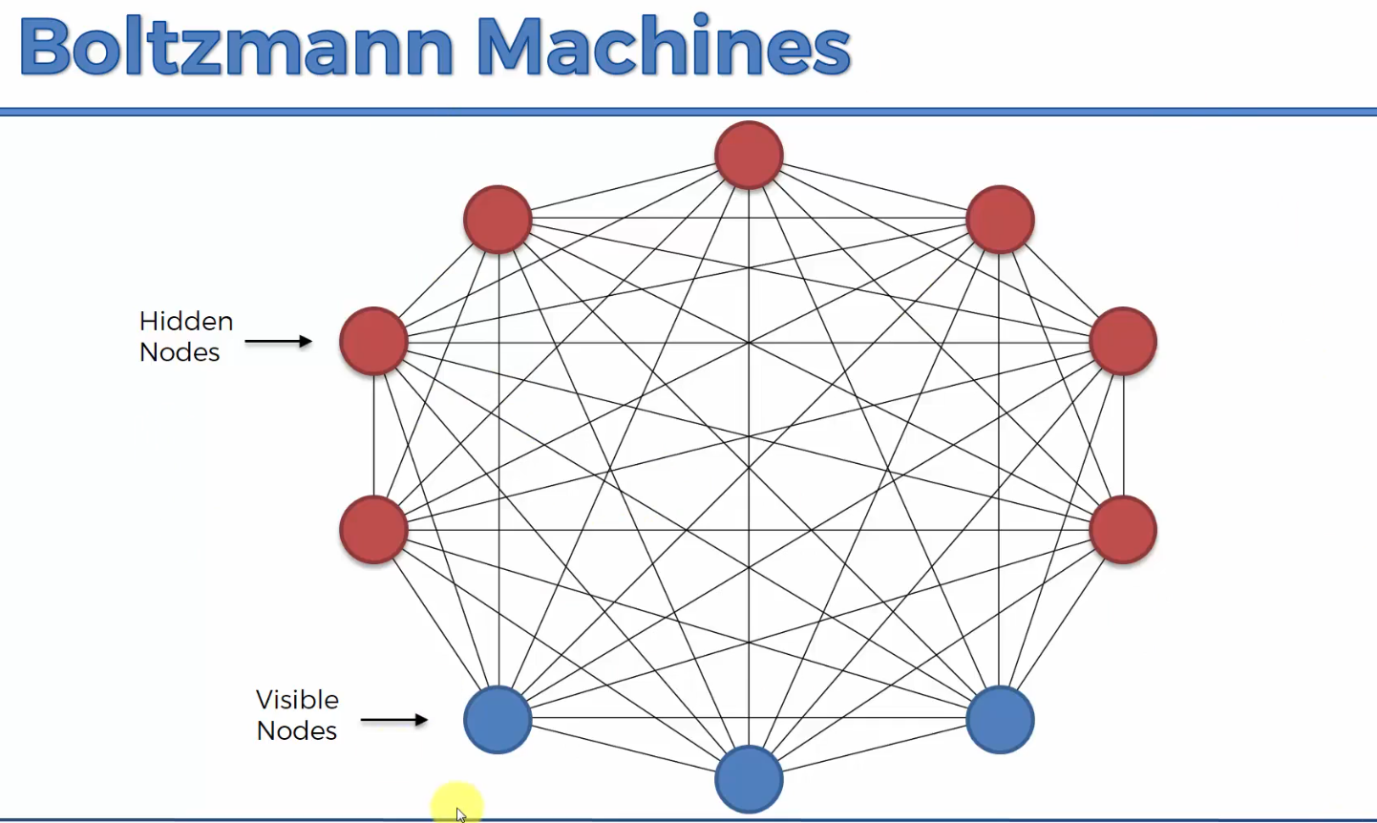

The system based on the trained weights will try to find the lowest energy state for the system.

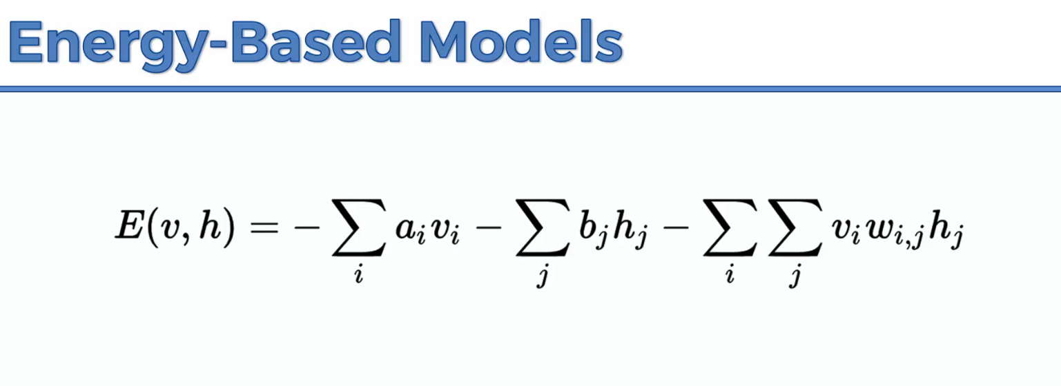

a and b are biases, v is a visible node and h is a hidden node.

Reading Material

Yann LeCun, 2006, A Tutorial on Energy-Based Learning

**Restricted Boltzmann Machines (RBM)**

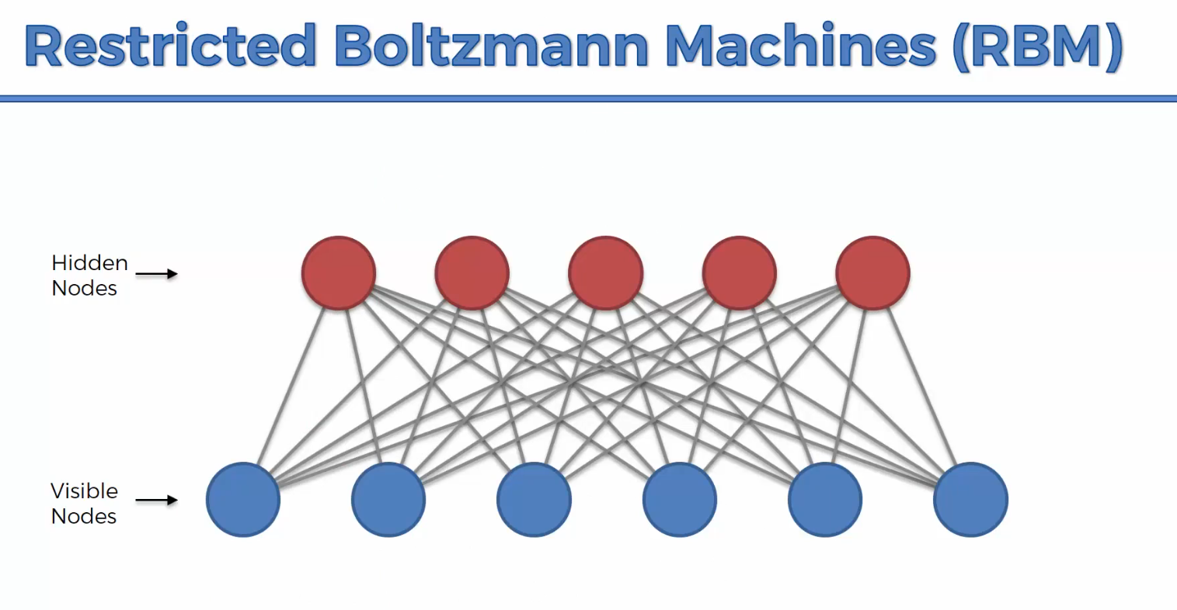

They were created to reduce the overhead that comes with computing a regular Boltzmann machine.

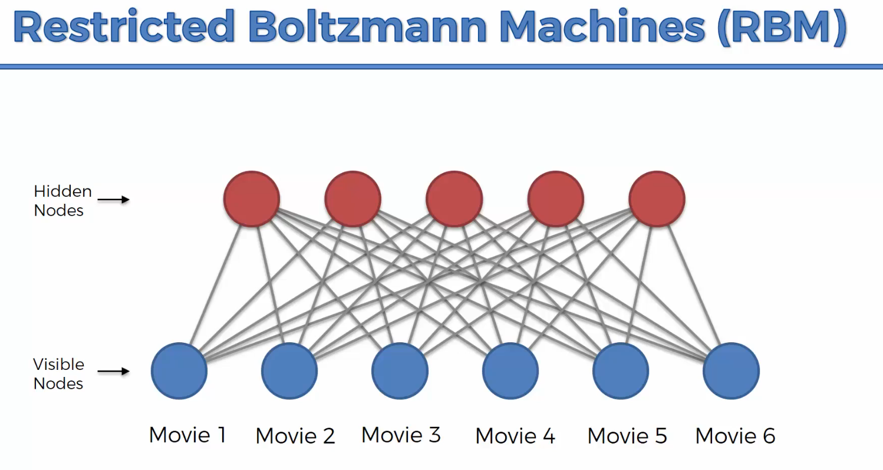

Let’s say our recommender system is working with 6 movies.

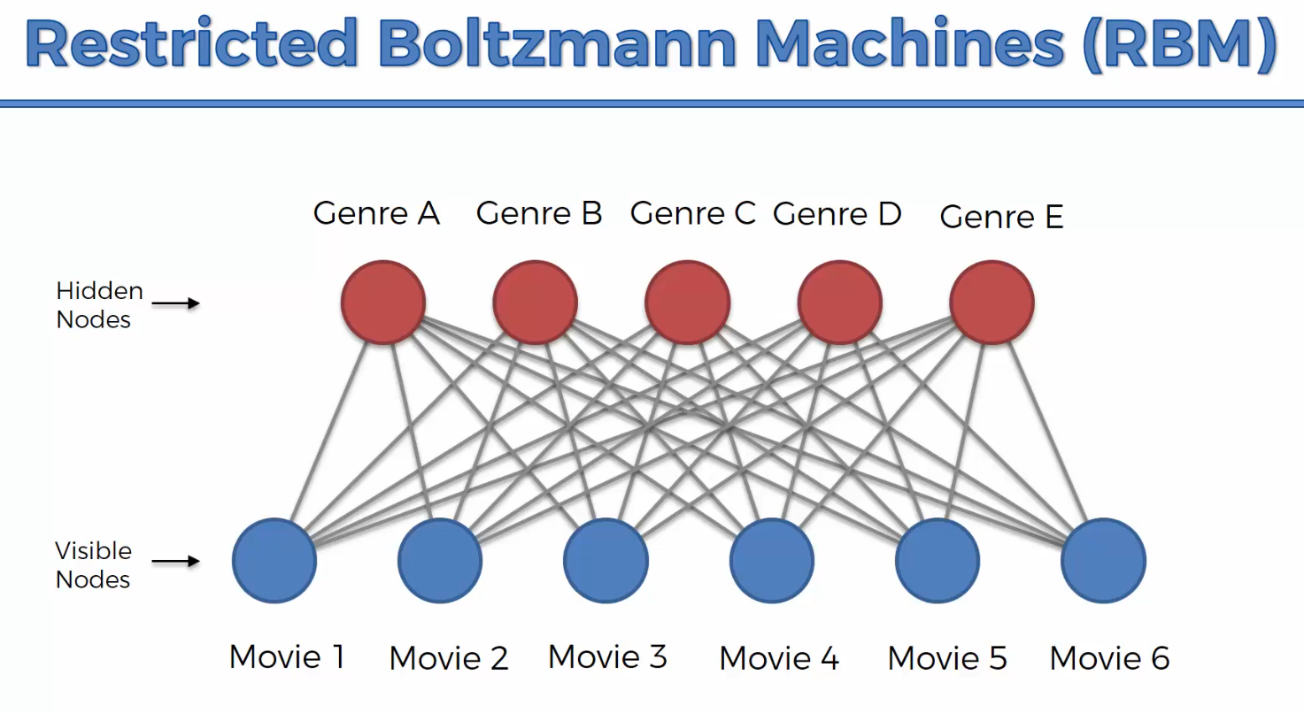

It doesn’t know that these are genres, it just identifies important features.

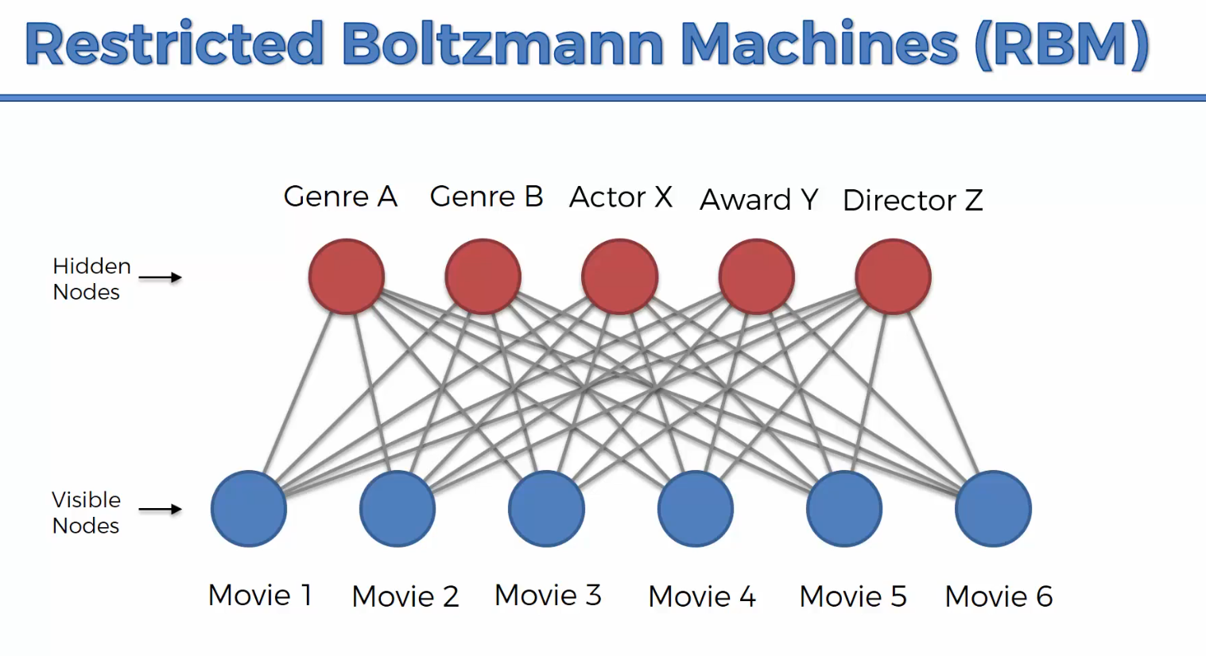

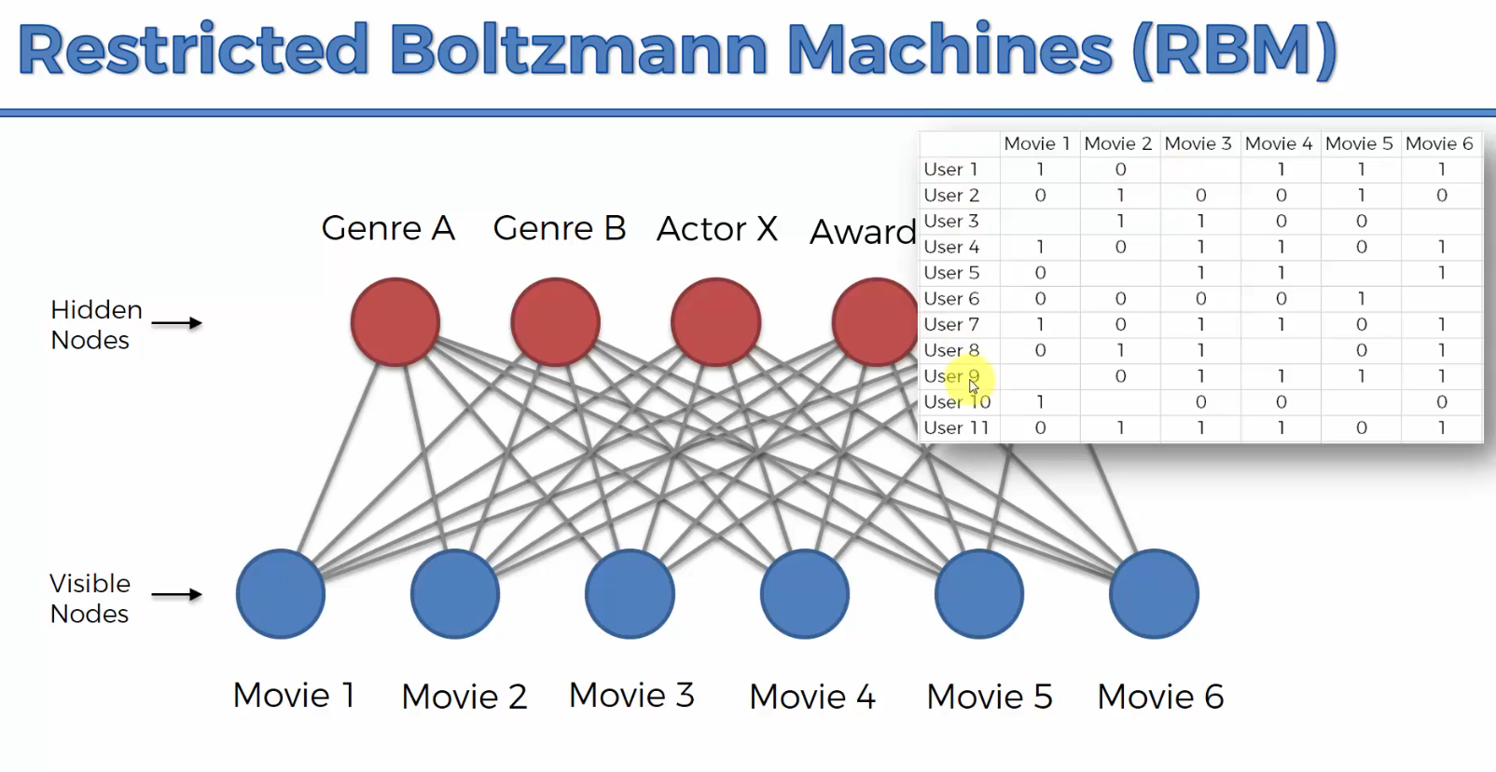

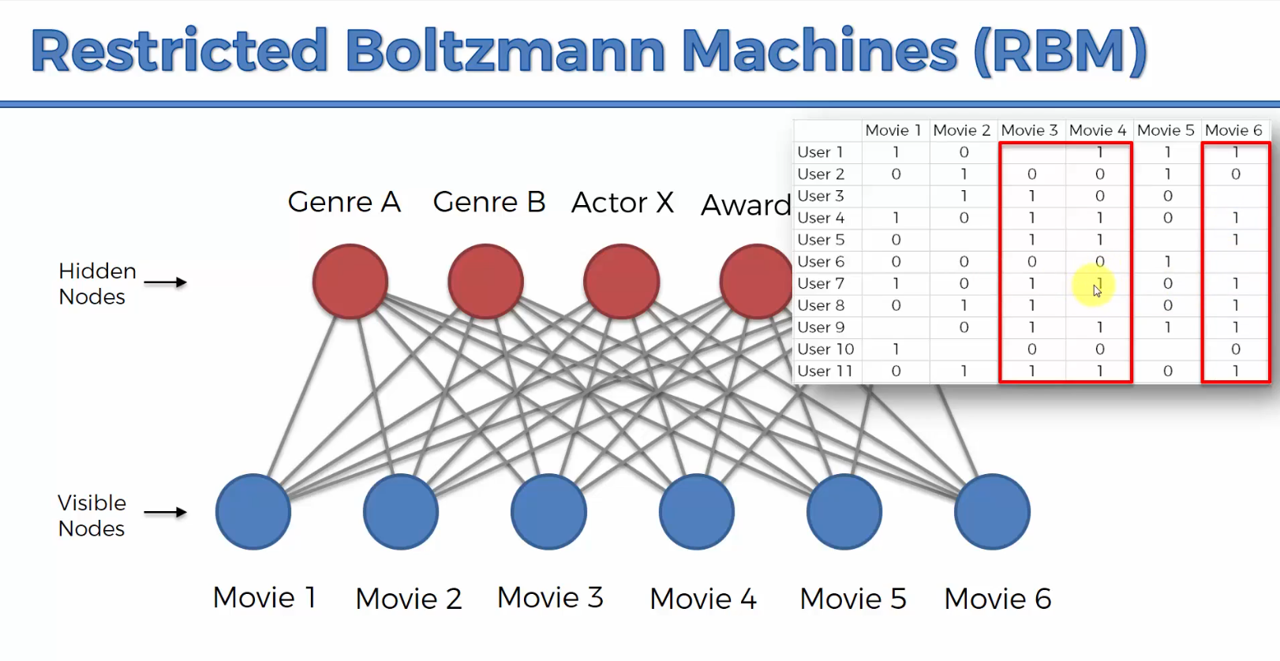

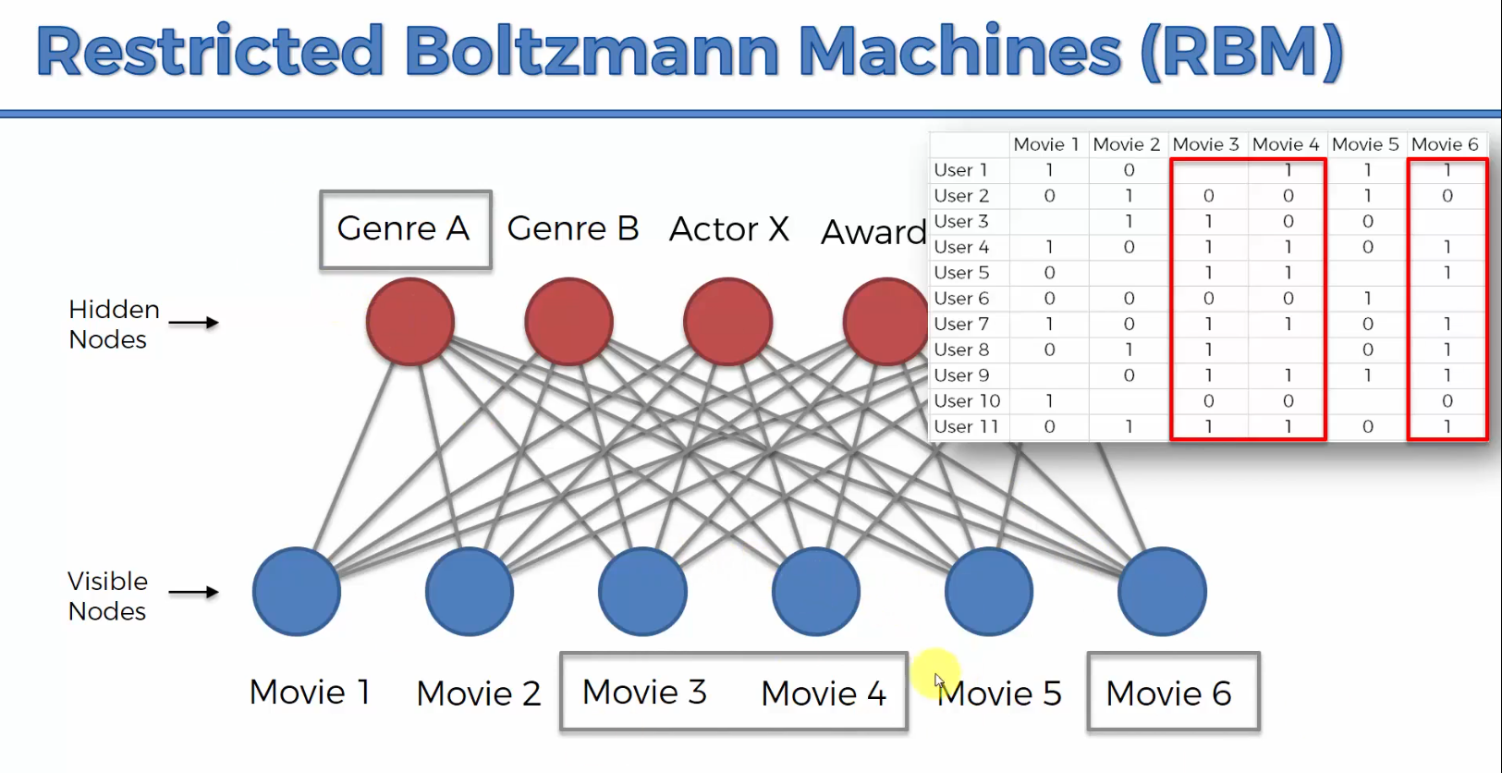

The RBM through training identifies a relevant feature and here it’s using Genre

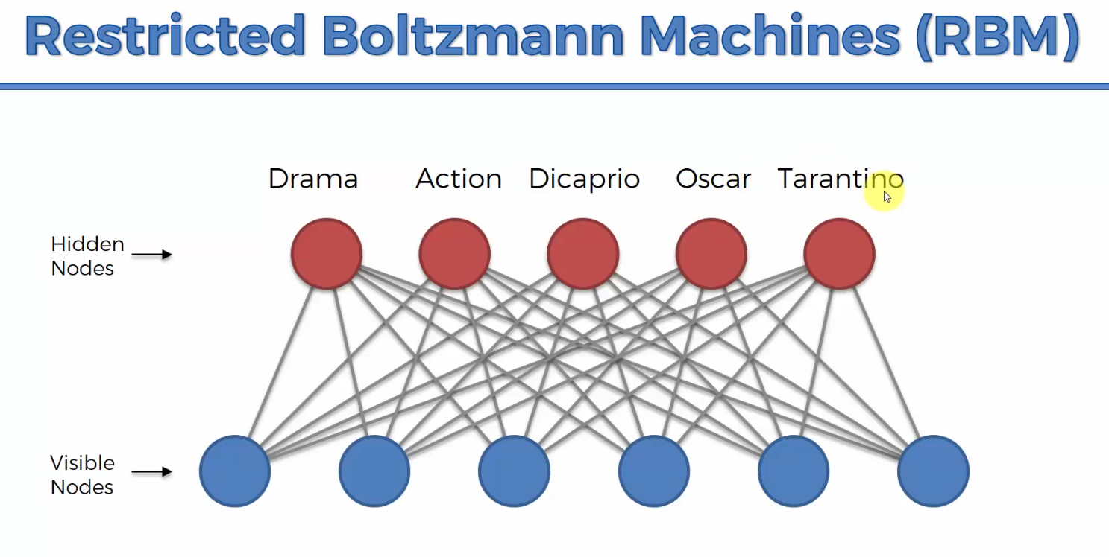

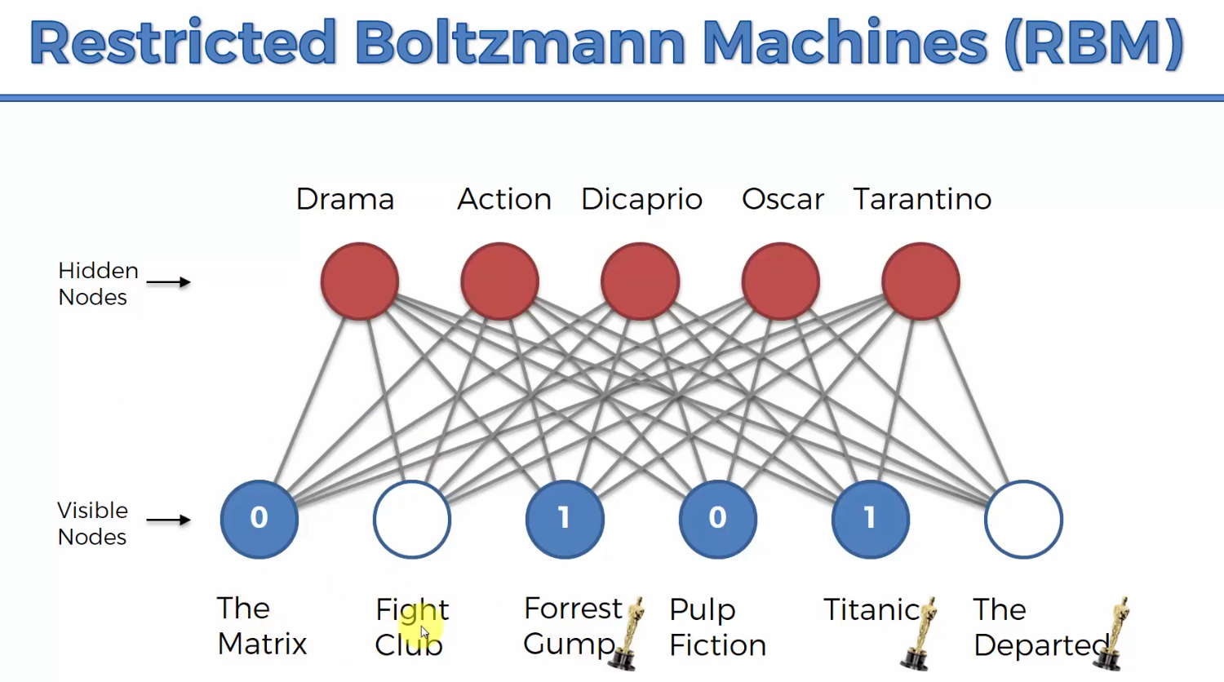

We feed in a row and certain features are going to light up

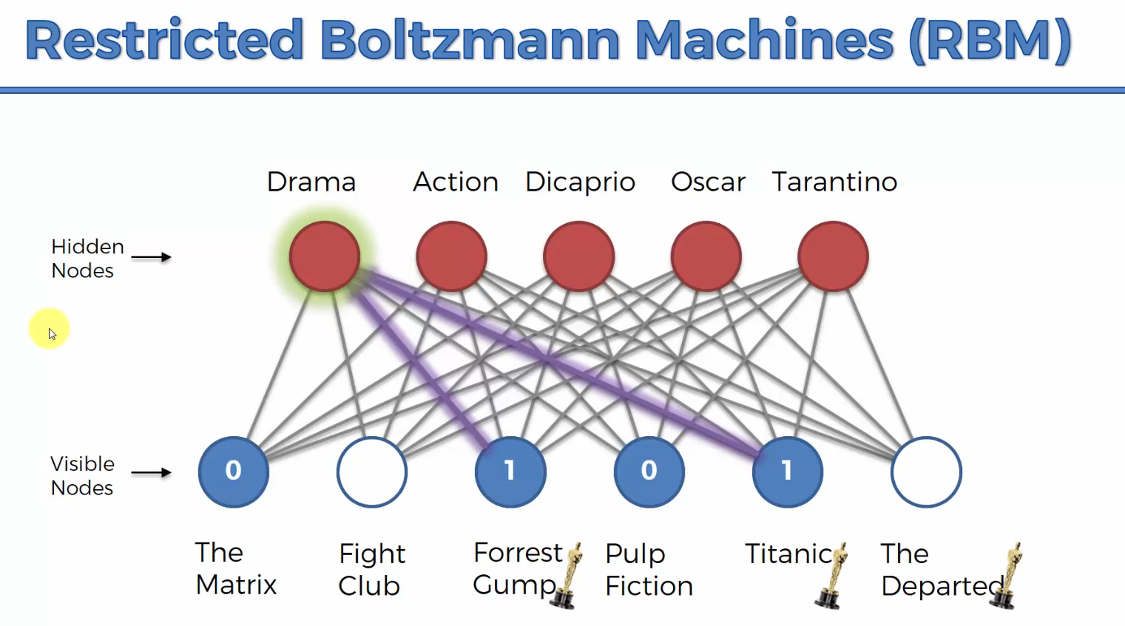

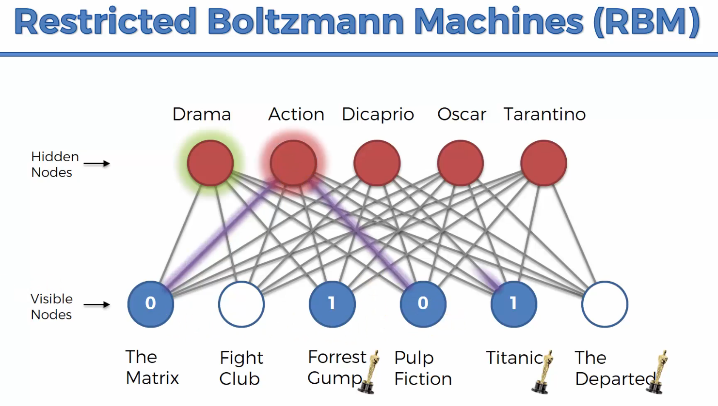

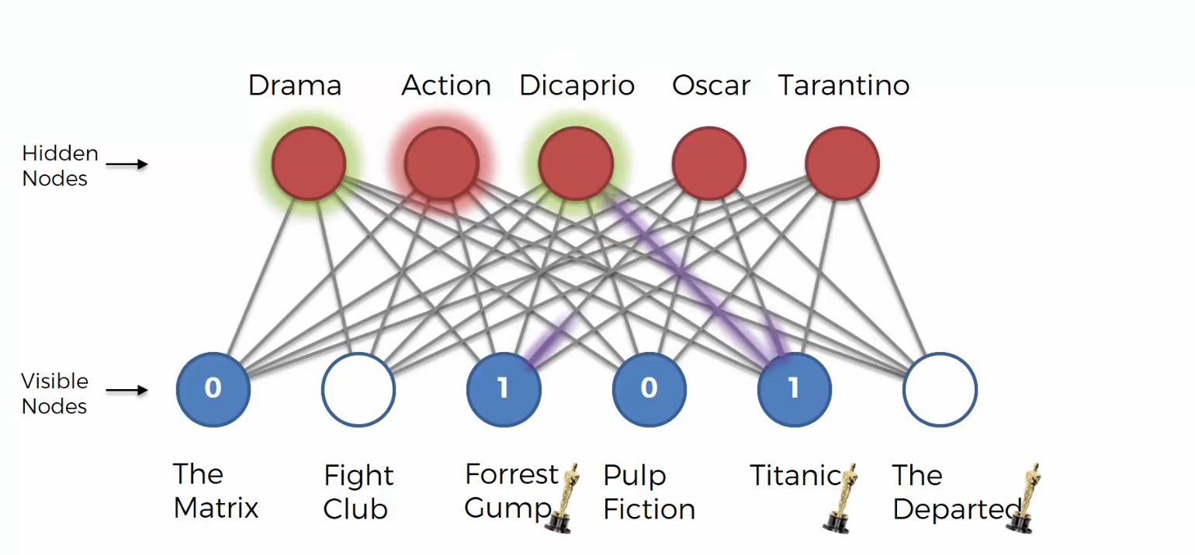

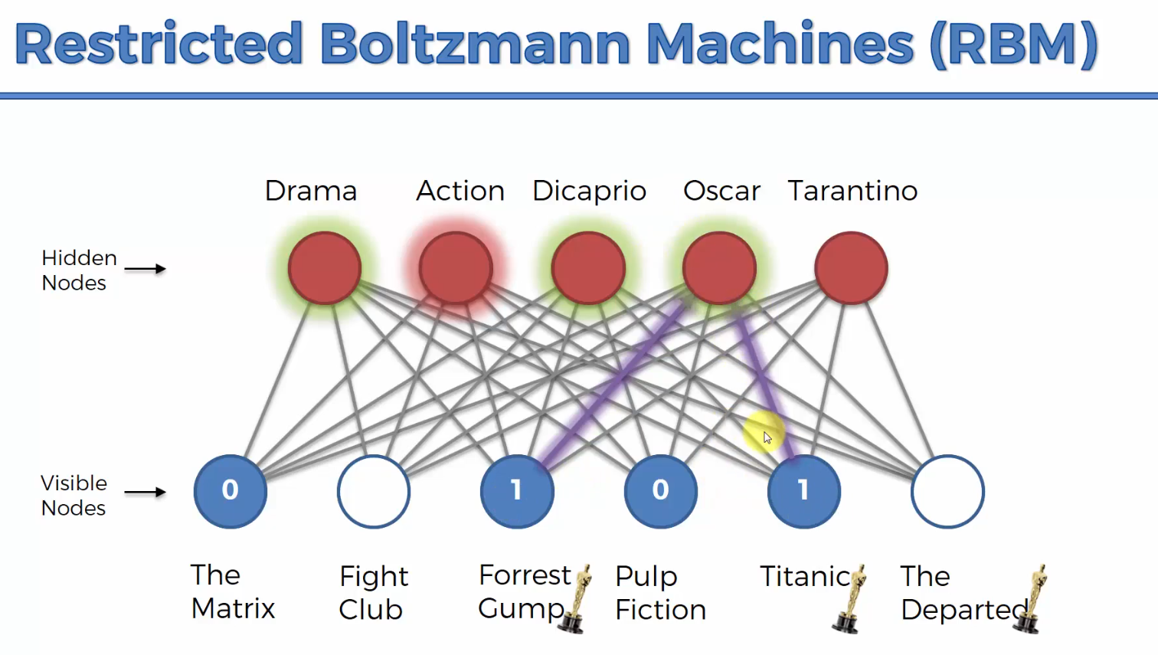

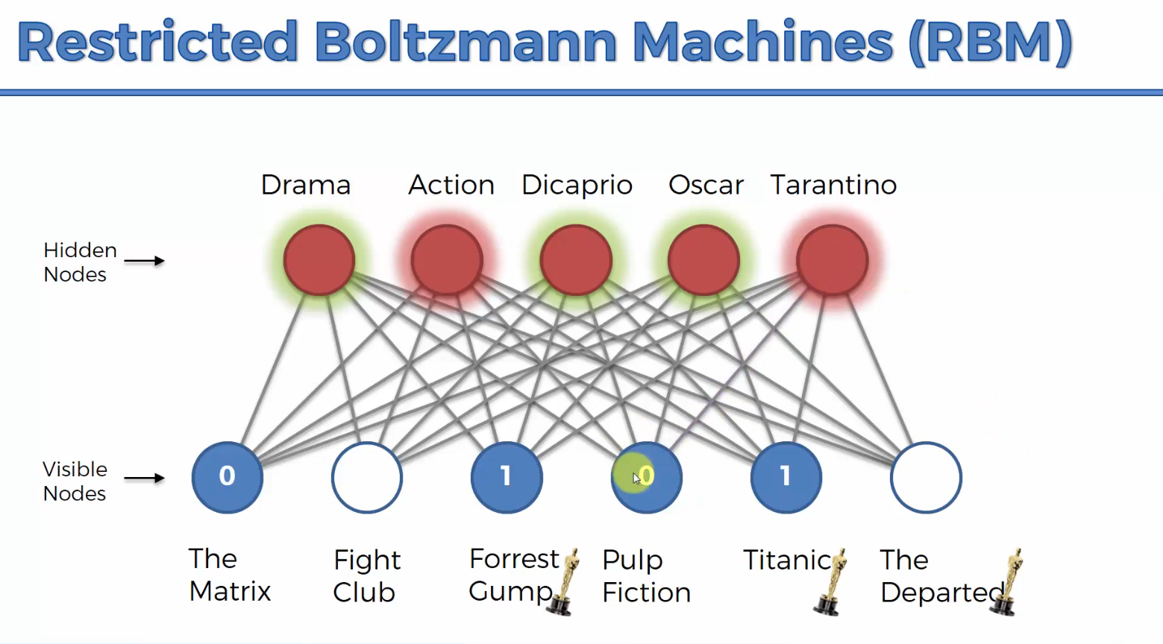

Then the Boltzmann machine will reconstruct its input based off what it’s learned from training.

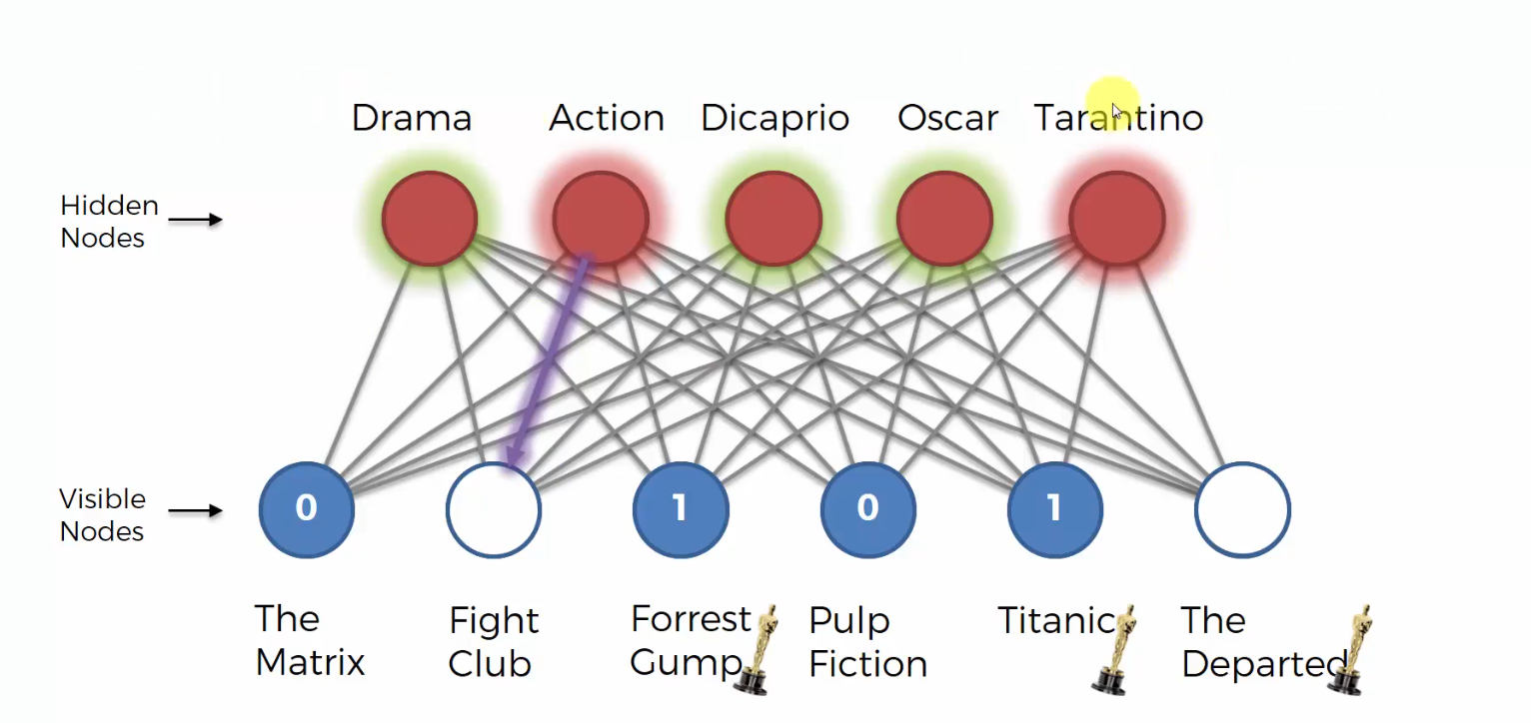

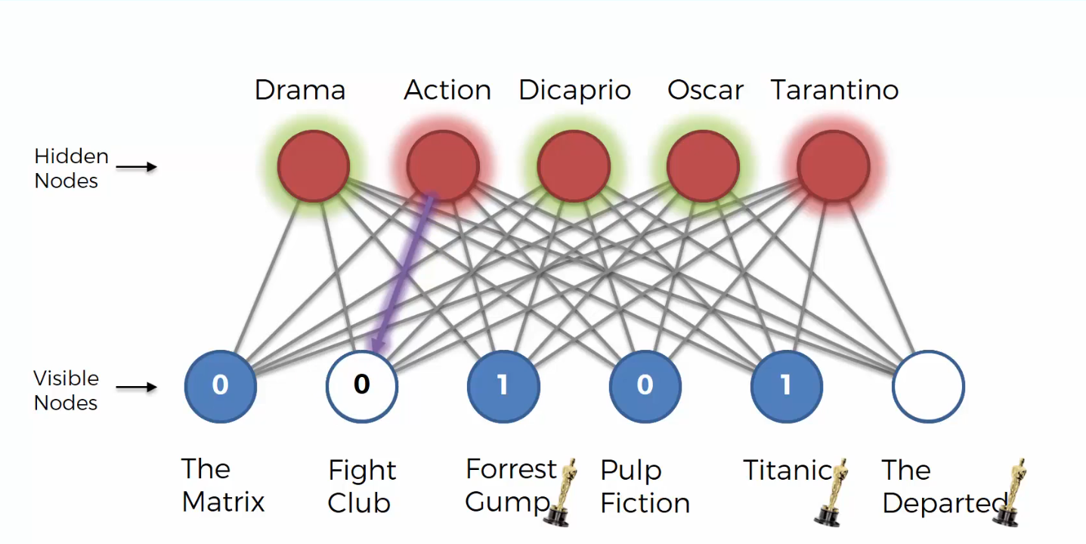

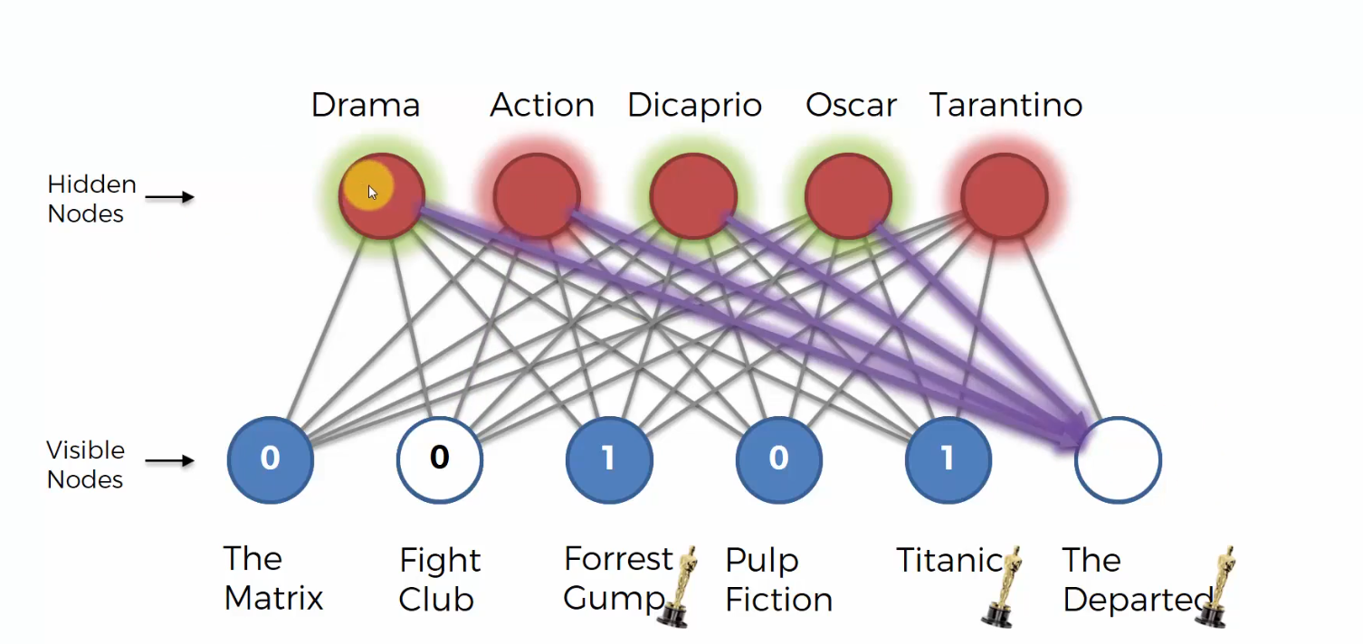

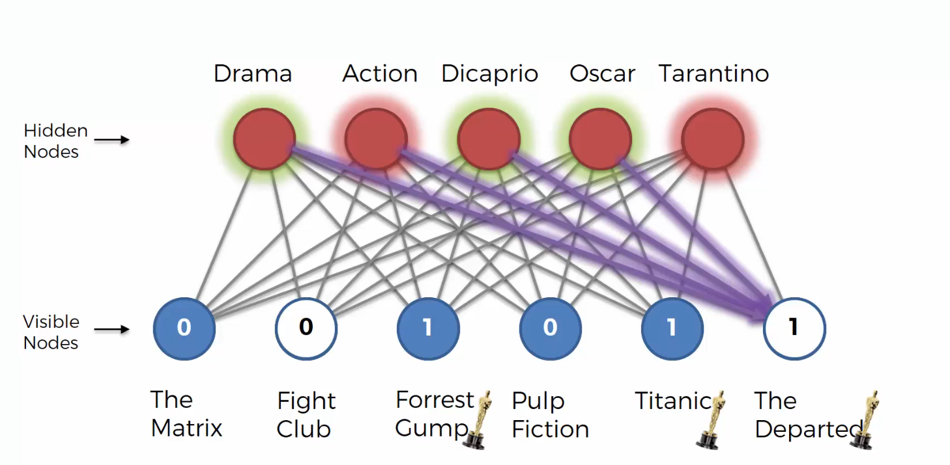

**CONTRASTIVE DIVERGENCE**

The algorithm that allows restricted Boltzmann machines to learn.

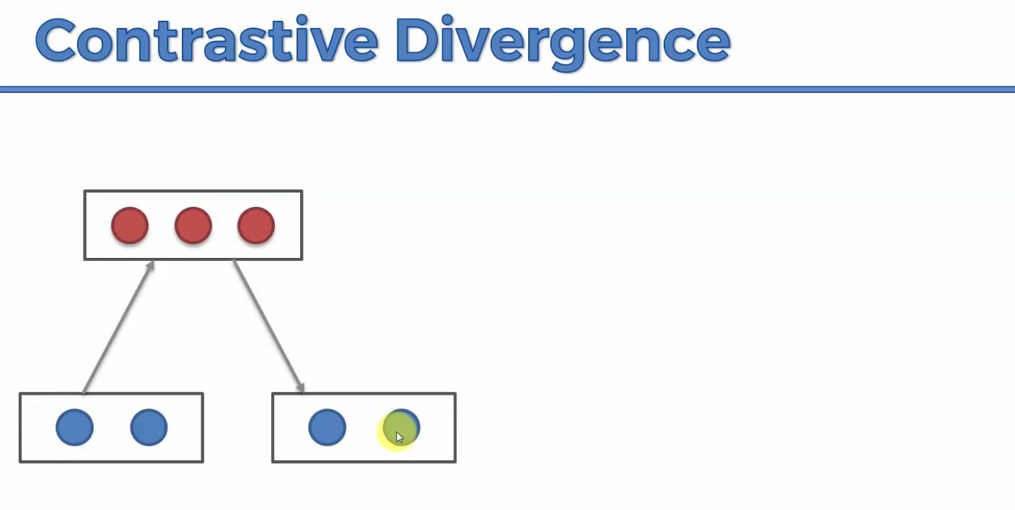

Our input nodes, at the start using some randomly assigned weights, the RBM calculates the weights of the hidden nodes. The calculated weights of the hidden nodes are then used to reconstruct the inputs.

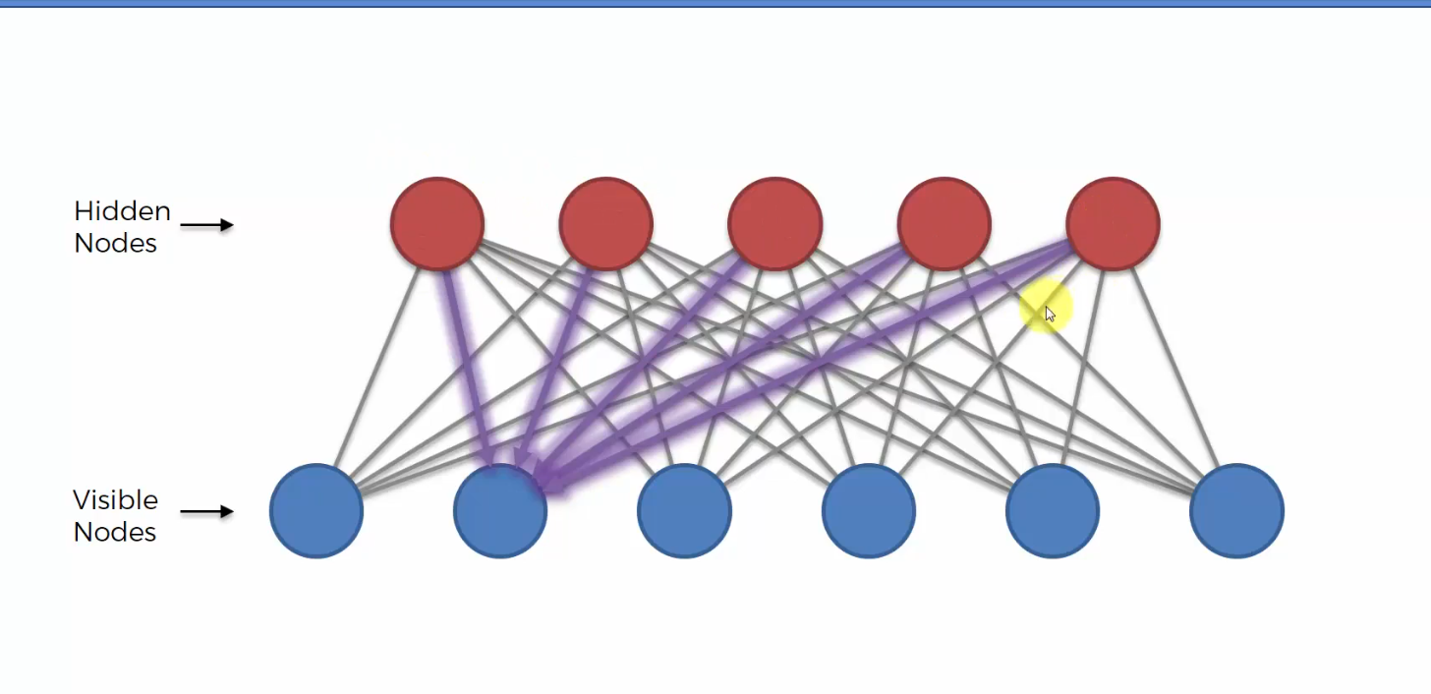

Each hidden node’s weight is constructed from all the 6 input nodes.

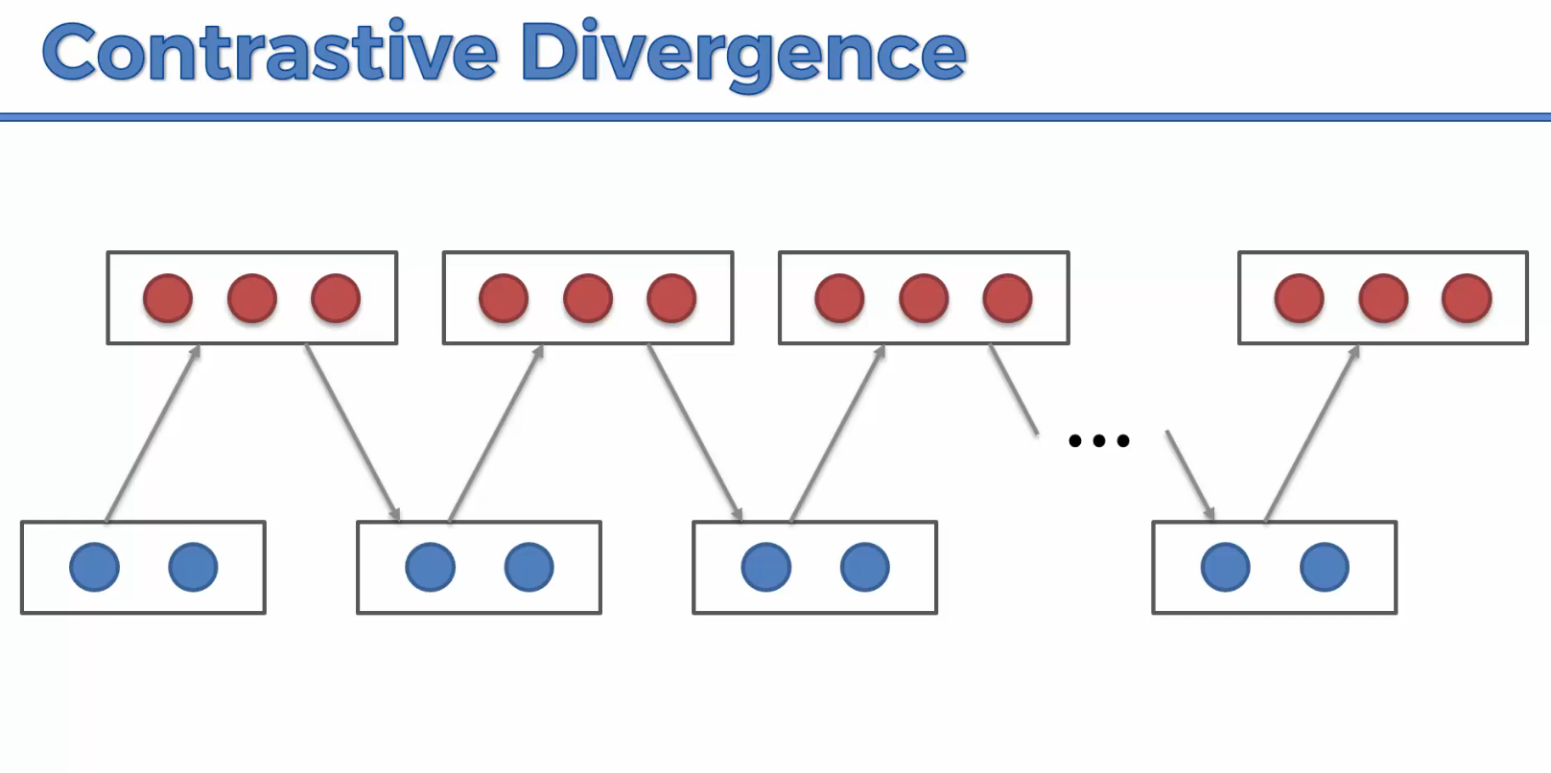

The process above is called gibbs sampling. It ends when we try to reconstruct our input, it’s the same remains the same as before.

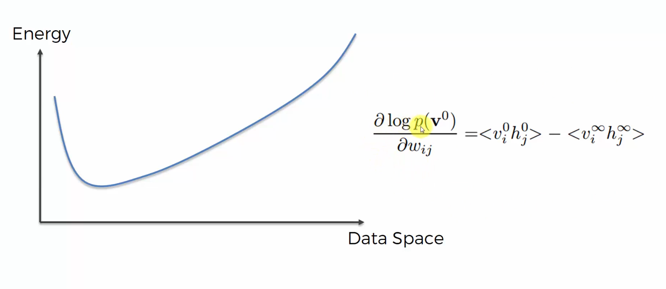

Weights are initialized randomly.

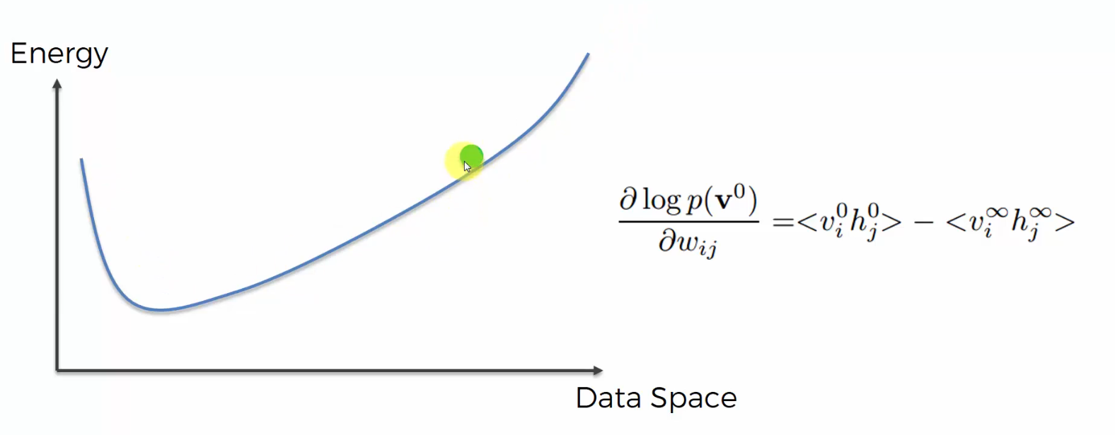

After the second pass

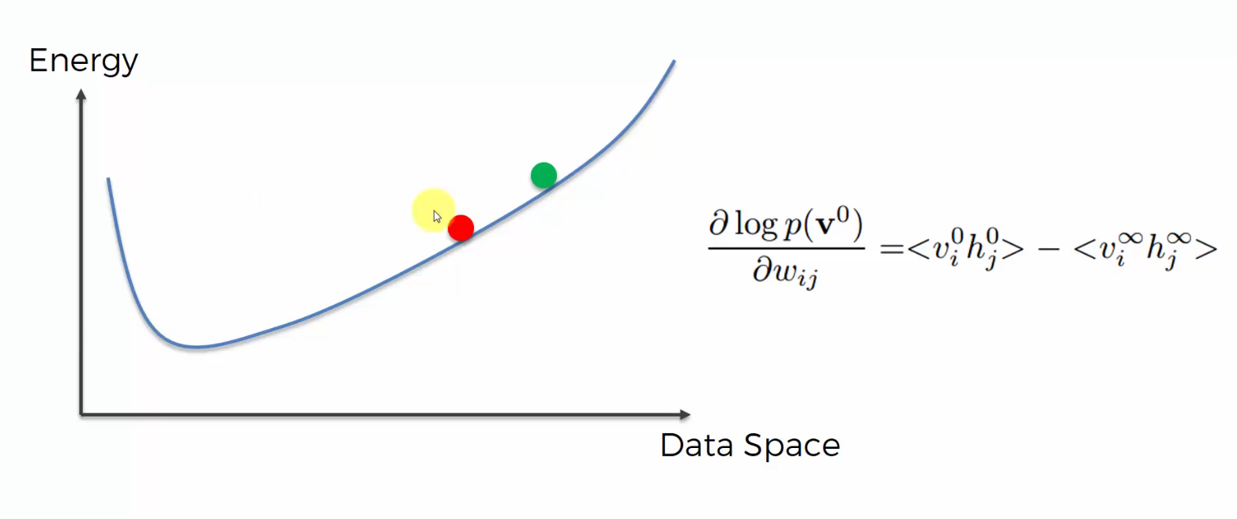

We aim to go closer and closer to the lowest energy state.

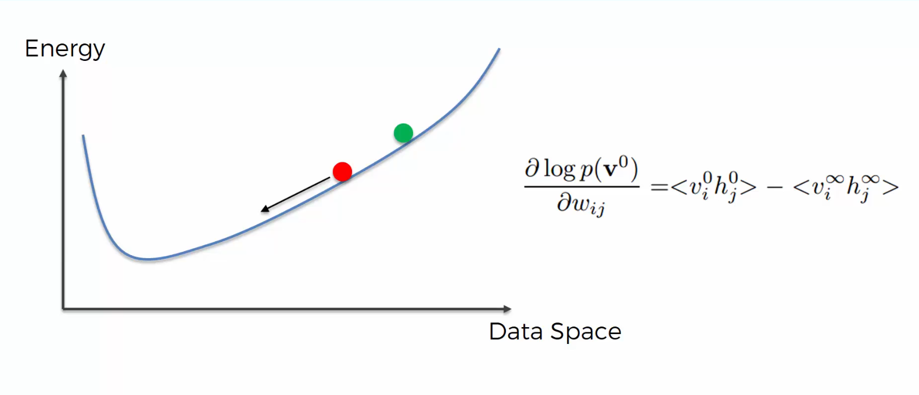

Below is a way to prevent going through the whole processing of sampling to reach the minimum but you can adjust the weights of the first states.

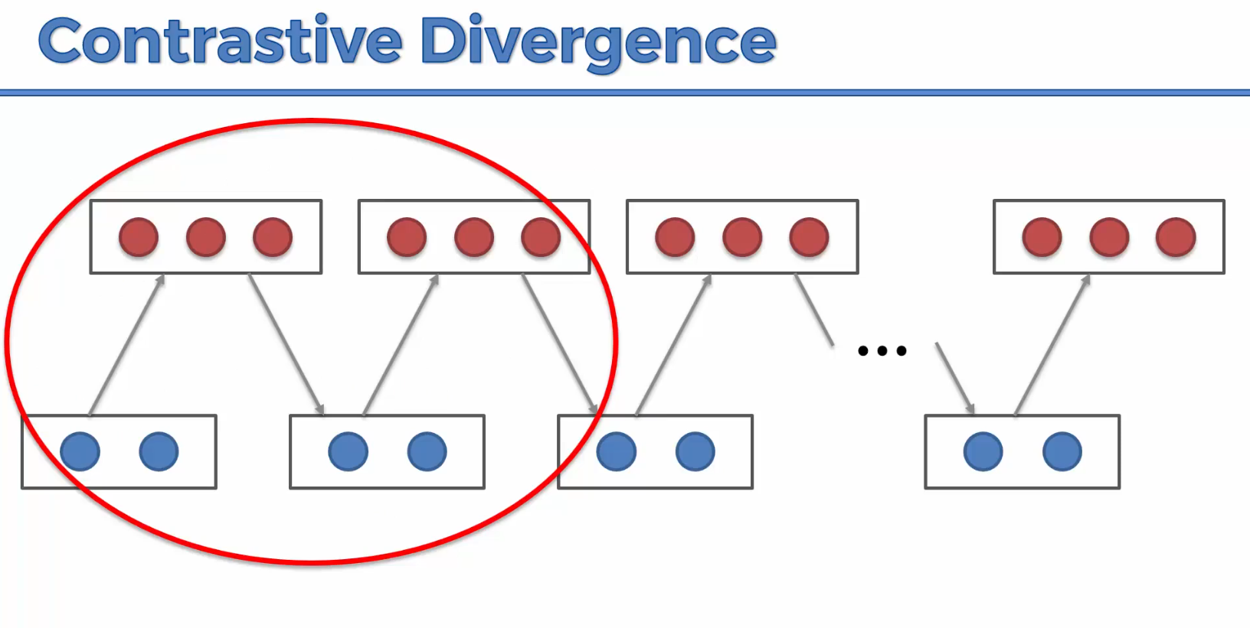

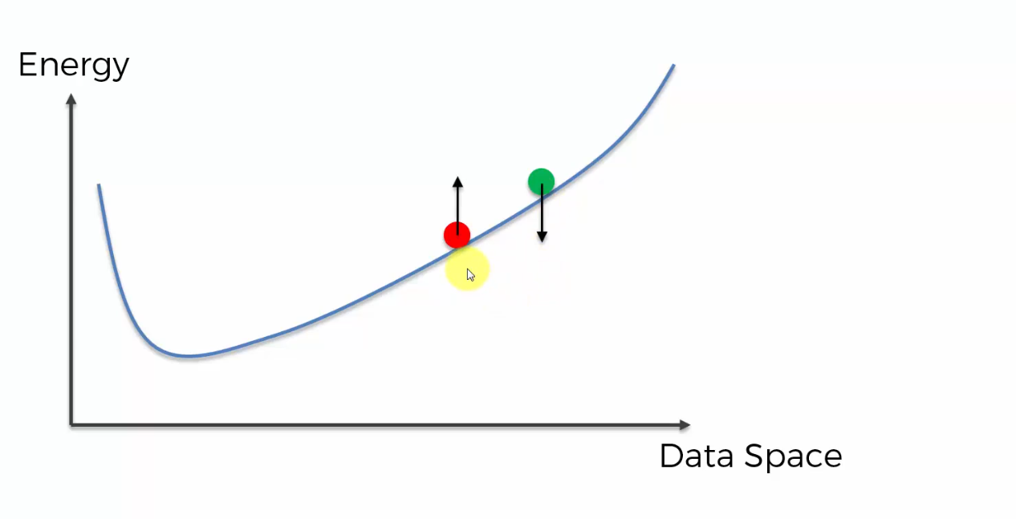

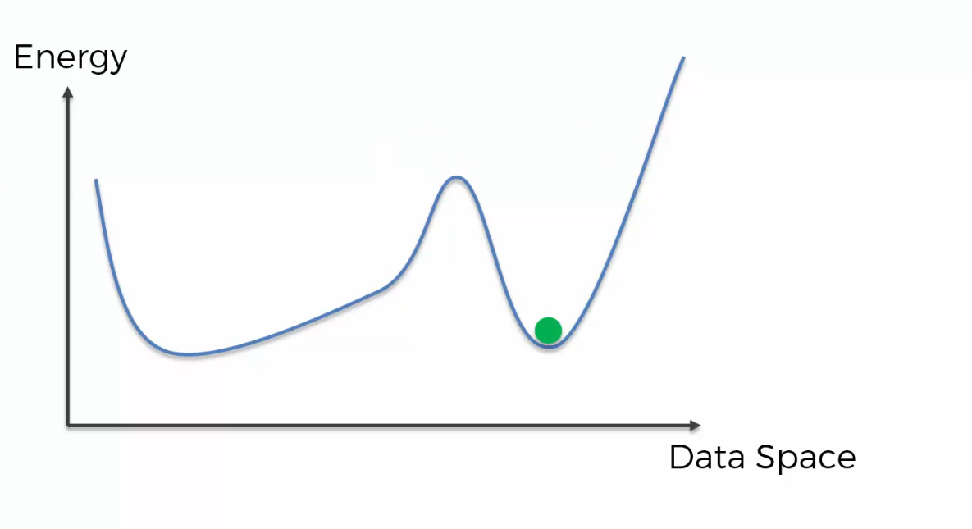

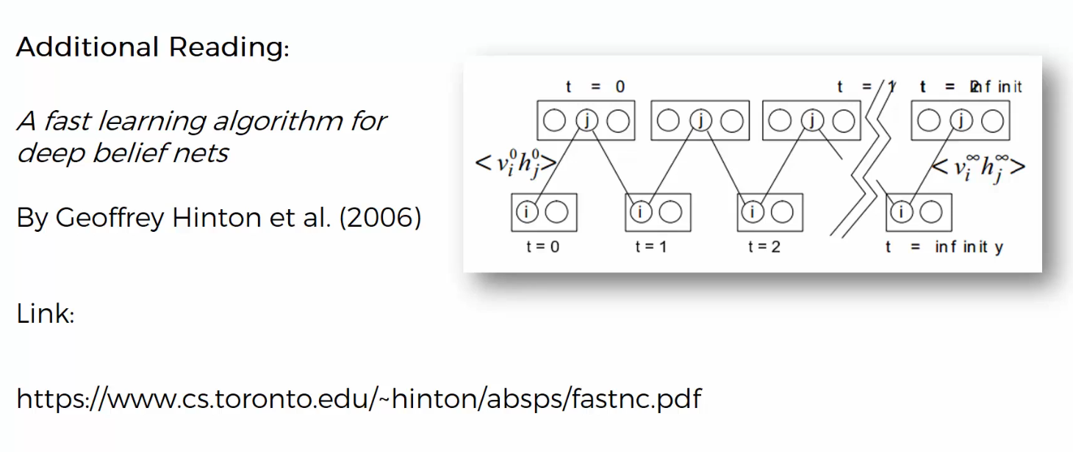

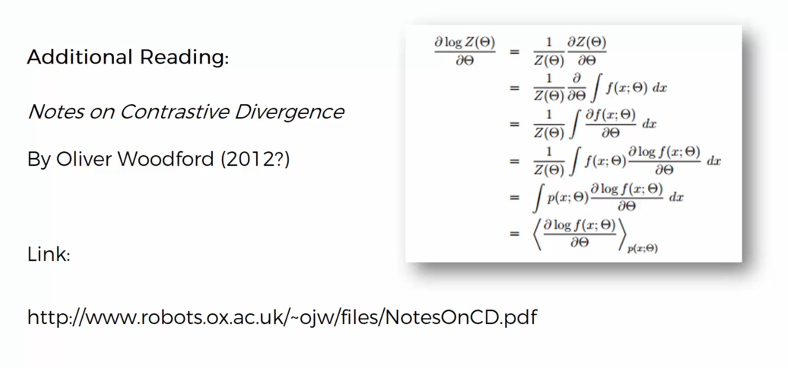

**DEEP BELIEF NETWORS (DBN)**

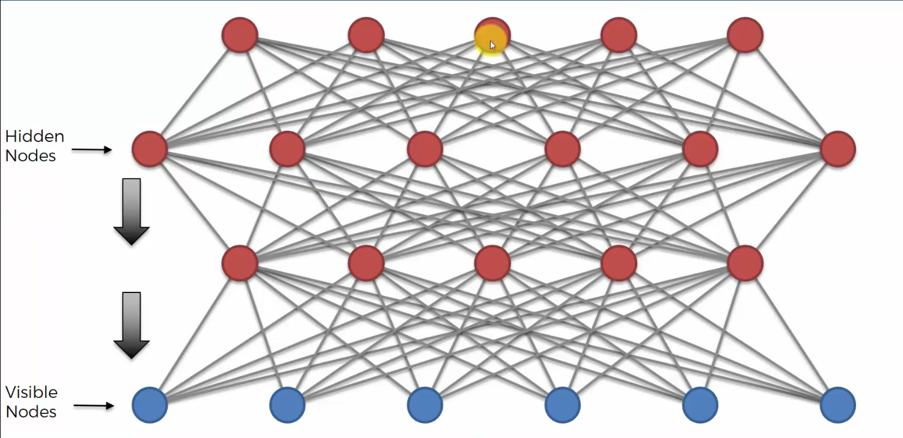

**DEEP BOLTZMANN MACHINES**

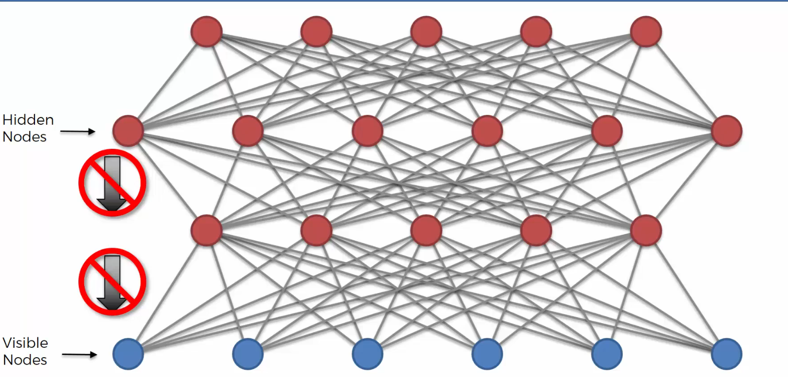

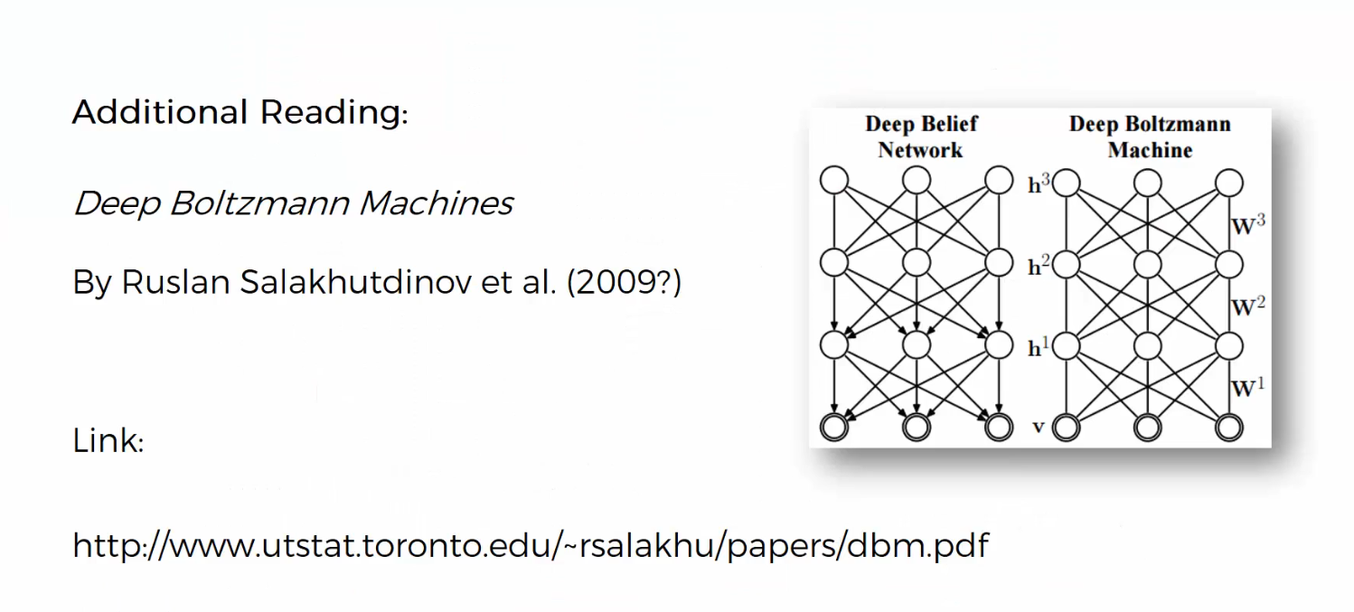

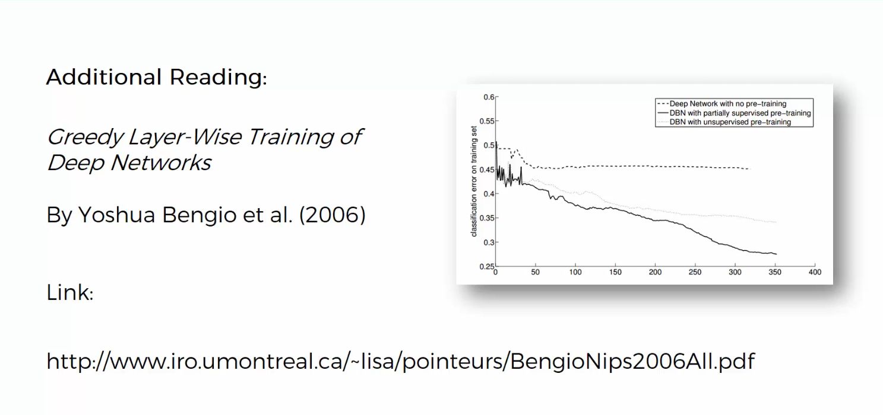

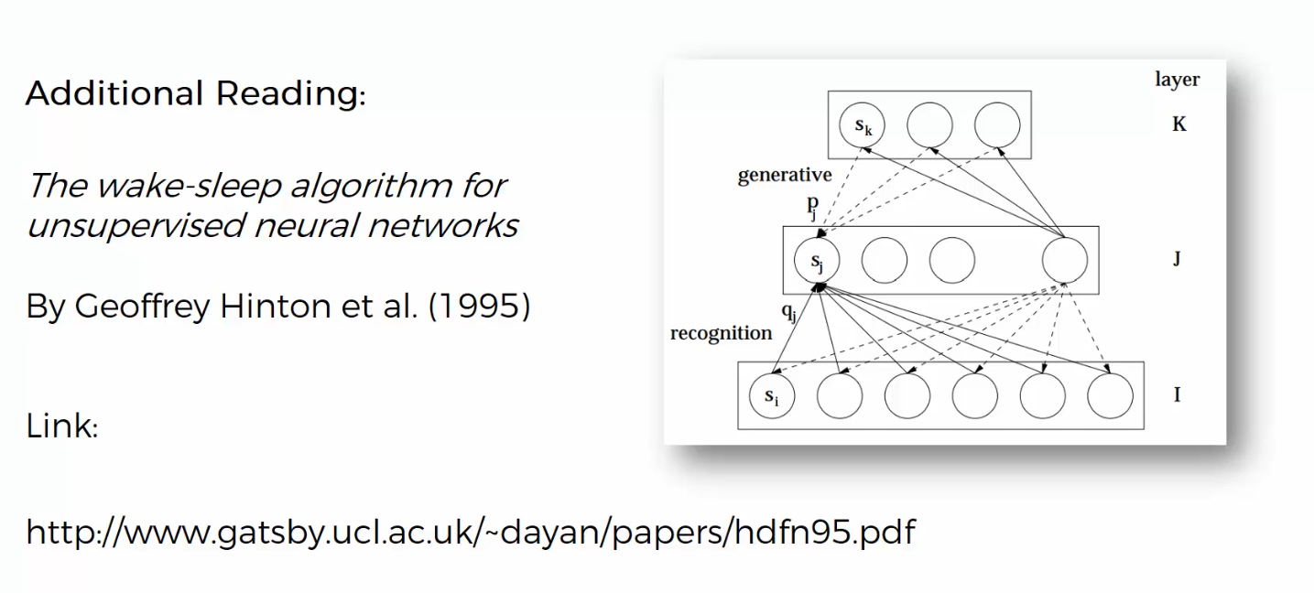

**AUTO ENCODERS**

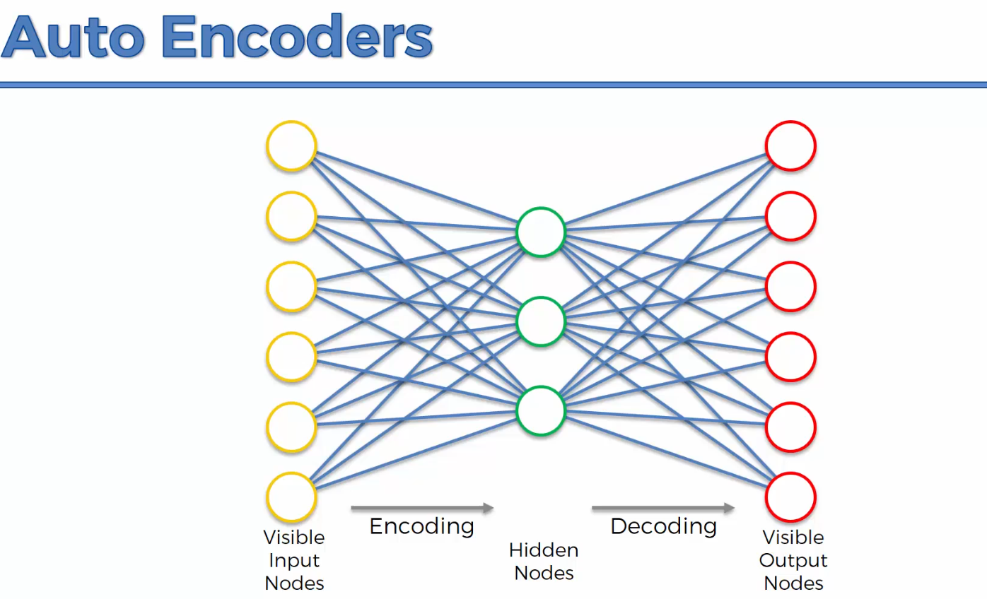

It takes some sort of input, puts it in a hidden layer and presents outputs but it aims for the outputs to be identical to the inputs. They are not a pure type of unsupervised deep learning algorithms. So, it’s a self-supervised deep learning algorithm.

Auto encoders are used for feature detection, building powerful recommender systems as well as encoding data.

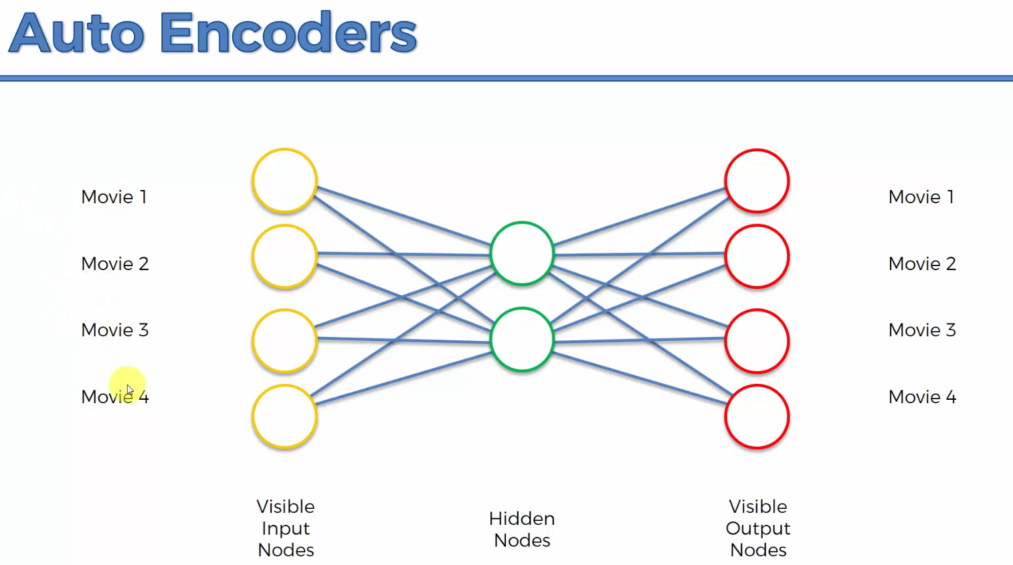

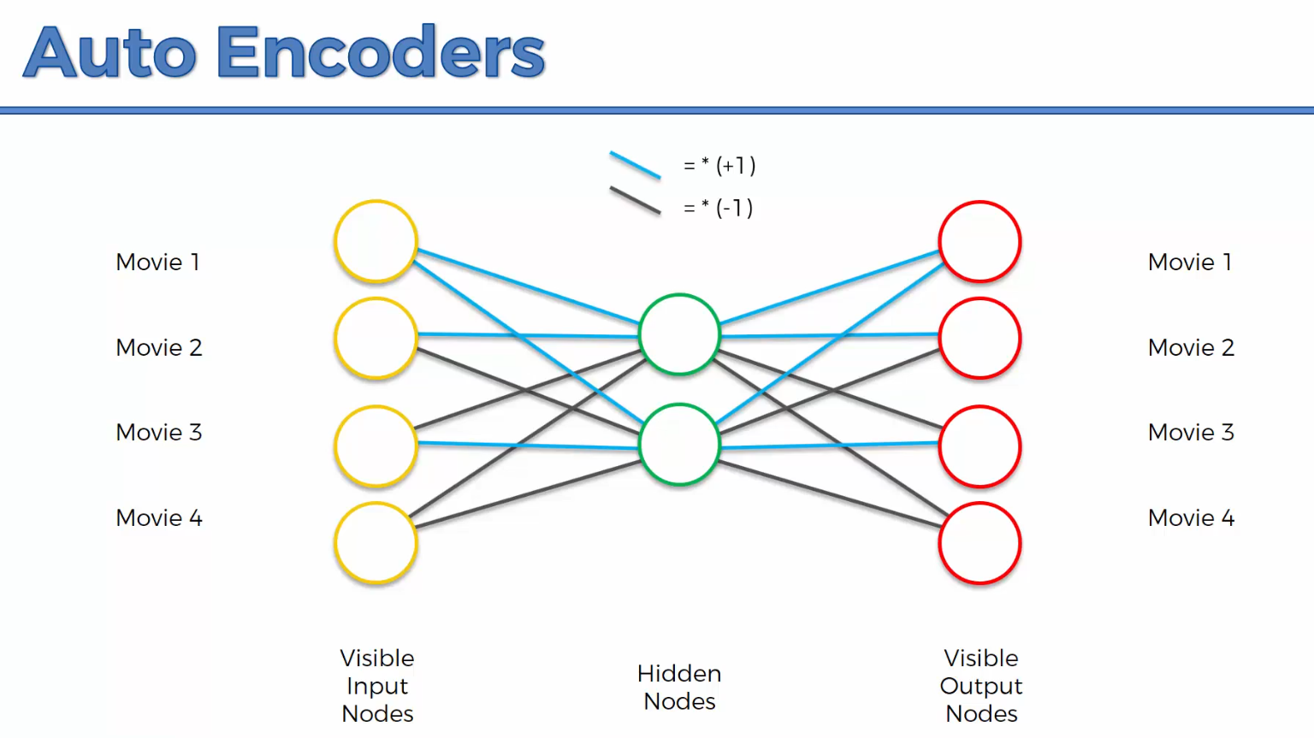

You normally use the hyperbolic tangent activation function in auto encoders.

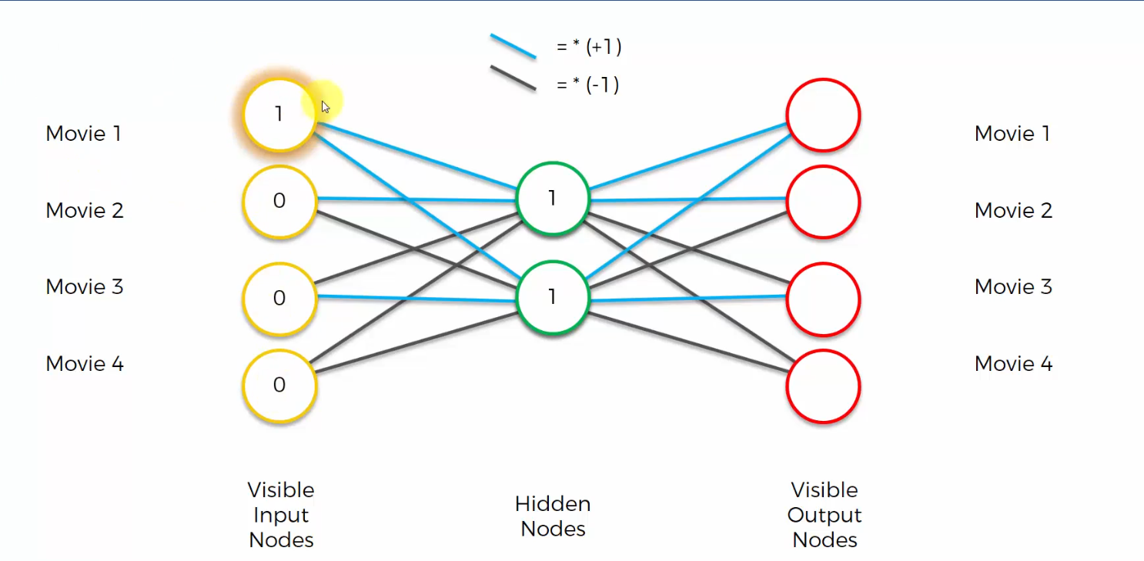

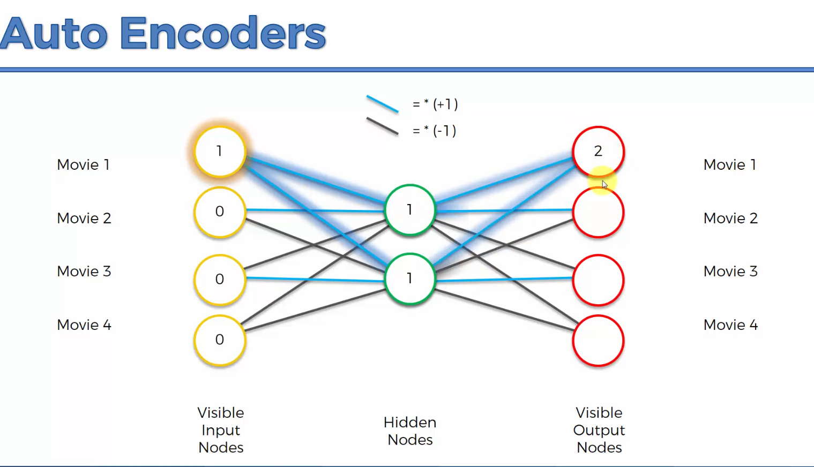

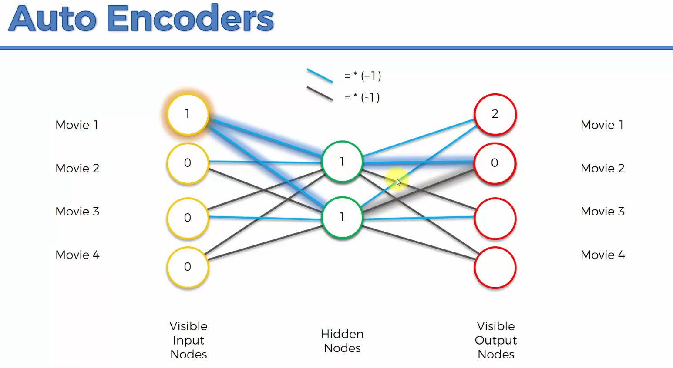

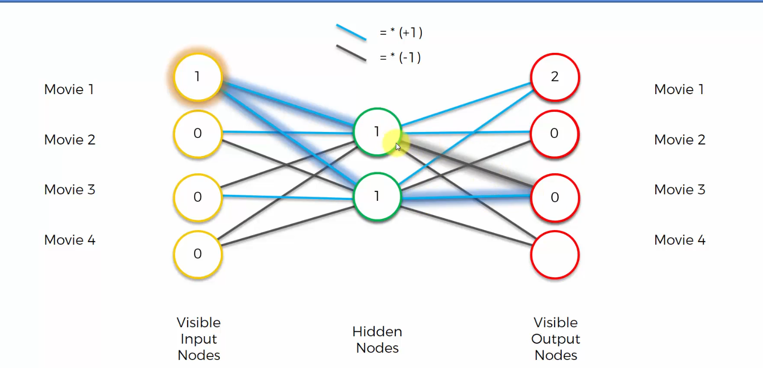

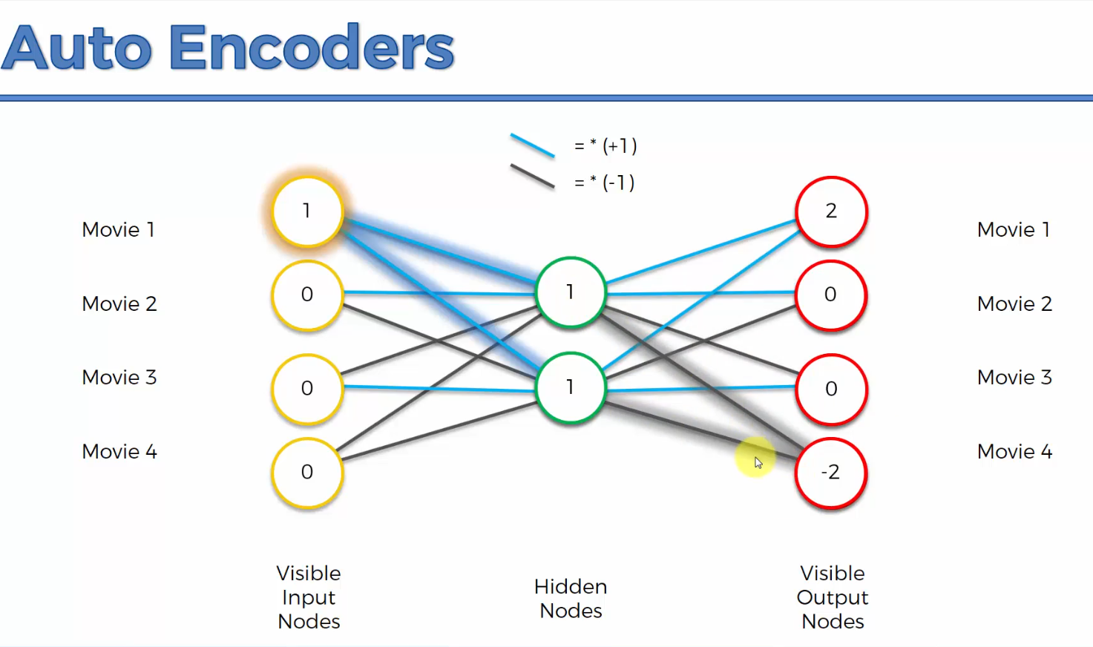

The softmax function takes the highest value and makes zero everywhere else and hence it’ll end up being identical to what we have in the input nodes.

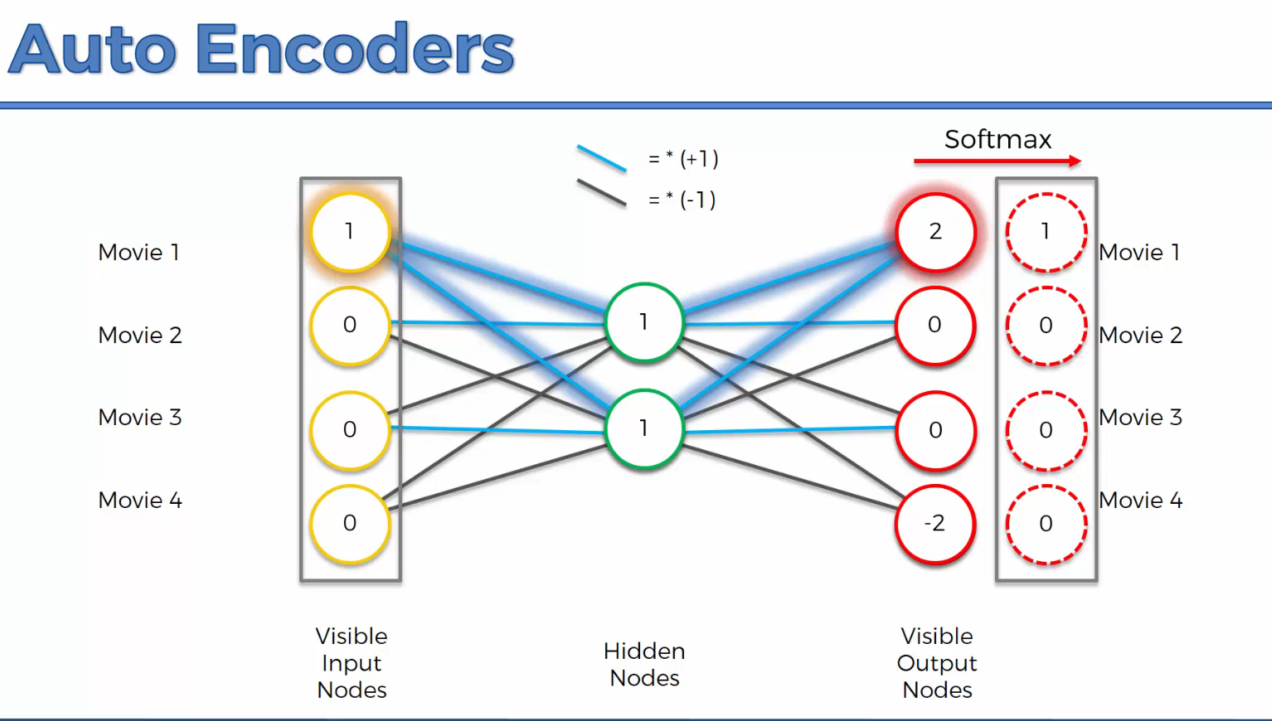

**A Note on Biases**

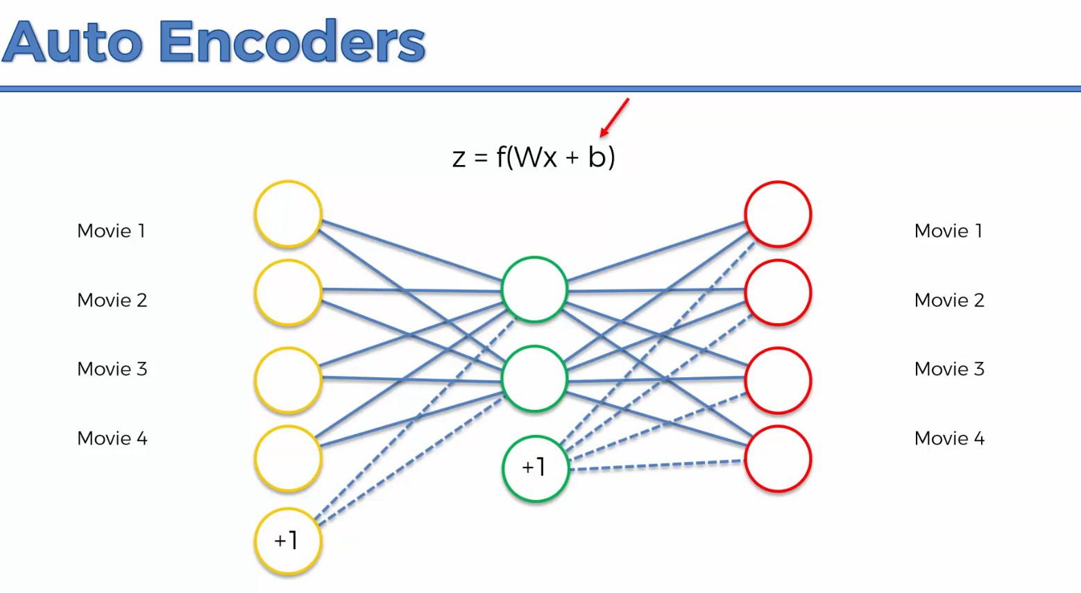

Basically, instead of **weights times x** it adds a **plus b.**

**Training an Auto Encoder**

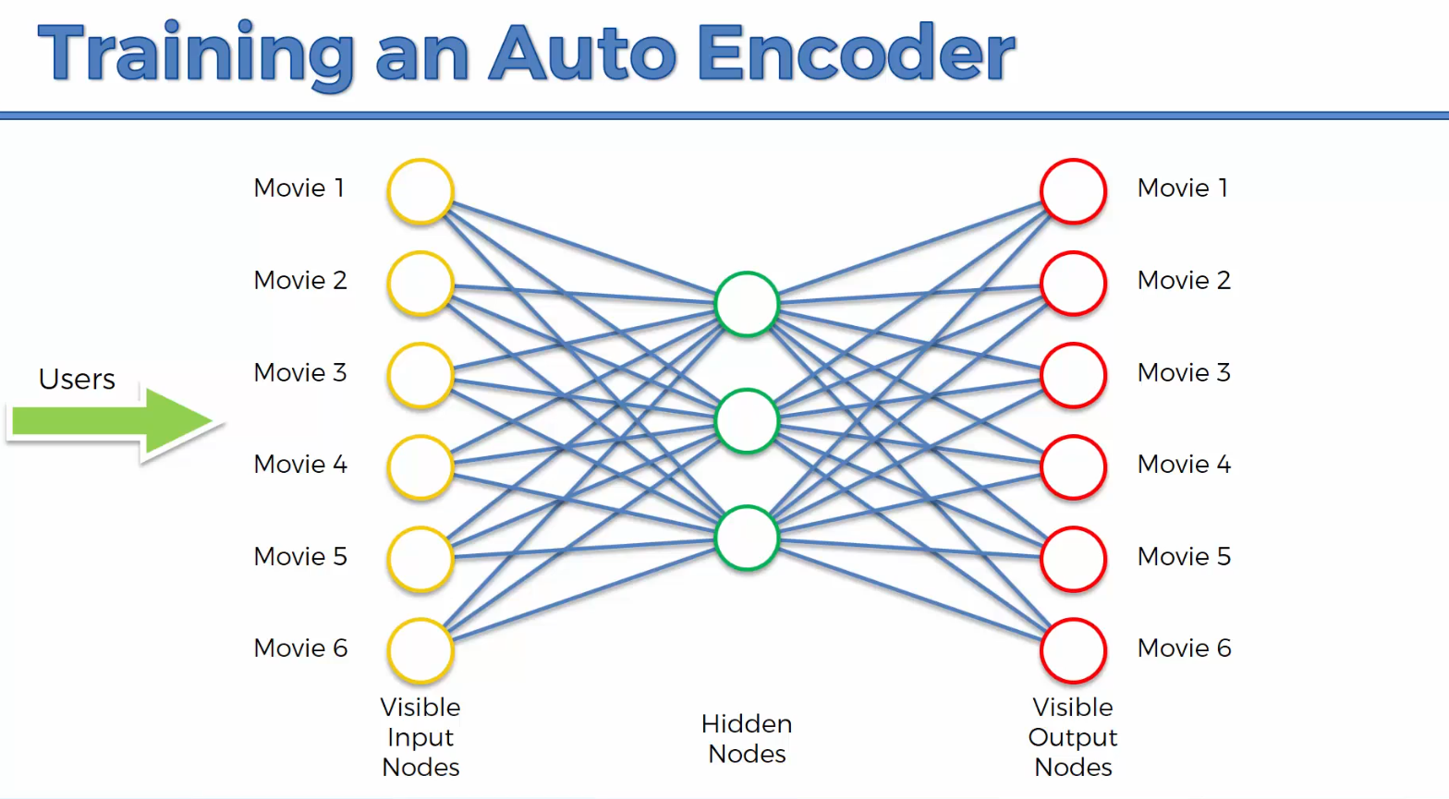

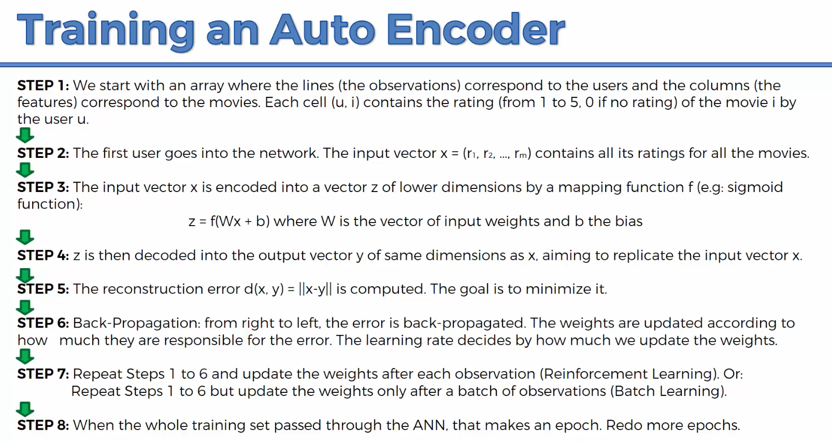

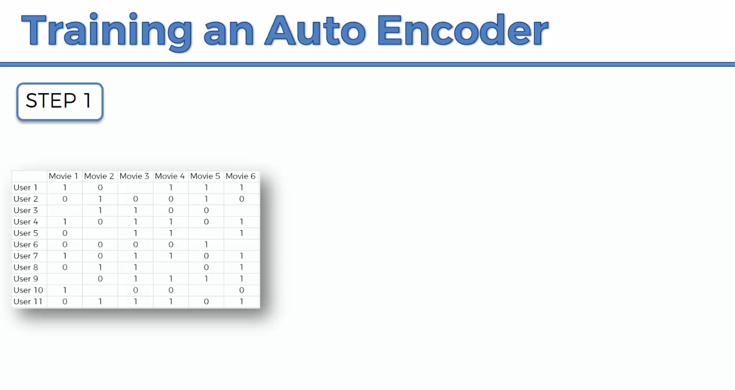

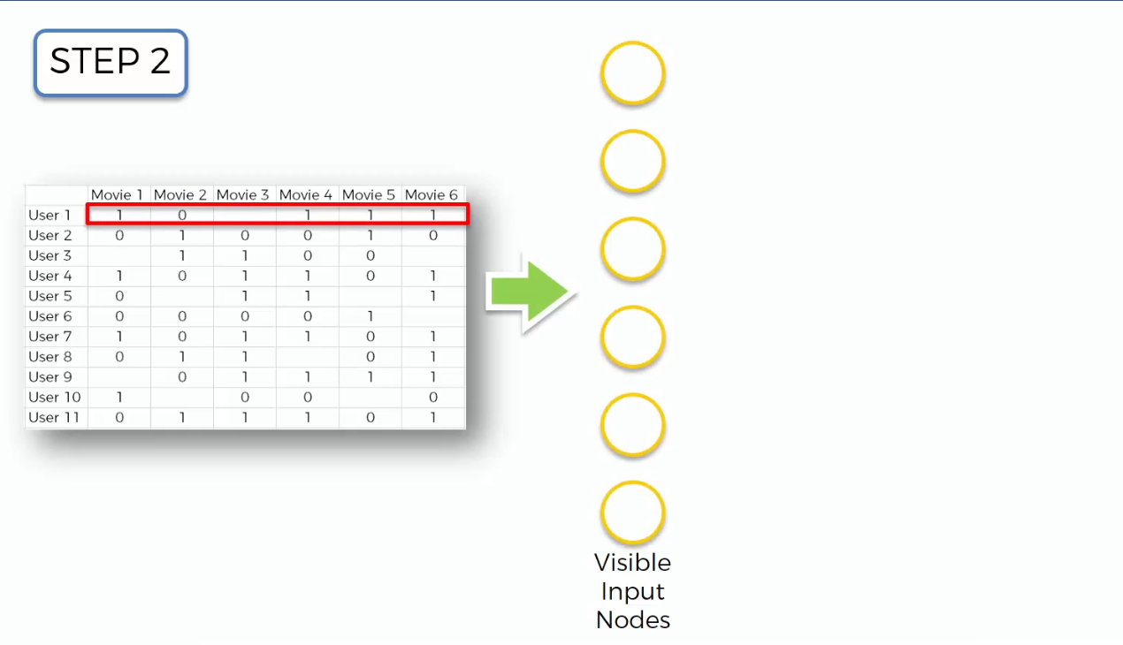

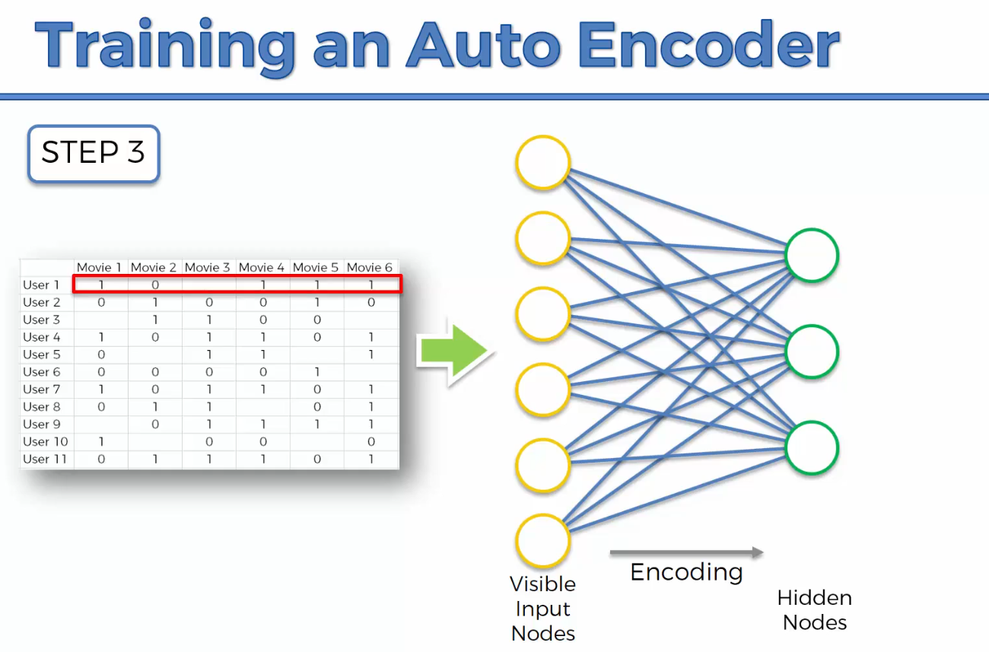

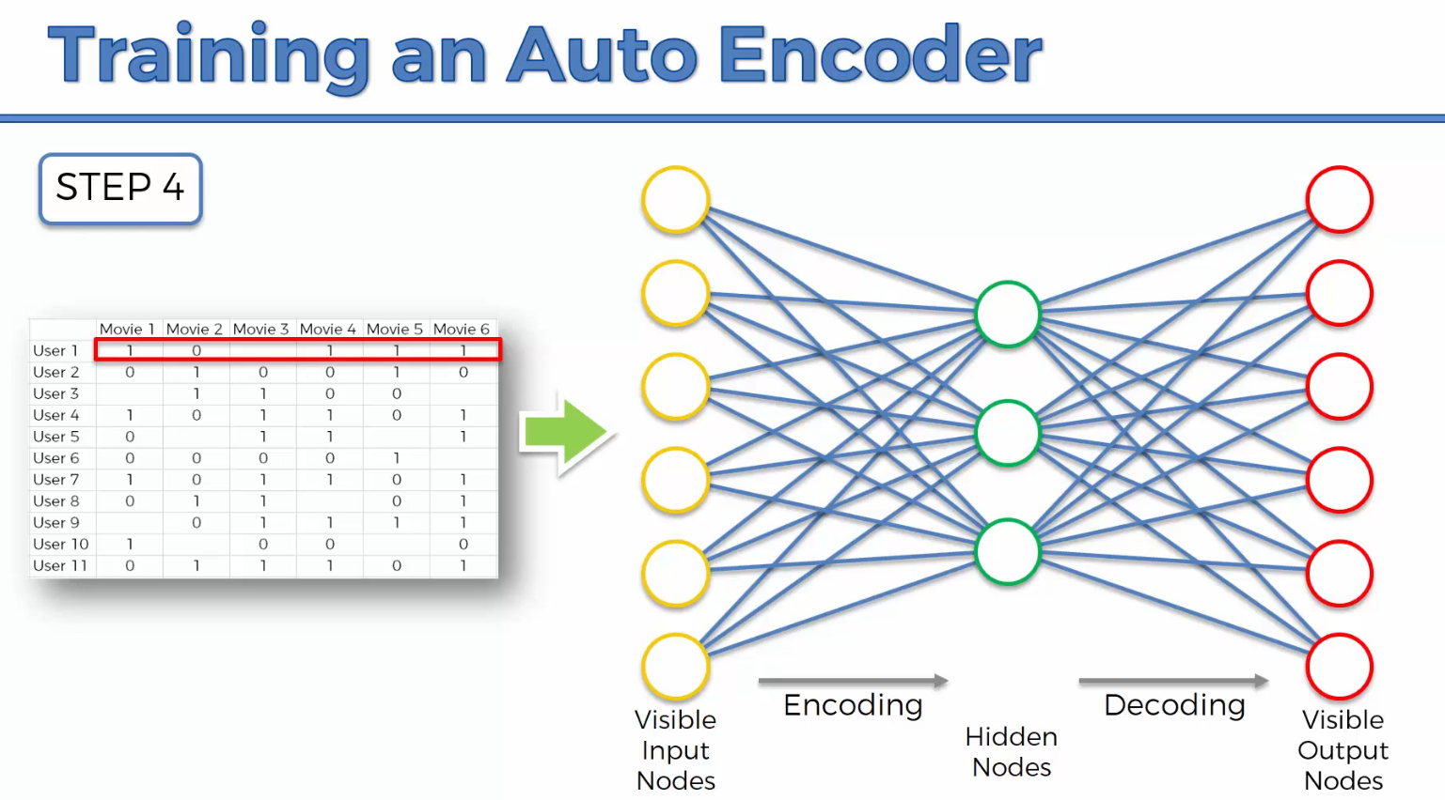

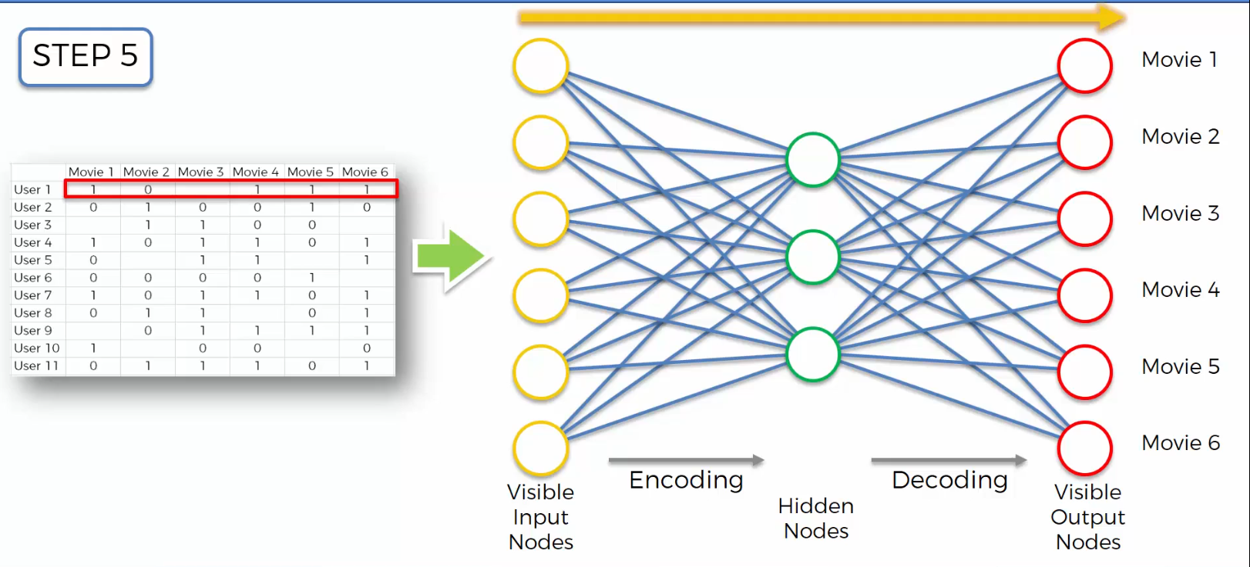

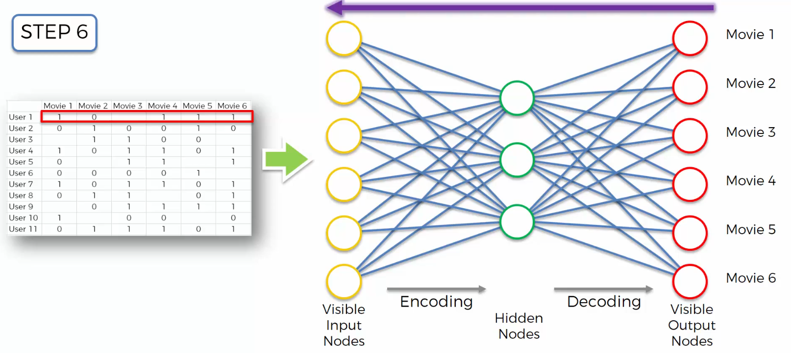

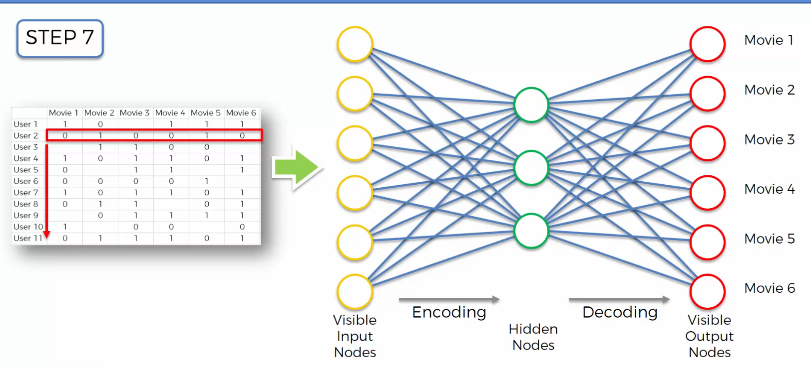

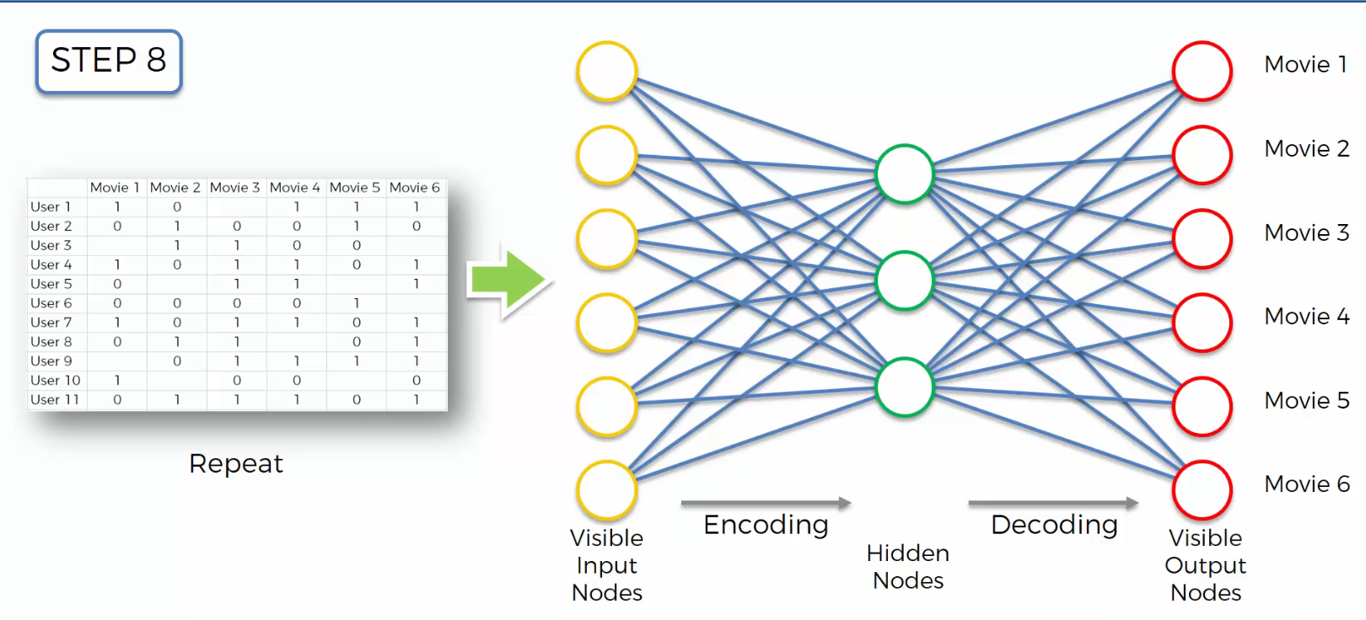

**Additional Reading**

<https://probablydance.com/2016/04/30/neural-networks-are-impressively-good-at-compression/>

<https://blog.keras.io/building-autoencoders-in-keras.html>

<https://mccormickml.com/2014/05/30/deep-learning-tutorial-sparse-autoencoder/>

**Overcomplete Hidden Layers**

Gives the ability to extract more features from the limited features.

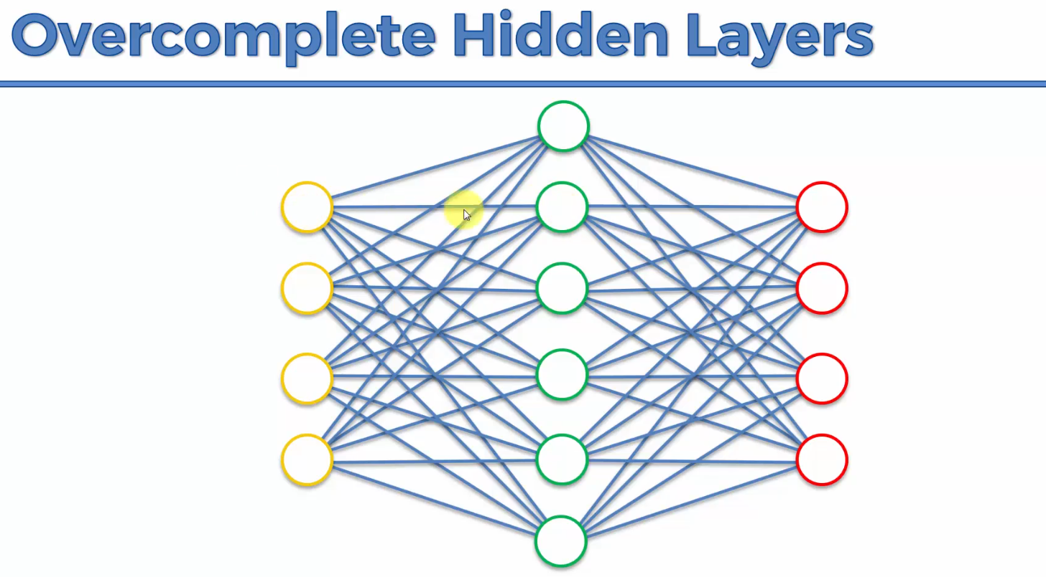

**Sparse Autoencoders**

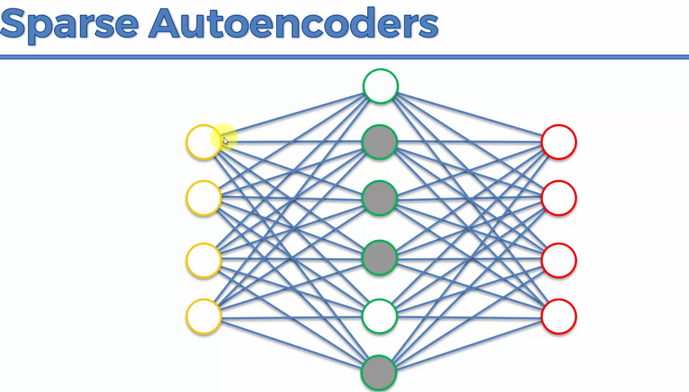

At any given time, the auto encoder can only use a certain number of nodes from the hidden layers.

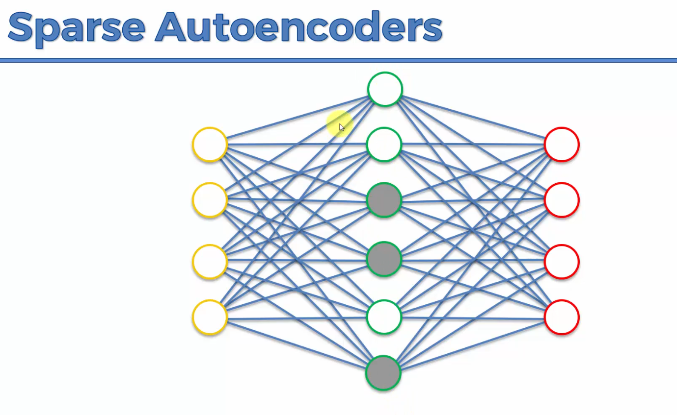

**Denoising Autoencoders**

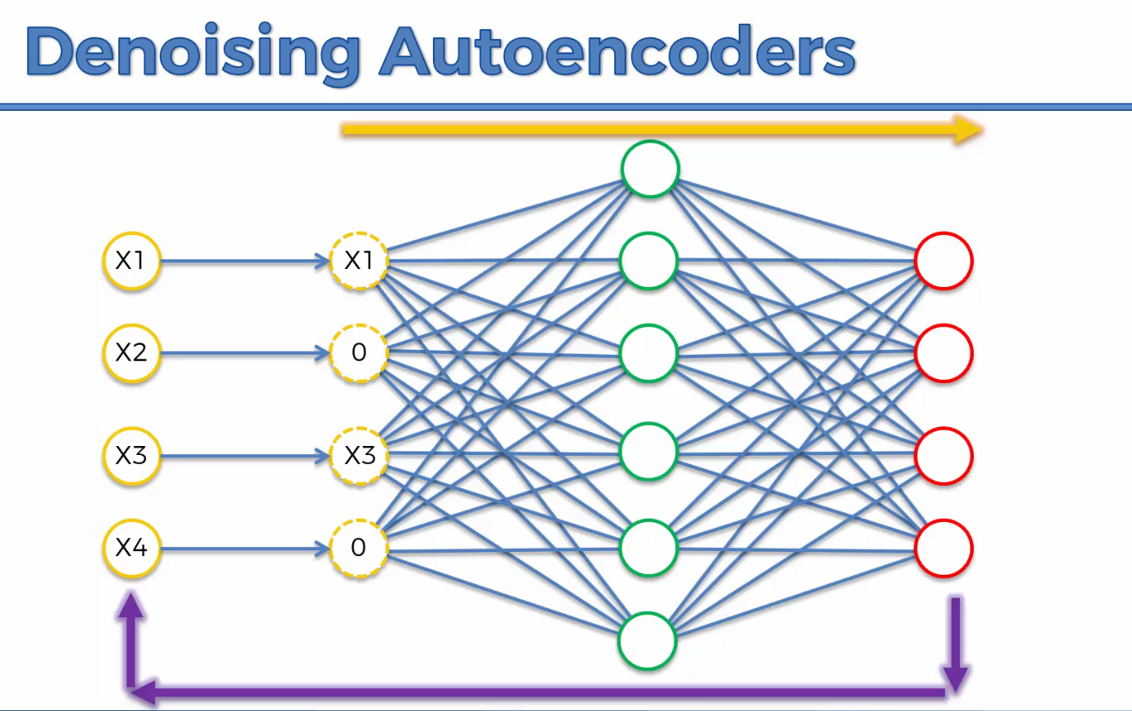

Take the inputs and randomly turn some of them into zeros. Once you put the values through the auto encoders, you compare them with the original inputs. Note: It’s a stochastic type of auto encoder.

**Contractive Autoencoders**

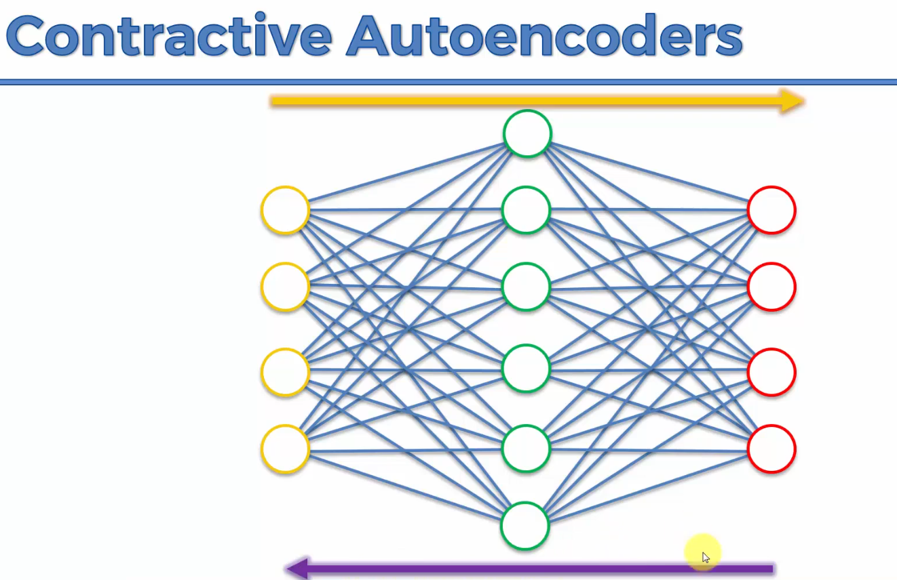

**Stacked Autoencoders**

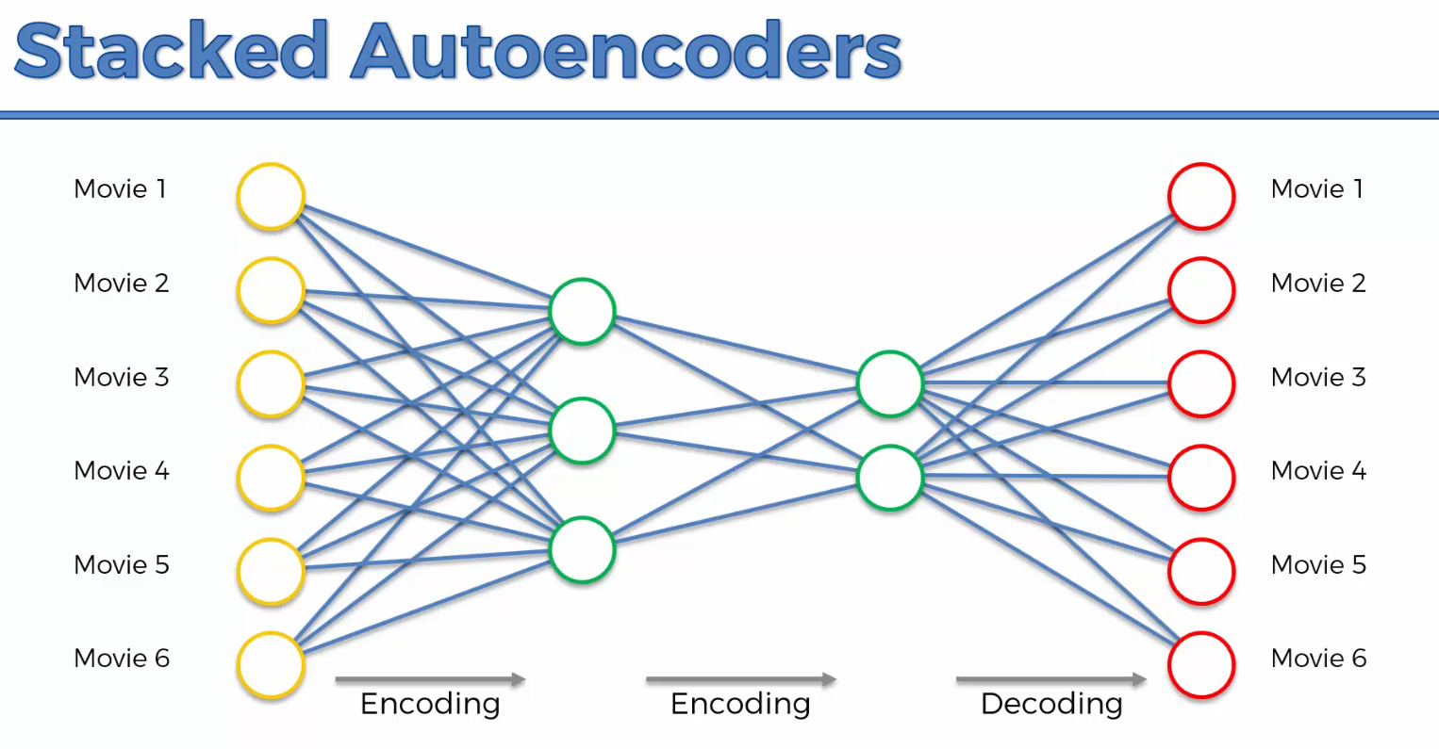

It’s a very powerful algorithm.

**Deep Autoencoders**



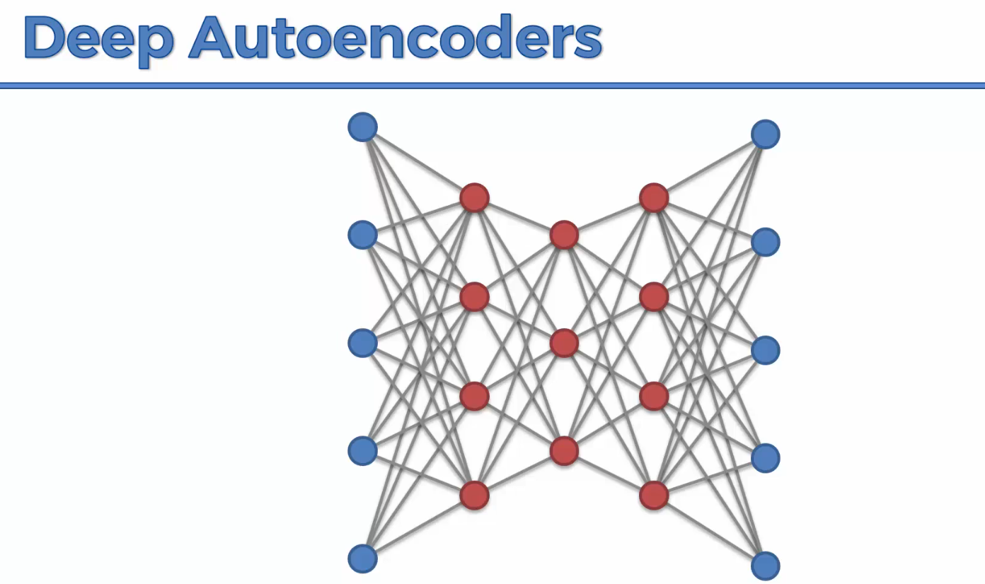

This is an RBM stacked on top.